**MINISTRY OF EDUCATION AND TRAINING**

|  |
| --- |
| **FPT UNIVERSITY** |
| **Capstone Project Document** |
| **Olives health care system** |
|  |
| |  |  | | --- | --- | | **TrendyPlus Team** | | | **Group Member** | * Nguyễn Duy Linh (SE03150) * Bùi Đức Trọng * Trần Ánh Dương (SE02797) * Phạm Đức Thắng * Phạm Minh Tuấn * Nguyễn Văn Hưng | | **Supervisor** | Lecturer : | | **Capstone Project code** | Olives |   Hanoi, 24/4/2015 |

**Contents**

Acknowledgements 3

Definitions and Acronyms 4

CHAPTER 4: SOFTWARE DESIGN 5

A. Purpose 5

B. Architecture Overview 5

1) System Architecture 5

System Architecture Explanation 5

i. *Olive system* 5

4.3. Design of Olives system 6

4.3.1. Architecture design of Olives Administration sub-system 6

4.3.1. Architecture design of Olives Administration sub-system 8

4.3.2. Database Design 10

4.3.4. Detail Design 19

# Acknowledgements

*The success and final outcome of this project required a lot of guidance and assistance from many people and wish to express our deepest gratitude to them. Without them, this project would have been done with much more obstacles than it was.*

*First, we want to say thanks to Mr. Nguyen Tat Trung for his continuously sharing and motivating throughout the project. Mr. Nguyen Tat Trung has always been very responsive in providing necessary information, and without his generous support project would lack in accurate information on current developments. Under the instructions of Mr. Nguyen, the project team has always felt comfortable and confident. Apart from all the technologies and methodologies, Mr. Nguyen shared with us the philosophy of keeping the right attitude towards problems.*

*Second, we would like to say thanks to the instructors at FPT University for all the classes. Without the knowledge that university teaches us through each class, semester, we cannot finish this project.*

*Third, we truly appreciate the random fellows on the internet who has discussed with us. Every our tiny problem was answered clearly.*

*Finally, we want to thank our family for their help, inspiring during this project.*

# Definitions and Acronyms

|  |  |  |
| --- | --- | --- |
| **Acronym** | **Definition** | **Note** |
| SRS | Software Requirement Specification |  |
| API | Application Programming Interface |  |
| HTML | Hypertext Markup Language |  |
| CSS | Cascading Style Sheets |  |
| IDE | Integrated Development Environment |  |
| DBMS | Database Management System |  |
| UML | Unified Modeling Language |  |
| PM | Project Manager |  |
| UC | Use Case |  |
| N/A | Not Available |  |
| ORM | Object Relational Mapping |  |
| GUI | Graphical User Interface |  |
| HTTP | Hypertext Transfer Protocol |  |
| PHP | Hypertext Preprocessor |  |
| REST | Representational State Transfer |  |
| RAM | Random Access Memory |  |
| URL | Uniform Resource Locator |  |

# CHAPTER 4: SOFTWARE DESIGN

## Purpose

This chapter is to give the developer team a guidance of what the system’s architecture is, and how they should be implemented. This chapter consists of:

* Architecture overview
* Component diagram
* Detailed design
* Detailed description of components
* Database design

## Architecture Overview

### System Architecture

<TODO: Import system data architecture>

**

*Figure 4-1: Olives System Architecture*

### System Architecture Explanation

The Olives System is divided into 2 sub-systems hosted on Azure cloud services, use one SQL in common:

* Olives system :
  + This sub-system is for ordinary users in the system: guests, doctors and patients. It includes 2 mobile applications and 1 web application and 1 API service.
    - Mobile applications for users who are doctors and patients.
      * These 2 applications are design for 2 specific roles: doctors and owners. They're built by using Objective C and run on iOS devices. These applications help users to be more flexible in using system. Messages and Notifications are sent instantly to bring Real-Time experience.
    - One web application for users of both role.
      * An application which has been built on AngularJS. It helps users interact and consume system services. It can be connected any time, any places by using browsers. Notifications are sent instantly to bring Real-Time experience.
    - API service:
      * A service which is built on ASP.NET Web API 2 framework and hosted on Azure cloud service. It takes responsibility in taking requests come from user applications, connecting to database and processing the received data and respond processed result to user applications.
* Olives administration system:
  + This sub-system is for administrators to manage system. It includes one web application and one API service application.
    - Web application: an application which helps administrators to manage users in system, to track their statuses, to activate/deactivate ordinary users …
    - API Service: A service which is built on ASP.NET Web API 2 framework and hosted on Azure cloud service. It takes responsibility in taking requests come from user applications, connecting to database and processing the received data and respond processed result to user applications.

## Architecture Design

### Olives Administration sub-system

#### API

**

|  |  |  |  |
| --- | --- | --- | --- |
| **No** | **Namespace/Directory** | **Description** | **Convention** |
| 1 | Controllers | Contains all controller source files which receive requests come from clients, processs data and return results back to requesters. | xxxController |
| 2 | Interfaces | Contains all interfaces definition files which are inherited by another classes, such as repositories, services, ... | **Ixxx** |
| 3 | Attributes | Contains all validation attributes source file which are used for data validation purposes. | xxxAttribute |
| 4 | Enumerations | Contains enumerations which are used in service. |  |
| 5 | Repositories | Contains classes which is used for access database to process data and return data to controller. Controllers don’t access database directly. | **Repositoryxxx** |
| 7 | Scripts | Contains javascript files which are used in Views. |  |
| 8 | ViewModels | Contains classes which define data structure sent from clients and vice versa. | xxxViewModel |

*Table 4-1: Namespace Explanation*

### Olives sub-system

#### API layer

*Figure 4-13: TrendyPlus Layer Design*



|  |  |  |  |
| --- | --- | --- | --- |
| **No** | **Namespace/Directory** | **Description** | **Convention** |
| 1 | Controllers | Contains all controller source files which receive requests come from clients, processs data and return results back to requesters. | xxxController |
| 2 | Interfaces | Contains all interfaces definition files which are inherited by another classes, such as repositories, services, ... | **Ixxx** |
| 3 | Attributes | Contains all validation attributes source file which are used for data validation purposes. | xxxAttribute |
| 4 | Enumerations | Contains enumerations which are used in service. |  |
| 5 | Repositories | Contains classes which is used for access database to process data and return data to controller. Controllers don’t access database directly. | **Repositoryxxx** |
| 7 | Scripts | Contains javascript files which are used in Views. |  |
| 8 | ViewModels | Contains classes which define data structure sent from clients and vice versa. | xxxViewModel |
| 9 | Views | Contains csthml files which are used for being displayed on client browsers. |  |

*Table 4-2: Namespace Explanation*

## Database Design

### Database diagram

<TODO: Import database diagram>

*Figure 4-14: Entity Relationship Diagram*

### Database dictionary

#### Person

|  |  |  |  |  |  |
| --- | --- | --- | --- | --- | --- |
| Stores general information about users : Admin, Patients, Doctors. | | | | | |
| **No.** | **Field** | **Type** | **Key** | **Description** | **Null** |
| 1 | Id | INT | PK | The id of user | No |
| 2 | Email | VARCHAR(64) |  | Email which is used for account registration. This can be understood as account name | No |
| 3 | Password | VARCHAR(16) |  | Password of user | No |
| 4 | FirstName | NVARCHAR(32) |  | User first name | No |
| 5 | LastName | NVARCHAR(32) |  | User last name | No |
| 6 | FullName | NVARCHAR(96) |  | Full name of user, this is the combination of First Name and Last Name. It is created for quick access. | No |
| 7 | Birthday | FLOAT |  | Time when user was born. Its format is UTC. | No |
| 8 | Phone | VARCHAR(15) |  | User phone number | Yes |
| 9 | Gender | TINYINT |  | User gender | No |
| 10 | Role | TINYINT |  | Role in the system: Admin, patient or doctor | No |
| 11 | Created | FLOAT |  | Time when account was signed up | No |
| 12 | LastModified | FLOAT |  | Time when the account information was lastly modified | Yes |
| 13 | Status | TINYINT |  | Status of account : pending, disabled or active | No |
| 14 | Address | NVARCHAR(128) |  | Address where user lives or works | Yes |
| 15 | PhotoUrl | NVARCHAR(MAX) |  | Relative path of user photo, this is used for render hyperlink. | Yes |
| 16 | PhotoPhysicPath | NVARCHAR(MAX) |  | The physical path where photo is stored, this is used for file access. | Yes |

#### Patient

|  |  |  |  |  |  |
| --- | --- | --- | --- | --- | --- |
| Stores general information about patients | | | | | |
| **No.** | **Field** | **Type** | **Key** | **Description** | **Null** |
| 1 | Id | INT | PK/FK | The id of patient. This is the same as person’s id | No |
| 2 | Height | FLOAT |  | Height of user | Yes |
| 3 | Weight | FLOAT |  | User weight | Yes |

#### Doctor

|  |  |  |  |  |  |
| --- | --- | --- | --- | --- | --- |
| Stores general information about doctors | | | | | |
| **No.** | **Field** | **Type** | **Key** | **Description** | **Null** |
| 1 | Id | INT | PK/FK | The id of doctor. This is the same as person’s id | No |
| 2 | Rank | FLOAT |  | Doctor rank, this indicates how good the doctor is | Yes |
| 3 | SpecialtyId | INT | FK | Id of doctor specialty | No |
| 4 | Voters | INT |  | Number of people who voted for this doctor | Yes |
| 5 | PlaceId | INT | FK | Id of place where doctor lives or works | No |
| 6 | ProfileUrl | NVARCHAR(MAX) |  | Url of doctor profile file. | Yes |
| 7 | ProfilePhysicalPath | NVARCHAR(MAX) |  | Storage location on the server where real file is stored. | Yes |

#### Place

|  |  |  |  |  |  |
| --- | --- | --- | --- | --- | --- |
| Stores general information about doctors | | | | | |
| **No.** | **Field** | **Type** | **Key** | **Description** | **Null** |
| 1 | Id | INT | PK/FK | The id of doctor. This is the same as person’s id | No |
| 2 | City | FLOAT |  | City name. | No |
| 3 | Country | INT | FK | Country name | No |

#### Specialty

|  |  |  |  |  |  |
| --- | --- | --- | --- | --- | --- |
| Stores general information about medical specialty. | | | | | |
| **No.** | **Field** | **Type** | **Key** | **Description** | **Null** |
| 1 | Id | INT | PK | Id which is used for identifying specialties. | No |
| 2 | Name | NVARCHAR(32) |  | Specialty name | No |

#### Diary

|  |  |  |  |  |  |
| --- | --- | --- | --- | --- | --- |
| Stores general information about medical diary. Diary is a personal of doctor about his/her one specific patient. | | | | | |
| **No.** | **Field** | **Type** | **Key** | **Description** | **Null** |
| 1 | Id | INT | PK | Diary unique index. | No |
| 2 | Owner | INT | FK | Id of doctor who owns the diary. | No |
| 3 | Target | INT | FK | Id of patient who diary notes about. | No |
| 4 | Time | FLOAT |  | Time when the diary was noted. | No |
| 5 | Note | NVARCHAR(512) |  | Diary note. | No |
| 6 | Created | FLOAT |  | Time when the diary was created. | No |
| 7 | LastModified | FLOAT |  | Time when the diary was lastly modified. | No |

#### Rating

|  |  |  |  |  |  |
| --- | --- | --- | --- | --- | --- |
| Stores general information about rating: who made the rating, who was rated, … | | | | | |
| **No.** | **Field** | **Type** | **Key** | **Description** | **Null** |
| 1 | Maker | INT | PK/FK | Id of patient who made the rating, with Target, they combine to one primary key. | No |
| 2 | Target | INT | PK/FK | Id of doctor who was rated, with Maker, they combine to one primary key. | No |
| 3 | Value | INT |  | Rating point. | No |
| 4 | Comment | FLOAT |  | Comment of patient when rating was made. | No |
| 5 | Created | FLOAT |  | When the rating was created. | No |

#### Relationship

|  |  |  |  |  |  |
| --- | --- | --- | --- | --- | --- |
| Stores general information about relationships between patients and doctors. | | | | | |
| **No.** | **Field** | **Type** | **Key** | **Description** | **Null** |
| 1 | Id | INT | PK | Id of relationship. | No |
| 2 | Source | INT | FK | Id of patient who started the relationship. | No |
| 3 | Target | INT | FK | Id of doctor who accepted the relationship. | No |
| 4 | Created | FLOAT |  | When the relationship was created. | No |

#### RelationshipRequest

|  |  |  |  |  |  |
| --- | --- | --- | --- | --- | --- |
| Stores relationship requests information between patients and doctors. | | | | | |
| **No.** | **Field** | **Type** | **Key** | **Description** | **Null** |
| 1 | Id | INT | PK | Id of relationship. | No |
| 2 | Source | INT | FK | Id of patient who started the relationship request. | No |
| 3 | Target | INT | FK | Id of doctor who accepted the relationship request. | No |
| 4 | Content | NVARCHAR(128) |  | Message sent from patient to doctor about this request. | No |
| 5 | Created | FLOAT |  | When the relationship was sent. | Yes |

#### Allergy

|  |  |  |  |  |  |
| --- | --- | --- | --- | --- | --- |
| Stores information of allergies which belong to patients. | | | | | |
| **No.** | **Field** | **Type** | **Key** | **Description** | **Null** |
| 1 | Id | INT | PK | Id of allergy note. | No |
| 2 | Owner | INT | FK | Id of patient who owns the allergy note. | No |
| 3 | Name | INT | FK | Name of allergy. | No |
| 4 | Cause | NVARCHAR(128) |  | Which patient is allergic with. | No |
| 5 | Note | FLOAT |  | Note information of allergy. | Yes |
| 6 | Created | FLOAT |  | When the note was created. | No |
| 7 | LastModified | FLOAT |  | When the note was lastly modified. | Yes |

#### Addiction

|  |  |  |  |  |  |
| --- | --- | --- | --- | --- | --- |
| Stores information of addictions which belong to patients. | | | | | |
| **No.** | **Field** | **Type** | **Key** | **Description** | **Null** |
| 1 | Id | INT | PK | Id of addiction note. | No |
| 2 | Owner | INT | FK | Id of patient who owns the addiction note. | No |
| 3 | Cause | NVARCHAR(128) |  | Which patient is addictive with. | No |
| 4 | Note | FLOAT |  | Note information of addiction. | Yes |
| 5 | Created | FLOAT |  | When the note was created. | No |
| 6 | LastModified | FLOAT |  | When the note was lastly modified. | Yes |

#### BloodPressure

|  |  |  |  |  |  |
| --- | --- | --- | --- | --- | --- |
| Stores information of blood pressure measurements which belong to patients. | | | | | |
| **No.** | **Field** | **Type** | **Key** | **Description** | **Null** |
| 1 | Id | INT | PK | Id of blood pressure note. | No |
| 2 | Owner | INT | FK | Id of patient who owns the note. | No |
| 3 | Systolic | INT |  | Max pressure of blood. | No |
| 4 | Diastolic | INT |  | Min pressure of blood. | No |
| 5 | Time | FLOAT |  | When the measurement was done. | No |
| 6 | Note | FLOAT |  | Note information of addiction. | Yes |
| 7 | Created | FLOAT |  | When the note was created. | No |
| 8 | LastModified | FLOAT |  | When the note was lastly modified. | Yes |

#### Heartbeat

|  |  |  |  |  |  |
| --- | --- | --- | --- | --- | --- |
| Stores information of heartbeat measurements which belong to patients. | | | | | |
| **No.** | **Field** | **Type** | **Key** | **Description** | **Null** |
| 1 | Id | INT | PK | Id of blood pressure note. | No |
| 2 | Owner | INT | FK | Id of patient who owns the note. | No |
| 3 | Rate | FLOAT |  | Heart rate at the time measurement was done. | No |
| 4 | Time | FLOAT |  | When the measurement was done. | No |
| 5 | Note | FLOAT |  | Note information of addiction. | Yes |
| 6 | Created | FLOAT |  | When the note was created. | No |
| 7 | LastModified | FLOAT |  | When the note was lastly modified. | Yes |

#### BloodSugar

|  |  |  |  |  |  |
| --- | --- | --- | --- | --- | --- |
| Stores information of blood sugar measurements which belong to patients. | | | | | |
| **No.** | **Field** | **Type** | **Key** | **Description** | **Null** |
| 1 | Id | INT | PK | Id of blood sugar note. | No |
| 2 | Owner | INT | FK | Id of patient who owns the note. | No |
| 3 | Value | FLOAT |  | Blood sugar level at the time measurement was done. | No |
| 4 | Time | FLOAT |  | When the measurement was done. | No |
| 5 | Note | FLOAT |  | Note information of addiction. | Yes |
| 6 | Created | FLOAT |  | When the note was created. | No |
| 7 | LastModified | FLOAT |  | When the note was lastly modified. | Yes |

#### MedicalRecord

|  |  |  |  |  |  |
| --- | --- | --- | --- | --- | --- |
| Stores information of medical records which belong to patients. | | | | | |
| **No.** | **Field** | **Type** | **Key** | **Description** | **Null** |
| 1 | Id | INT | PK | Id of medical record. | No |
| 2 | Owner | INT | FK | Who owned the record. | No |
| 3 | Creator | INT | FK | Who created medical record. | No |
| 4 | Category | INT |  | Category which medical record belongs to. | No |
| 5 | Name | NVARCHAR(64) |  | Name of medical record. | Yes |
| 6 | Info | NVARCHAR(MAX) |  | Key-value of necessary information.I.e : “Eye”:”good” | Yes |
| 7 | Time | FLOAT |  | When the record was about. | Yes |
| 8 | Created | FLOAT |  | When the record was created. | No |
| 9 | LastModified | FLOAT |  | When the note was lastly modified. | Yes |

#### Prescription

|  |  |  |  |  |  |
| --- | --- | --- | --- | --- | --- |
| Stores information of prescriptions which belong to patients. | | | | | |
| **No.** | **Field** | **Type** | **Key** | **Description** | **Null** |
| 1 | Id | INT | PK | Id of prescription. | No |
| 2 | Owner | INT | FK | Who owns the prescription. | No |
| 3 | Creator | INT | FK | Who created prescription. | No |
| 4 | MedicalRecordId | INT | FK | Id of medical record which prescription belongs to. | No |
| 5 | From | FLOAT |  | When the prescription should be available. | No |
| 6 | To | FLOAT |  | When the prescription should be expired | No |
| 7 | Name | NVARCHAR(32) |  | Name of prescription | No |
| 8 | Medicine | NVARCHAR(MAX) |  | Stores serialized information of medicine. Refer to API documentation for more detail (api/medical/prescription) | Yes |
| 9 | Note | NVARCHAR(128) |  | Note of prescription. | Yes |
| 10 | Created | FLOAT |  | When the prescription was created. | No |
| 11 | LastModified | FLOAT |  | When the prescription was lastly modified. | Yes |

#### PrescriptionImage

|  |  |  |  |  |  |
| --- | --- | --- | --- | --- | --- |
| Stores information of prescription images which belong to patients. | | | | | |
| **No.** | **Field** | **Type** | **Key** | **Description** | **Null** |
| 1 | Id | INT | PK | Id of prescription image. | No |
| 2 | Owner | INT | FK | Who owns the prescription image. | No |
| 3 | Creator | INT | FK | Who created prescription image. | No |
| 4 | MedicalRecordId | INT | FK | Id of medical record which prescription image belongs to. | No |
| 5 | PrescriptionId | INT | FK | Id of prescription which prescription image belongs to. | No |
| 6 | Image | NVARCHAR(32) |  | Name of image. | No |
| 7 | FullPath | NVARCHAR(MAX) |  | Physical path where image is stored on server. | No |
| 8 | Created | FLOAT |  | When the prescription image was created. | No |
| 9 | LastModified | FLOAT |  | When the prescription image was lastly modified. | Yes |

#### MedicalNote

|  |  |  |  |  |  |
| --- | --- | --- | --- | --- | --- |
| Stores information of medical notes which belong to patients. | | | | | |
| **No.** | **Field** | **Type** | **Key** | **Description** | **Null** |
| 1 | Id | INT | PK | Id of prescription image. | No |
| 2 | Owner | INT | FK | Who owns the prescription image. | No |
| 3 | Creator | INT | FK | Who created prescription image. | No |
| 4 | MedicalRecordId | INT | FK | Id of medical record which note belongs to. | No |
| 5 | Note | NVARCHAR(128) |  | Note of medical record. | No |
| 6 | Time | INT |  | Time when the note was about. | No |
| 7 | Created | FLOAT |  | When the note was created. | No |
| 8 | LastModified | FLOAT |  | When the note was lastly modified. | Yes |

#### MedicalCategory

|  |  |  |  |  |  |
| --- | --- | --- | --- | --- | --- |
| Stores information of medical category which medical records belong to. | | | | | |
| **No.** | **Field** | **Type** | **Key** | **Description** | **Null** |
| 1 | Id | INT | PK | Id of prescription image. | No |
| 2 | Name | NVARCHAR(32) |  | Name of medical category. | No |
| 3 | Created | FLOAT |  | When the category was created. | No |
| 4 | LastModified | FLOAT |  | When the category was lastly modified. | Yes |

#### MedicalImage

|  |  |  |  |  |  |
| --- | --- | --- | --- | --- | --- |
| Stores information of medical image which are contained in medical records. | | | | | |
| **No.** | **Field** | **Type** | **Key** | **Description** | **Null** |
| 1 | Id | INT | PK | Id of .medical image. | No |
| 2 | MedicalRecordId | INT | FK | Id of medical record which medical image belongs to. | No |
| 3 | Owner | INT | FK | Id of person who owns the medical image. | No |
| 4 | Creator | INT | FK | Id of person who created medical image. | No |
| 5 | Image | NVARCHAR(32) |  | Name of image. | No |
| 6 | FullPath | NVARCHAR(MAX) |  | Physical path on server where image is stored. | No |
| 7 | Created | FLOAT |  | When medical image was created. | No |

#### ExperimentNote

|  |  |  |  |  |  |
| --- | --- | --- | --- | --- | --- |
| Stores information of medical image which are contained in medical records. | | | | | |
| **No.** | **Field** | **Type** | **Key** | **Description** | **Null** |
| 1 | Id | INT | PK | Id of of experiment note. | No |
| 2 | MedicalRecordId | INT | FK | Id of medical record which medical record belongs to. | No |
| 3 | Owner | INT | FK | Id of person who owns the experiment note. | No |
| 4 | Creator | INT | FK | Id of person who created experiment note. | No |
| 5 | Name | INT |  | Name of experiment note. | No |
| 6 | Info | INT |  | Stores serialized information of experiment measurement. | No |
| 7 | Time | INT |  | Time when the experiment note is about. | No |
| 8 | Created | FLOAT |  | When medical image was created. | No |
| 9 | LastModified | FLOAT |  | When medical image was lastly modified. | No |

#### Notification

|  |  |  |  |  |  |
| --- | --- | --- | --- | --- | --- |
| Stores information of notification which broadcasted from service. | | | | | |
| **No.** | **Field** | **Type** | **Key** | **Description** | **Null** |
| 1 | Id | INT | PK | Id of of notification. | No |
| 2 | Type | INT |  | Type of notification : create/edit/remove/… | No |
| 3 | Topic | INT |  | Topic of notification : Medical record/ Prescription/… | No |
| 4 | Container | INT |  | Id of the container (Medical Record ID, Prescription ID, …). | No |
| 5 | ContainerType | INT |  | Type of container (Medical Record, Prescription, …). | No |
| 6 | Broadcaster | INT |  | Who causes the notification broadcasted. | No |
| 7 | Recipient | INT |  | Who should receive the notification. | No |
| 8 | Record | FLOAT |  | Id of record which is targeted. | No |
| 9 | Message | FLOAT |  | Message from service. | No |
| 10 | Created | FLOAT |  | When the notification is created. | No |
| 11 | IsSeen | FLOAT |  | Whether recipient has seen the notification or not. | No |

#### RealTimeConnection

|  |  |  |  |  |  |
| --- | --- | --- | --- | --- | --- |
| Stores information of connections made to service, the connections information will be used by service to broadcast realtime notification to clients. | | | | | |
| **No.** | **Field** | **Type** | **Key** | **Description** | **Null** |
| 1 | Id | INT | PK | Id of of realtime connection. | No |
| 2 | Owner | INT |  | Id of person who connects to service. | No |
| 3 | ConnectionId | INT |  | Connection index which generated by service. | No |
| 4 | Created | INT |  | Time when the note was created. | No |

#### Message

|  |  |  |  |  |  |
| --- | --- | --- | --- | --- | --- |
| Stores information of message which are broadcasted on server. | | | | | |
| **No.** | **Field** | **Type** | **Key** | **Description** | **Null** |
| 1 | Id | INT | PK | Id of of message. | No |
| 2 | Broadcaster | INT | FK | Id of person who broadcasted the message. | No |
| 3 | Recipient | INT | FK | Id of person who receives the message. | No |
| 4 | Content | NVARCHAR(512) |  | Message content. | No |
| 5 | Created | FLOAT |  | Time when the message was broadcasted. | No |
| 6 | IsSeen | BIT |  | Whether message has been seen or not. | No |

#### AccountToken

|  |  |  |  |  |  |
| --- | --- | --- | --- | --- | --- |
| Stores information of tokens which are used for account activation or account password modification. | | | | | |
| **No.** | **Field** | **Type** | **Key** | **Description** | **Null** |
| 1 | Owner | INT | PK/FK | Id of patient who has the code. | No |
| 2 | Code | NVARCHAR(36) |  | Code for account activation/account password modification. | No |
| 3 | Type | INT | PK/FK | Id of person who receives the message. | No |
| 4 | Expired | DATETIME |  | Time when the account token is expired. | No |

#### Appointment

|  |  |  |  |  |  |
| --- | --- | --- | --- | --- | --- |
| Appointment information which is broadcasted from patients to doctors and vice versa. | | | | | |
| **No.** | **Field** | **Type** | **Key** | **Description** | **Null** |
| 1 | Id | INT | PK/FK | Appointment index. | No |
| 2 | Maker | INT | FK | Id of person who made the appointment request. | No |
| 3 | Dater | INT | FK | Id of person who received the appointment request. | No |
| 4 | From | FLOAT |  | Time when the appointment should be started. | No |
| 5 | To | FLOAT |  | Time when the appointment should be emded. | No |
| 6 | Note | NVARCHAR(128) |  | Note of appointment | No |
| 7 | Created | FLOAT |  | Time when the appointment was created. | No |
| 8 | LastModified | FLOAT |  | Time when the appointment was lastly modified. | No |
| 9 | LastModifiedNote | NVARCHAR(128) |  | Note of the time appointment was lastly modified. | Yes |
| 10 | Status | TINYINT |  | Status of appointment | No |

## References

## Class diagram

### Olives Administration sub-system

#### Login

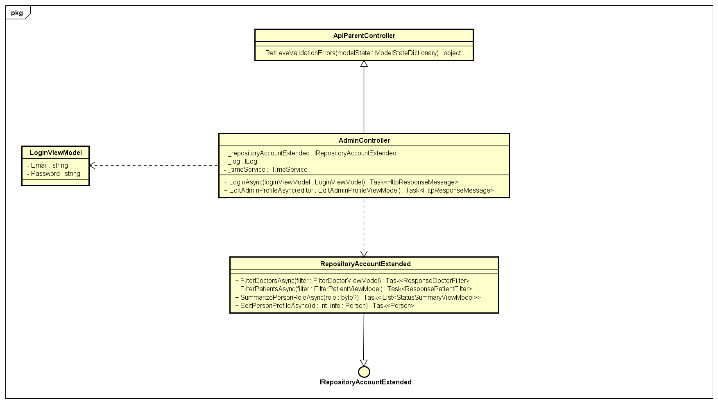

Class diagram of Admin Login.

#### Create medical categories

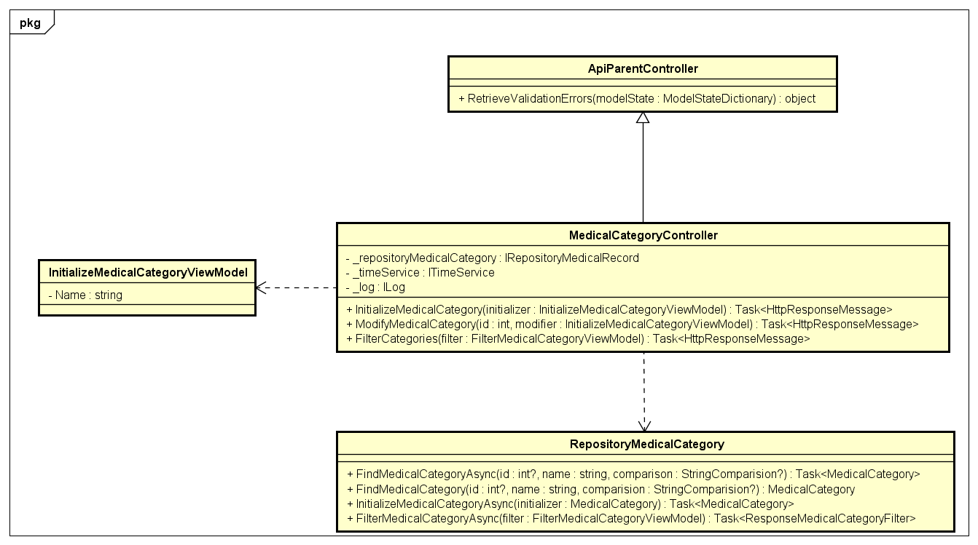

#### Edit medical categories



#### Activate account

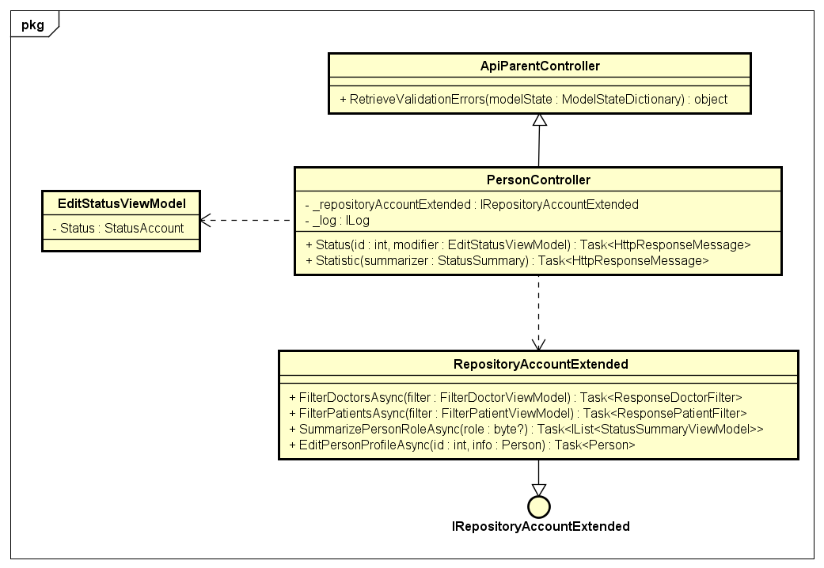

#### Get information of a specific doctor

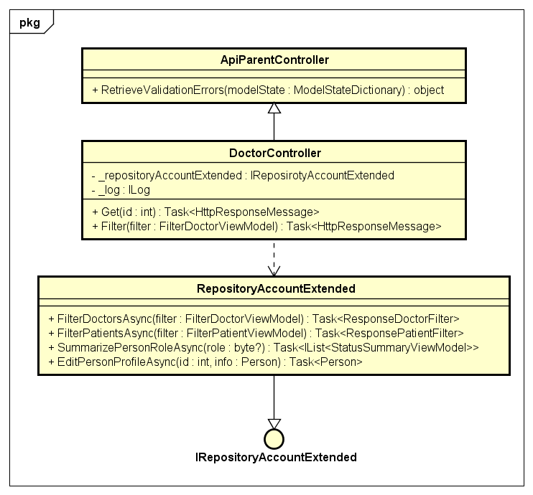

#### Filter doctors list

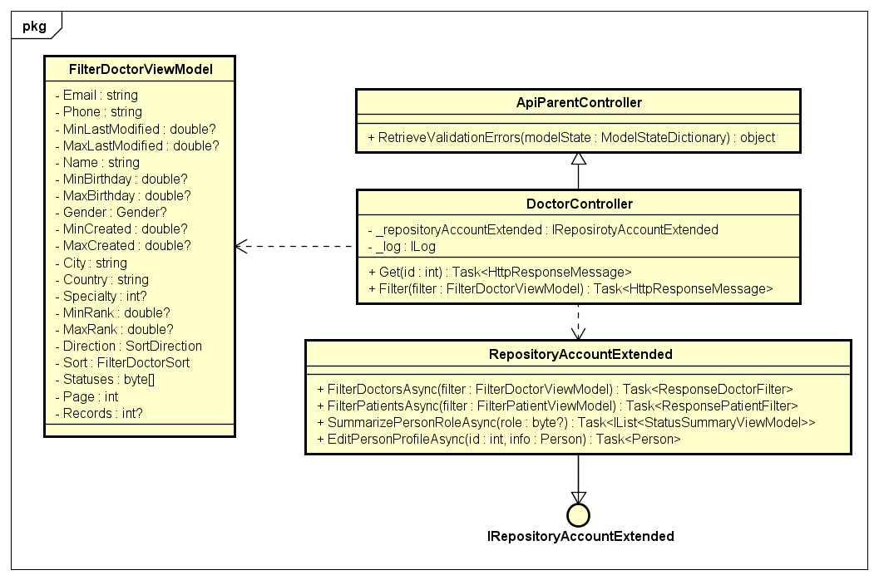

#### Filter patients list

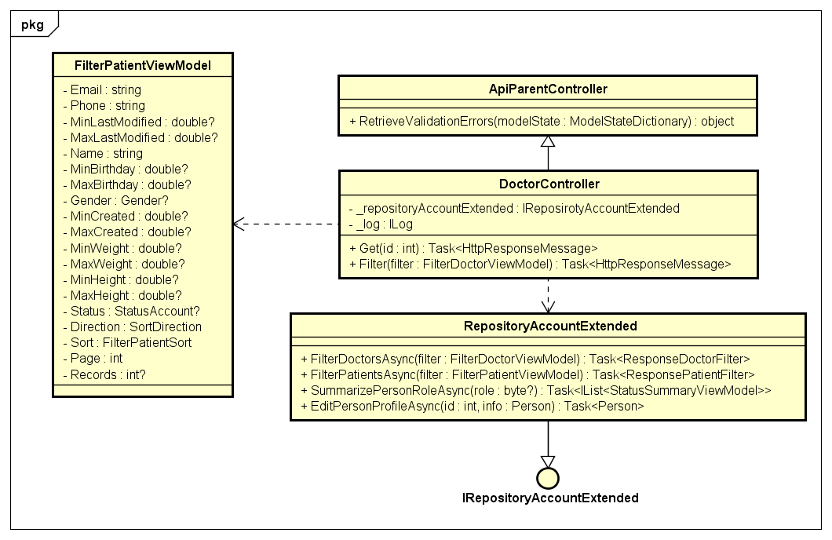

#### Statistic account by role

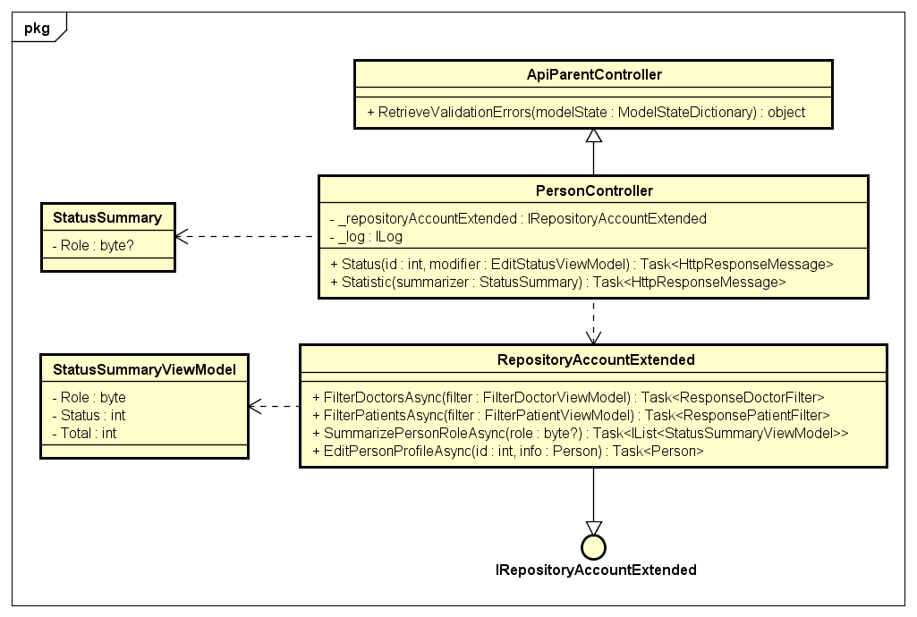

#### Create place

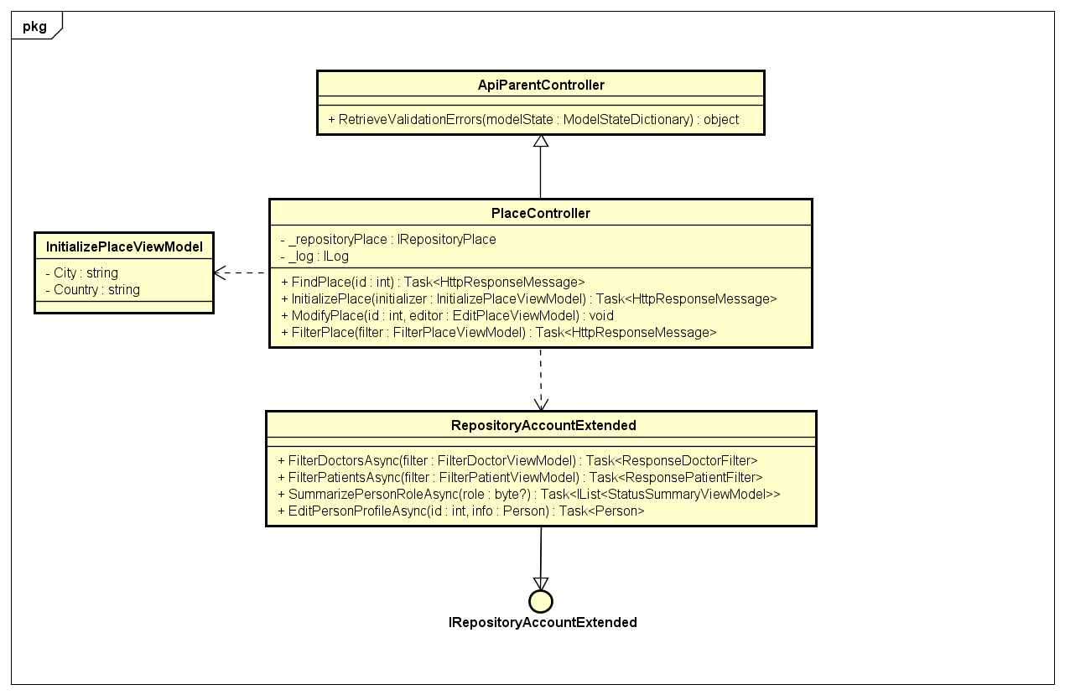

#### Edit place

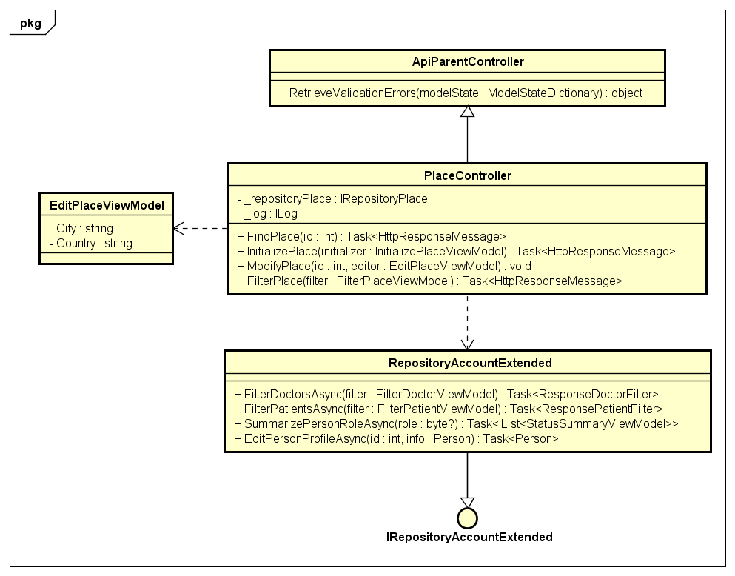

## Class definition

## Screen design

### 4.3.4.1. Guest

#### 4.3.4.1.1. Login

#### Description

* Actor logins into TrendyPlus.

#### Class Diagram

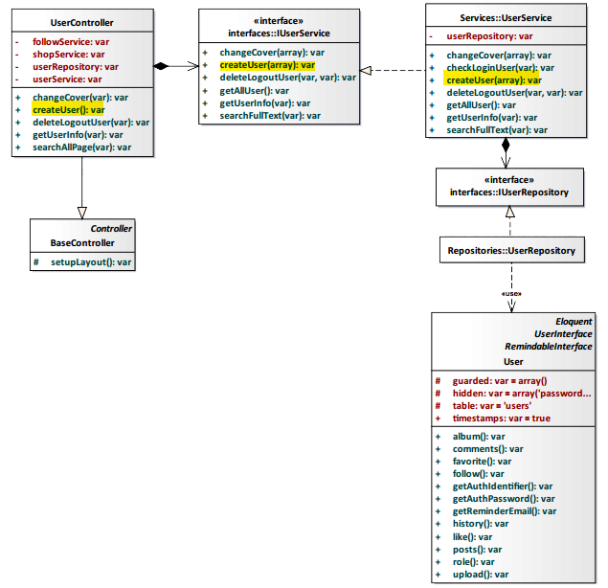

*Figure 4-23: Login Class Diagram*

#### Class Specification

#### UserController class

#### Physical Address: Trendy-Server\app\controllers*UserController.php*

#### Attribute

|  |  |  |  |
| --- | --- | --- | --- |
| No | Name | Type | Description |
| 1 | followService | var | Instance of interface using to call methods in IFollowService. |
| 2 | shopService | var | Instance of interface using to call methods in IShopService. |
| 3 | userRepository | var | Instance of interface using to call methods in IUserRepository. |
| 4 | userService | var | Instance of interface using to call methods in IUserService. |

#### Method: createUser()

|  |  |  |
| --- | --- | --- |
| Purpose | Create actor’s account after actor logins into system. | |
| Return | **Type** | **Description** |
| var | Return actor’s account. |

#### UserService class

#### Physical Address: Trendy-Server\app\Services*UserService.php*

#### Attribute

|  |  |  |  |
| --- | --- | --- | --- |
| No | Name | Type | Description |
| 1 | userRepository | var | Instance of interface using to call methods in IUserRepository. |

#### Method: createUser(var $array)

|  |  |  |  |  |
| --- | --- | --- | --- | --- |
| Purpose | Process to creat actor’s account after actor logins into system. | | | |
| Return | **Type** | | | **Description** |
| var | | | Return actor’s account. |
| Parameter | **No** | **Name** | **Type** | **Description** |
| 1 | array | var | Array contains actor’s information. |

#### Sequence Diagram

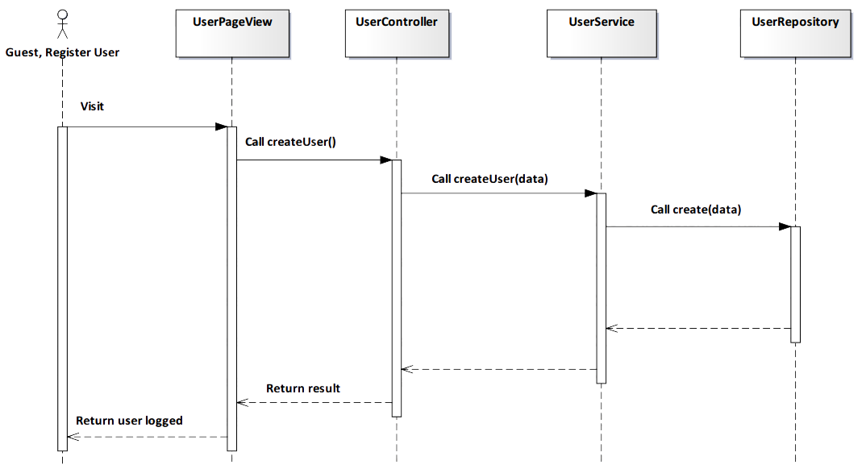

*Figure 4-24: Login Sequence Diagram*

#### Screen Design

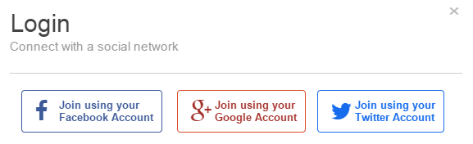

*Figure 4-25: Login Screen*

|  |  |  |
| --- | --- | --- |
| **Element** | **Type** | **Description** |
| **Join using your Facebook Account** | Button | Click to login by Facebook account. |
| **Join using your Google Account** | Button | Click to login by Google account. |
| **Join using your Twitter Account** | Button | Click to login by Twitter account. |

#### 4.3.4.1.2. View Trendy

#### Description

* User view fashion Trendy in website.

#### Class Diagram

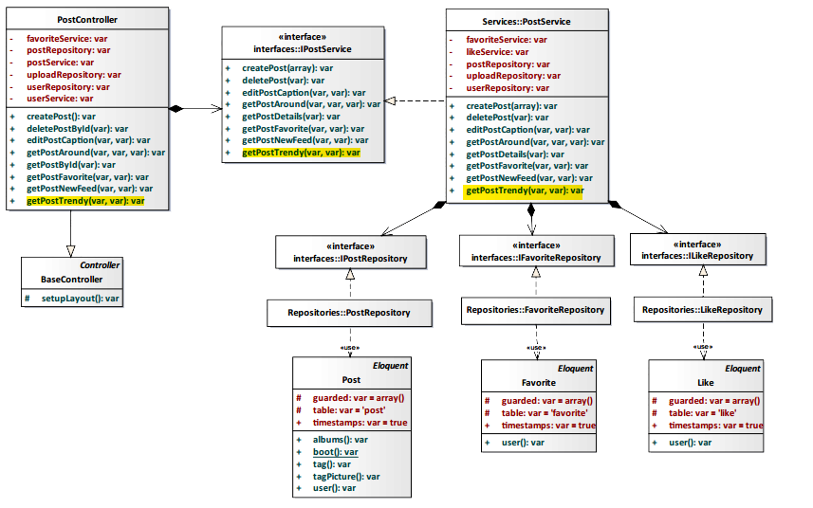

*Figure 4-26: View Trendy Class Diagram*

#### Class Specification

#### PostController class

#### Physical Address: Trendy-Server\app\Controller*PostController.php*

#### Attribute

|  |  |  |  |
| --- | --- | --- | --- |
| No | Name | Type | Description |
| 1 | favoriteService | var | Instance of interface using to call methods in IFavoriteService. |
| 2 | postRepository | var | Instance of interface using to call methods in IPostRepository. |
| 3 | postService | var | Instance of interface using to call methods in IPostService. |
| 4 | uploadRepository | var | Instance of interface using to call methods in IUploadRepository. |
| 6 | userRepository | var | Instance of interface using to call methods in IUserRepository. |
| 7 | userService | var | Instance of interface using to call methods in IUserService. |
| 8 | postRepository | var | Instance of interface using to call methods in IPostRepository. |

#### Method: getPostTrendy($id, $tag)

|  |  |  |  |  |
| --- | --- | --- | --- | --- |
| Purpose | Display trendy post | | | |
| Return | **Type** | | | **Description** |
| var | | | All trendy of post. |
| Parameter | **No** | **Name** | **Type** | **Description** |
| 1 | id | var | id of post. |
| 2 | tag | var | tag of post. |

#### PostService class

#### Physical Address: Trendy-Server\app\Services*PostService.php*

#### Attribute

|  |  |  |  |
| --- | --- | --- | --- |
| No | Name | Type | Description |
| 1 | favoriteRepository | var | Instance of interface using to call methods in IFavoriteRepository. |
| 2 | likeService | var | Instance of interface using to call methods in ILikeService. |
| 3 | postRepository | var | Instance of interface using to call methods in IPostRepository. |
| 4 | uploadRepository | var | Instance of interface using to call methods in IUploadRepository. |
| 5 | userRepository | var | Instance of interface using to call methods in IUserRepository. |

#### Method: getPostTrendy($id, $tag)

|  |  |  |  |  |
| --- | --- | --- | --- | --- |
| Purpose | Display trendy post | | | |
| Return | **Type** | | | **Description** |
| var | | | All trendy of post. |
| Parameter | **No** | **Name** | **Type** | **Description** |
| 1 | id | var | id of post. |
| 2 | tag | var | tag of post. |

#### Sequence Diagram

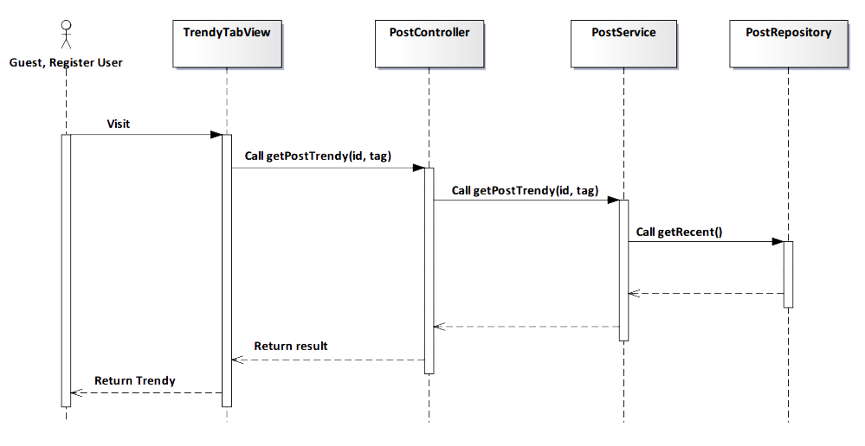

*Figure 4-27: View Trendy Sequence Diagram*

#### Screen Design

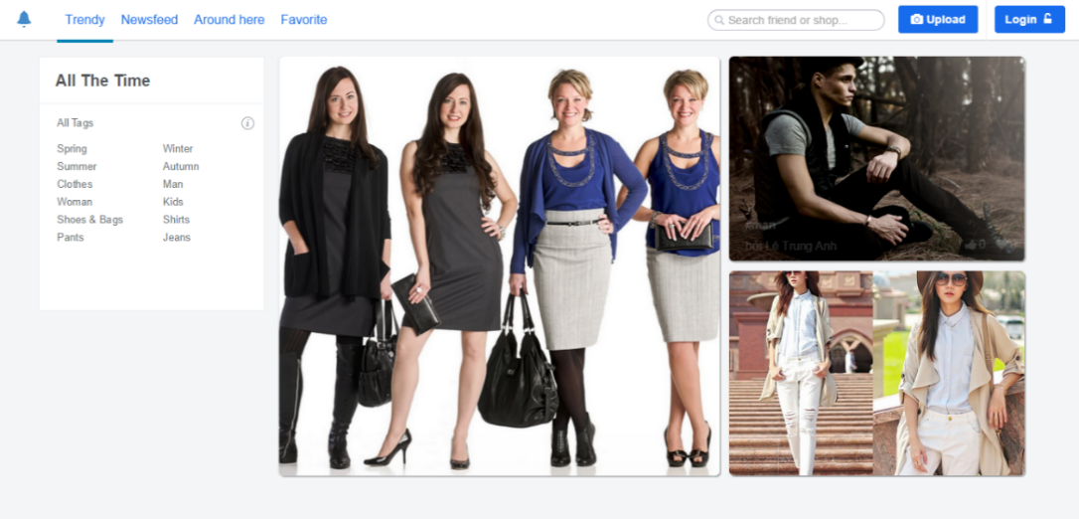

*Figure 4-28: View Trendy Screen*

|  |  |  |
| --- | --- | --- |
| **Element** | **Type** | **Description** |
| **All tag** | Button | Click to view Trendy order by content. |
| **Scroll** | Button | Scroll down to get more trend. |

#### 4.3.4.1.3. View Newsfeed

#### Description

* User see new posts which user’s following posting.

#### Class Diagram

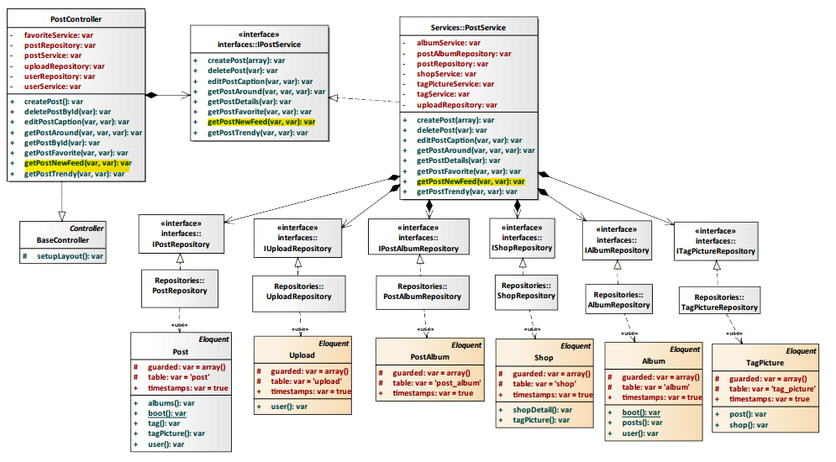

*Figure 4-29: View Newsfeed Class Diagram*

#### Class Specification

#### PostController class

#### Physical Address: Trendy-Server\app\Controller*PostController.php*

#### Attribute

|  |  |  |  |
| --- | --- | --- | --- |
| No | Name | Type | Description |
| 1 | favoriteService | var | Instance of interface using to call methods in IFavoriteService. |
| 2 | postRepository | var | Instance of interface using to call methods in IPostRepository. |
| 3 | postService | var | Instance of interface using to call methods in IPostService. |
| 4 | uploadRepository | var | Instance of interface using to call methods in IUploadRepository. |
| 6 | userRepository | var | Instance of interface using to call methods in IUserRepository. |
| 7 | userService | var | Instance of interface using to call methods in IUserService. |

#### Method: getPostNewFeed($id, $user_id)

|  |  |  |  |  |
| --- | --- | --- | --- | --- |
| Purpose | Display new post which user’s following posting | | | |
| Return | **Type** | | | **Description** |
| var | | | All new post which user’s following posting. |
| Parameter | **No** | **Name** | **Type** | **Description** |
| 1 | id | var | id of post which actor’s following posting. |
| 2 | user_id | var | id of user who actor’s following. |

#### PostService class

#### Physical Address: Trendy-Server\app\Services*PostService.php*

#### Attribute

|  |  |  |  |
| --- | --- | --- | --- |
| No | Name | Type | Description |
| 1 | albumService | var | Instance of interface using to call methods in IAlbumService. |
| 2 | postAlbumRepository | var | Instance of interface using to call methods in IPostAlbumRepository. |
| 3 | postRepository | var | Instance of interface using to call methods in IPostRepository. |
| 4 | shopService | var | Instance of interface using to call methods in IShopService. |
| 5 | tagPictureService | var | Instance of interface using to call methods in ITagPictureService. |
| 6 | tagService | var | Instance of interface using to call methods in ITagService. |
| 7 | uploadRepository | var | Instance of interface using to call methods in IUploadRepository. |

#### Method: getPostNewFeed($id, $user_id)

|  |  |  |  |  |
| --- | --- | --- | --- | --- |
| Purpose | Display new post which user’s following posting | | | |
| Return | **Type** | | | **Description** |
| var | | | All new post which user’s following posting. |
| Parameter | **No** | **Name** | **Type** | **Description** |
| 1 | id | var | id of post which actor’s following posting. |
| 2 | user_id | var | id of user who actor’s following. |

#### Sequence Diagram

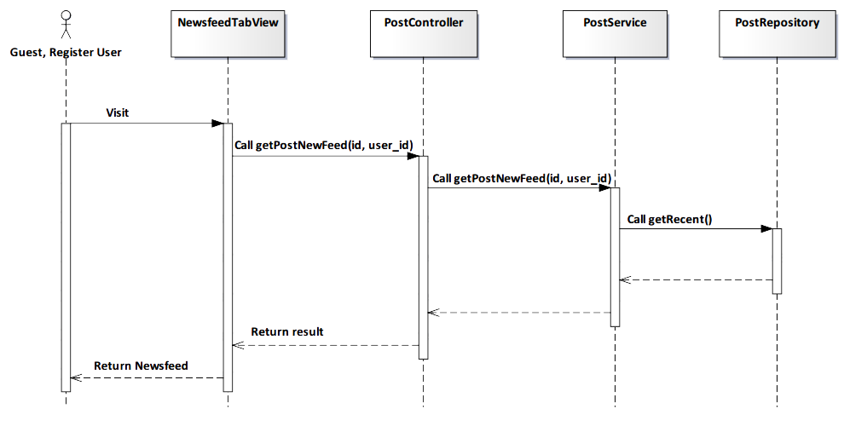

*Figure 4-30: View Newsfeed Sequence Diagram*

#### Screen Design

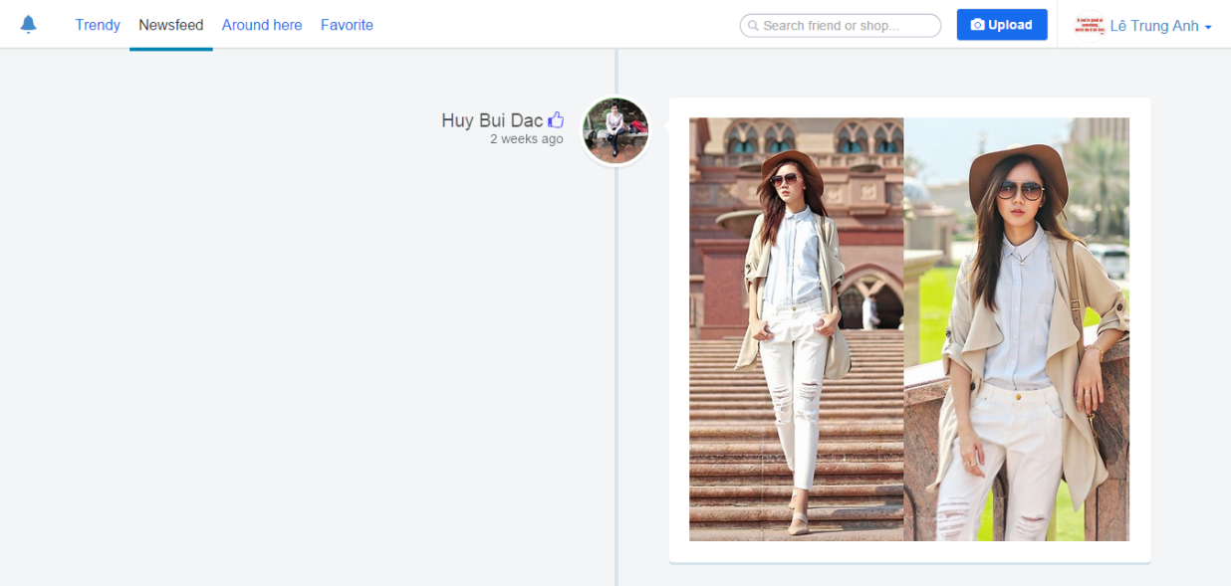

*Figure 4-31: View Newsfeed Screen*

|  |  |  |
| --- | --- | --- |
| **Element** | **Type** | **Description** |
| **Scroll** | Button | Scroll down to get more newsfeed. |

#### 4.3.4.1.4. View User page

#### Description

* User view User page.

#### Class Diagram

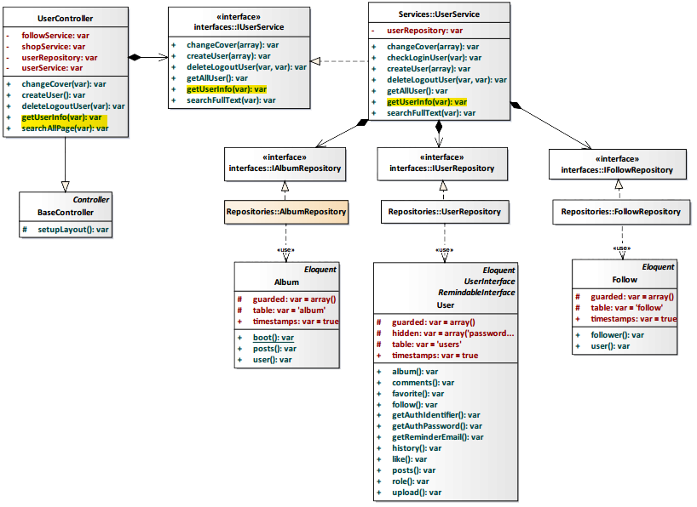

*Figure 4-32: View User page Class Diagram*

#### Class Specification

#### UserController class

#### Physical Address: Trendy-Server\app\Controller*UserController.php*

#### Attribute

|  |  |  |  |
| --- | --- | --- | --- |
| No | Name | Type | Description |
| 1 | followService | var | Instance of interface using to call methods in IFollowService. |
| 2 | shopService | var | Instance of interface using to call methods in IShopService. |
| 3 | userRepository | var | Instance of interface using to call methods in IUserRepository. |
| 4 | userService | var | Instance of interface using to call methods in IUserService. |

#### Method: getUserInfo($id)

|  |  |  |  |  |
| --- | --- | --- | --- | --- |
| Purpose | Display the user page. | | | |
| Return | **Type** | | | **Description** |
| var | | | Return information about user page. |
| Parameter | **No** | **Name** | **Type** | **Description** |
| 1 | id | var | id of the user that want to view page. |

#### UserService class

#### Physical Address: Trendy-Server\app\Services*UserService.php*

#### Attribute

|  |  |  |  |
| --- | --- | --- | --- |
| No | Name | Type | Description |
| 1 | userRepository | var | Instance of interface using to call methods in IUserRepository. |

#### Method: getUserInfo($id)

|  |  |  |  |  |
| --- | --- | --- | --- | --- |
| Purpose | Process to get information user page. | | | |
| Return | **Type** | | | **Description** |
| var | | | Return information about user page. |
| Parameter | **No** | **Name** | **Type** | **Description** |
| 1 | id | var | id of the user that want to view user page. |

#### Sequence Diagram

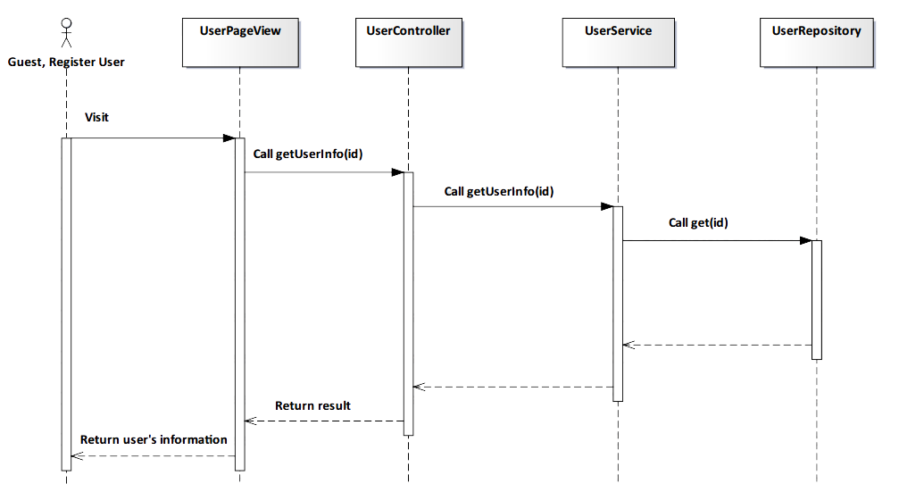

*Figure 4-33: View User page Sequence Diagram*

#### Screen Design

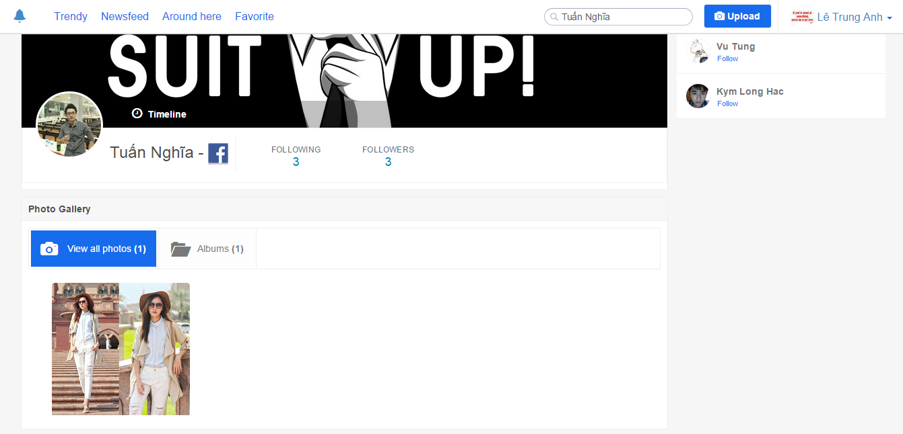

*Figure 4-34: View User page Screen*

#### 4.3.4.1.5. View Shop page

#### Description

* User browses the shop page of a specific shop.

#### Class Diagram

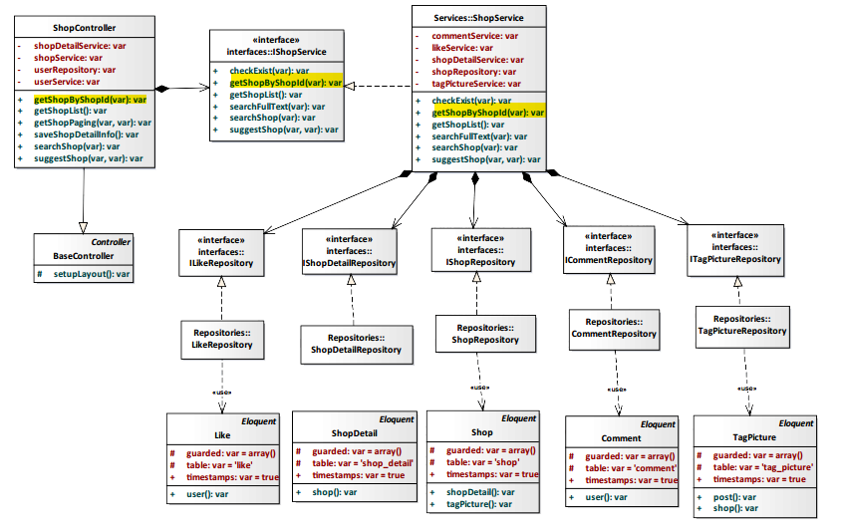

*Figure 4-35: View Shop page Class Diagram*

#### Class Specification

#### ShopController class

#### Physical Address: Trendy-Server\app\controllers*ShopController.php*

#### Attribute

|  |  |  |  |
| --- | --- | --- | --- |
| No | Name | Type | Description |
| 1 | shopDetailService | var | Instance of interface using to call methods in IShopDetailService. |
| 2 | shopService | var | Instance of interface using to call methods in IShopService. |
| 3 | userRepository | var | Instance of interface using to call methods in IUserRepository. |
| 4 | userService | var | Instance of interface using to call methods in IUserService. |

#### Method: getShopByShopId($id)

|  |  |  |  |  |
| --- | --- | --- | --- | --- |
| Purpose | Display all shop’s information to client. | | | |
| Return | **Type** | | | **Description** |
| var | | | Return shop information. |
| Parameter | **No** | **Name** | **Type** | **Description** |
| 1 | id | var | id of the shop that want to view. |

#### ShopService class

#### Physical Address: Trendy-Server\app\Services*ShopService.php*

#### Attribute

|  |  |  |  |
| --- | --- | --- | --- |
| No | Name | Type | Description |
| 1 | commentService | var | Instance of interface using to call methods in ICommentService. |
| 2 | likeService | var | Instance of interface using to call methods in ILikeService. |
| 3 | shopDetailService | var | Instance of interface using to call methods in IShopDetailService. |
| 4 | shopRepository | var | Instance of interface using to call methods in IshopRepository. |
| 5 | tagPictureService | var | Instance of interface using to call methods in ITagPictureService. |

#### Method: getShopByShopId($id)

|  |  |  |  |  |
| --- | --- | --- | --- | --- |
| Purpose | Process to get all shop’s information. | | | |
| Return | **Type** | | | **Description** |
| var | | | Return shop information. |
| Parameter | **No** | **Name** | **Type** | **Description** |
| 1 | id | var | Id of the shop that want to view. |

#### Sequence Diagram

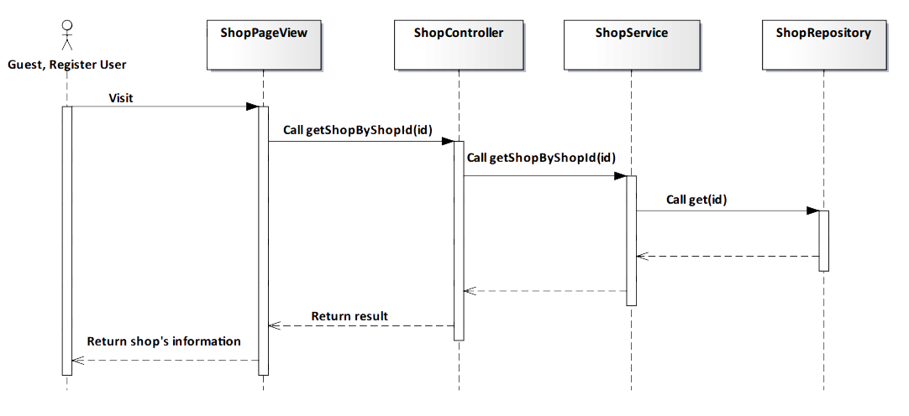

*Figure 4-36: View Shop page Sequence Diagram*

#### Screen Design

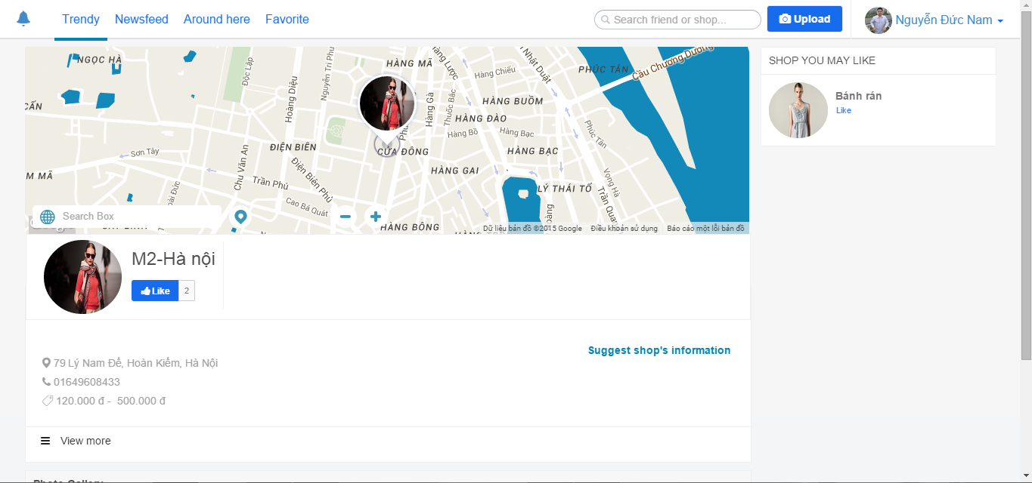

*Figure 4-37: View Shop page Screen*

|  |  |  |
| --- | --- | --- |
| **Element** | **Type** | **Description** |
| **View more** | Button | Click to view more about shop. |

#### 4.3.4.1.6. View Around here

#### Description

* User views Fashion Post near user location.

#### Class Diagram

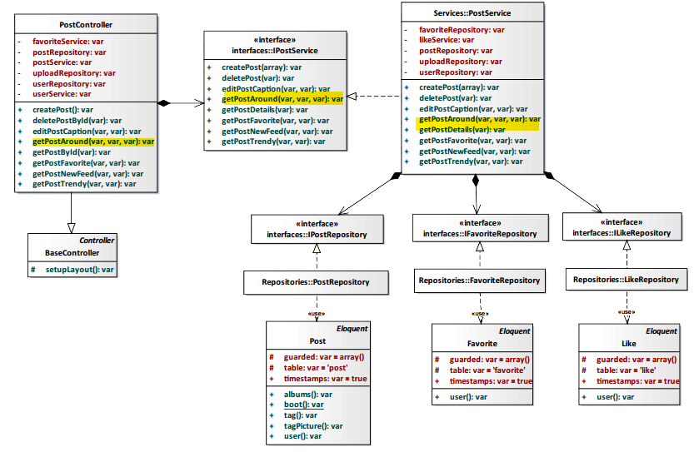

*Figure 4-38: View Around here Class Diagram*

#### Class Specification

#### PostController class

#### Physical Address: Trendy-Server\app\Controller*PostController.php*

#### Attribute

|  |  |  |  |
| --- | --- | --- | --- |
| No | Name | Type | Description |
| 1 | favoriteService | var | Instance of interface using to call methods in IFavoriteService. |
| 2 | postRepository | var | Instance of interface using to call methods in IPostRepository. |
| 3 | postService | var | Instance of interface using to call methods in IPostService. |
| 4 | uploadRepository | var | Instance of interface using to call methods in IUploadRepository. |
| 6 | userRepository | var | Instance of interface using to call methods in IUserRepository. |
| 7 | userService | var | Instance of interface using to call methods in IUserService. |

#### Method: getPostAround($id, $lat, $long)

|  |  |  |  |  |
| --- | --- | --- | --- | --- |
| Purpose | User view fashion posts around user’s location. | | | |
| Return | **Type** | | | **Description** |
| var | | | All fashion near post. |
| Parameter | **No** | **Name** | **Type** | **Description** |
| 1 | id | var | id of post. |
| 2 | lat | var | lat of post. |
| 3 | long | var | long of post. |

#### PostService class

#### Physical Address: Trendy-Server\app\Services*PostService.php*

#### Attribute

|  |  |  |  |
| --- | --- | --- | --- |
| No | Name | Type | Description |
| 1 | favoriteRepository | var | Instance of interface using to call methods in IFavoriteRepository. |
| 2 | likeService | var | Instance of interface using to call methods in ILikeService. |
| 3 | postRepository | var | Instance of interface using to call methods in IPostRepository. |
| 4 | uploadRepository | var | Instance of interface using to call methods in IUploadRepository. |
| 5 | userRepository | var | Instance of interface using to call methods in IUserRepository. |

#### Method: getPostAround ($id, $lat, $long)

|  |  |  |  |  |
| --- | --- | --- | --- | --- |
| Purpose | User view fashion posts around user’s location. | | | |
| Return | **Type** | | | **Description** |
| var | | | Display all fashion post nearly user’s location. |
| Parameter | **No** | **Name** | **Type** | **Description** |
| 1 | id | var | id of post. |
| 2 | lat | var | lat of post. |
| 3 | long | var | long of post. |

#### Sequence Diagram

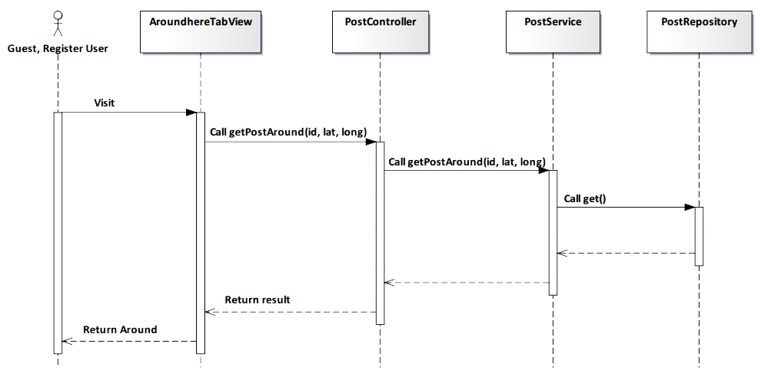

*Figure 4-39: View Around here Sequence Diagram*

#### Screen Design

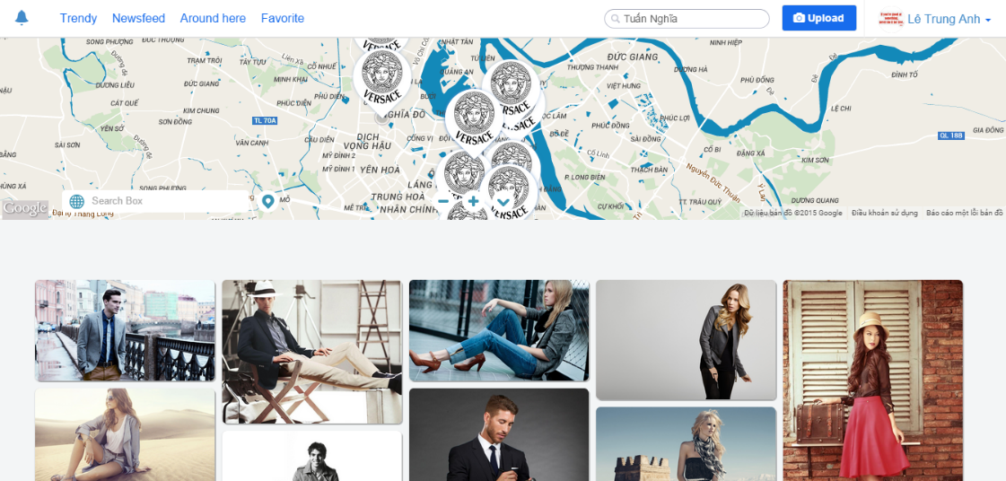

*Figure 4-40: View Around here Screen*

|  |  |  |
| --- | --- | --- |
| **Element** | **Type** | **Description** |
| **Scroll** | Button | Scroll down to view more post around. |
| **Pin** | Button | Click to get position on map. |

#### 4.3.4.1.7. View Album

#### Description

* Actor views album of user.

#### Class Diagram

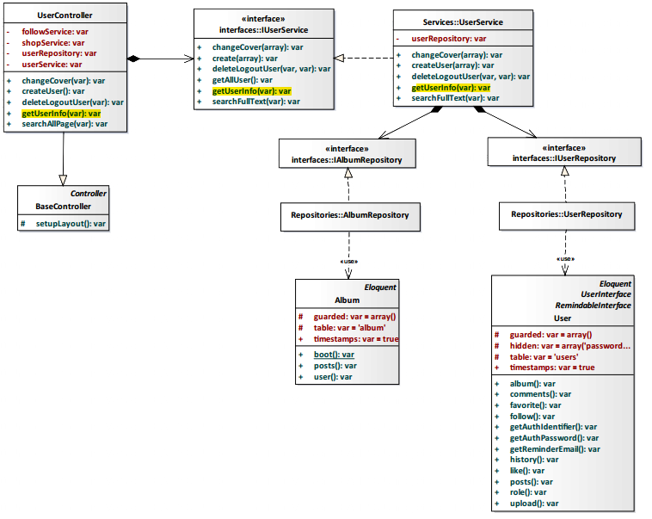

*Figure 4-41: View Album Class Diagram*

#### Class Specification

#### UserController class

#### Physical Address: Trendy-Server\app\controllers*UserController.php*

#### Attribute

|  |  |  |  |
| --- | --- | --- | --- |
| No | Name | Type | Description |
| 1 | followService | var | Instance of interface using to call methods in IFollowService. |
| 2 | shopService | var | Instance of interface using to call methods in IShopService. |
| 3 | userRepository | var | Instance of interface using to call methods in IUserRepostiory. |
| 4 | userService | var | Instance of interface using to call methods in IUserService. |

#### Method: getUserInfo(var $id)

|  |  |  |  |  |
| --- | --- | --- | --- | --- |
| Purpose | Show user’s album for actor. | | | |
| Return | **Type** | | | **Description** |
| var | | | Return user’s album. |
| Parameter | **No** | **Name** | **Type** | **Description** |
| 1 | id | var | id of the user that want to view album. |

#### UserService class

#### Physical Address: Trendy-Server\app\Services*UserService.php*

#### Attribute

|  |  |  |  |
| --- | --- | --- | --- |
| No | Name | Type | Description |
| 1 | userRepository | var | Instance of interface using to call methods in IUserRepository. |

#### Method: getUserInfo(var $id)

|  |  |  |  |  |
| --- | --- | --- | --- | --- |
| Purpose | Process to show user’s album. | | | |
| Return | **Type** | | | **Description** |
| var | | | Return user’s album. |
| Parameter | **No** | **Name** | **Type** | **Description** |
| 1 | id | var | id of the user that want to view album. |

#### Sequence Diagram

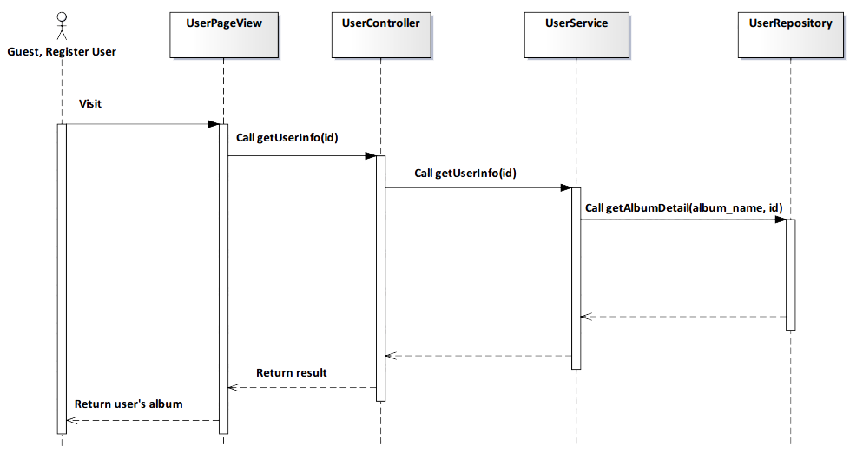

*Figure 4-42: View Album Sequence Diagram*

#### Screen Design

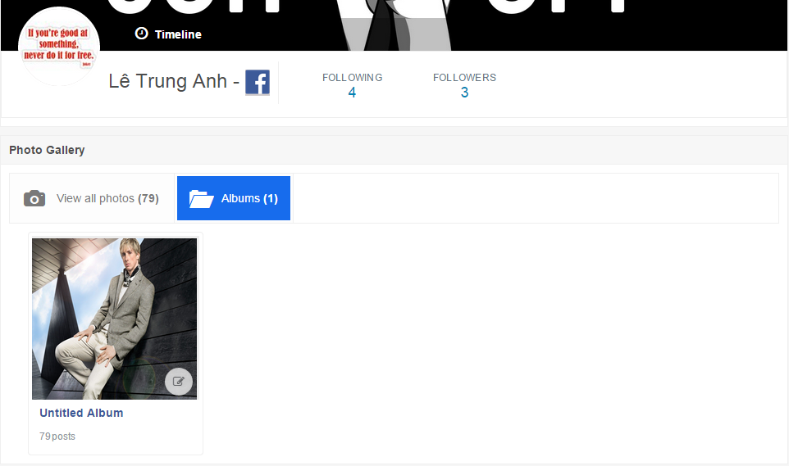

*Figure 4-43: View Album Screen*

#### 4.3.4.1.8. View Post

#### Description

* Actor views a post on TrendyPlus that they want.

#### Class Diagram

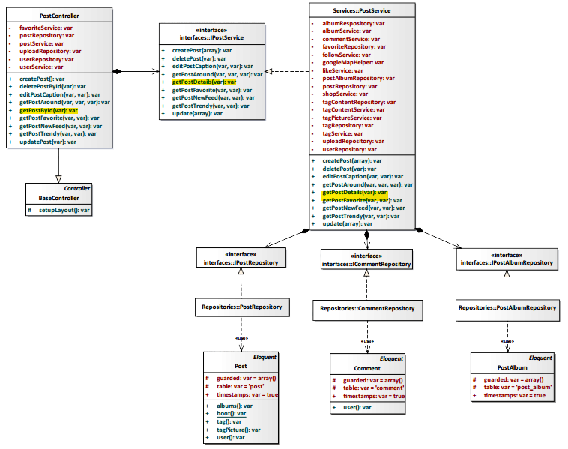

*Figure 4-44: View Post Class Diagram*

#### Class Specification

#### PostController class

#### Physical Address: Trendy-Server\app\controllers*PostController.php*

#### Attribute

|  |  |  |  |
| --- | --- | --- | --- |
| No | Name | Type | Description |
| 1 | favoriteService | var | Instance of interface using to call methods in IFavoriteService. |
| 2 | postRepository | var | Instance of interface using to call methods in IPostRepository. |
| 3 | postService | var | Instance of interface using to call methods in IPostService. |
| 4 | uploadRepository | var | Instance of interface using to call methods in IUploadRepostiory. |
| 5 | userRepository | var | Instance of interface using to call methods in IUserRepostiory. |
| 6 | userService | var | Instance of interface using to call methods in IUserService. |

#### Method: getPostById(var $id)

|  |  |  |  |  |
| --- | --- | --- | --- | --- |
| Purpose | Display post to client. | | | |
| Return | **Type** | | | **Description** |
| var | | | Return to a post. |
| Parameter | **No** | **Name** | **Type** | **Description** |
| 1 | id | var | id of the post that want to view post details. |

#### PostService class

#### Physical Address: Trendy-Server\app\Services*PostService.php*

#### Attribute

|  |  |  |  |
| --- | --- | --- | --- |
| No | Name | Type | Description |
| 1 | albumRepository | var | Instance of interface using to call methods in IAlbumRepository. |
| 2 | albumService | var | Instance of interface using to call methods in IAlbumService. |
| 3 | commentService | var | Instance of interface using to call methods in ICommentService. |
| 4 | favoriteRepository | var | Instance of interface using to call methods in IFavoriteRepository. |
| 5 | followService | var | Instance of interface using to call methods in IFollowSerivce. |
| 6 | googleMapHelper | var | Instance of interface using to call methods in IGoogleMapHelper. |
| 7 | likeService | var | Instance of interface using to call methods in ILikeSerivce. |
| 8 | postAlbumRepository | var | Instance of interface using to call methods in IAlbumRepository. |
| 9 | postRepository | var | Instance of interface using to call methods in IPostRepository. |
| 10 | shopService | var | Instance of interface using to call methods in IShopSerivce. |
| 11 | tagContentRepository | var | Instance of interface using to call methods in ITagContentRepository. |
| 12 | tagContentService | var | Instance of interface using to call methods in ITagContentSerivce. |
| 13 | tagPictureService | var | Instance of interface using to call methods in ITagPictureSerivce. |
| 14 | tagRepository | var | Instance of interface using to call methods in ITagRepository. |
| 15 | tagService | var | Instance of interface using to call methods in ITagSerivce. |
| 16 | uploadRepository | var | Instance of interface using to call methods in IUploadRepository. |
| 17 | userRepository | var | Instance of interface using to call methods in IUserRepository. |

#### Method: getPostDetails(var $id)

|  |  |  |  |  |
| --- | --- | --- | --- | --- |
| Purpose | Process to show all information details of a post. | | | |
| Return | **Type** | | | **Description** |
| var | | | Return to a post. |
| Parameter | **No** | **Name** | **Type** | **Description** |
| 1 | id | var | id of the post that want to view post details. |

#### Sequence Diagram

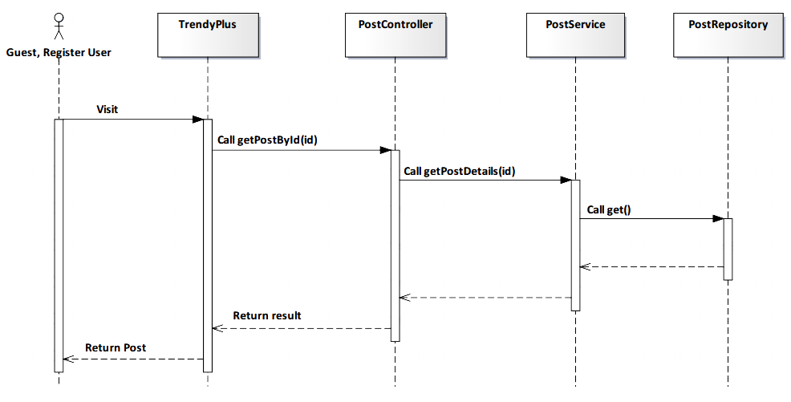

*Figure 4-45: View Post Sequence Diagram*

#### Screen Design

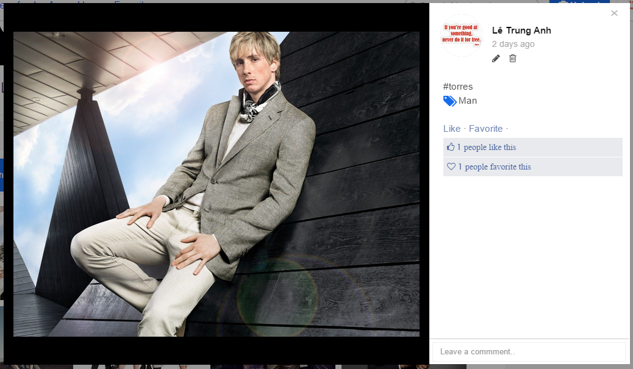

*Figure 4-46: View Post Screen Diagram*

|  |  |  |
| --- | --- | --- |
| **Element** | **Type** | **Description** |
| **Leave a comment** | Input text | Text field for entering comment. |
| **Like** | Button | Click to like post. |
| **Favorite** | Button | Click to add favorite. |
| **Edit** | Button | Click to edit post’s caption. |
| **Delete** | Button | Click to delete post’s caption. |

#### 4.3.4.1.9. View Shop on map

#### Description

* Actor views address of shop on map.

#### Class Diagram

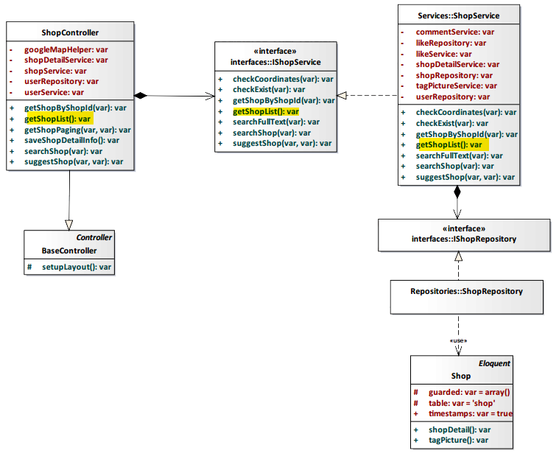

*Figure 4-47: View Shop on map Class Diagram*

#### Class Specification

#### ShopController class

#### Physical Address: Trendy-Server\app\controllers*ShopController.php*

#### Attribute

|  |  |  |  |
| --- | --- | --- | --- |
| No | Name | Type | Description |
| 1 | googleMapHelper | var | Instance of interface using to call methods in IGoogleMapHelper. |
| 2 | shopDetailService | var | Instance of interface using to call methods in IShopDetailService. |
| 3 | shopService | var | Instance of interface using to call methods in IShopService. |
| 4 | userRepository | var | Instance of interface using to call methods in IUserRepository. |
| 5 | userService | var | Instance of interface using to call methods in IUserService. |

#### Method: getShopList()

|  |  |  |
| --- | --- | --- |
| Purpose | Display all shop on map to client. | |
| Return | **Type** | **Description** |
| var | Return shop’s address. |

#### ShopService class

#### Physical Address: Trendy-Server\app\Services*ShopService.php*

#### Attribute

|  |  |  |  |
| --- | --- | --- | --- |
| No | Name | Type | Description |
| 1 | commentService | var | Instance of interface using to call methods in ITagCommentService. |
| 2 | likeRepository | var | Instance of interface using to call methods in ILikeRepository. |
| 3 | likeSerivce | var | Instance of interface using to call methods in ILikeService. |
| 4 | shopDetailService | var | Instance of interface using to call methods in IShopDetailService. |
| 5 | shopRepository | var | Instance of interface using to call methods in IShopRepository. |
| 6 | tagPictureService | var | Instance of interface using to call methods in ITagPictureService. |
| 7 | userRepository | var | Instance of interface using to call methods in IUserRepository. |

#### Method: getShopList()

|  |  |  |
| --- | --- | --- |
| Purpose | Process to show all shop on map. | |
| Return | **Type** | **Description** |
| var | Return shop’s address. |

#### Sequence Diagram

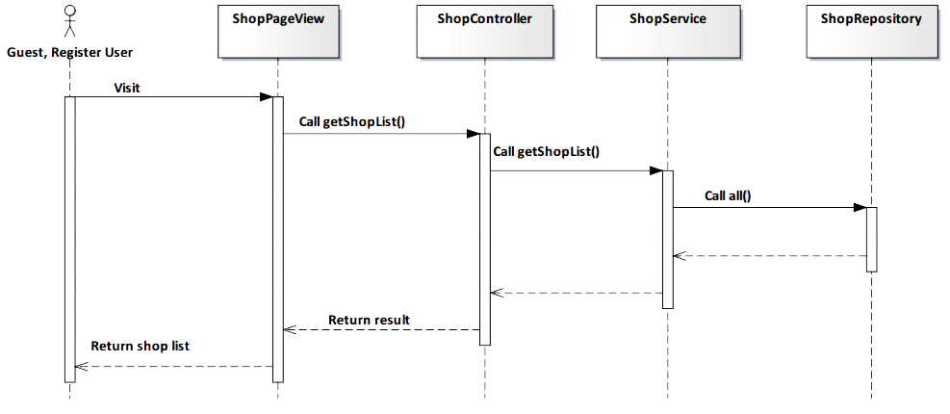

*Figure 4-48: View Shop on map Sequence Diagram*

#### Screen Design

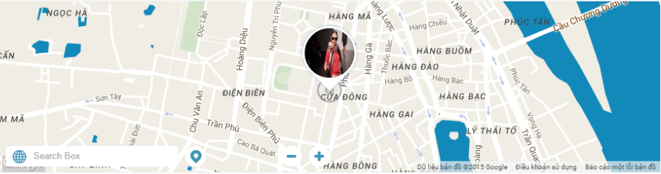

*Figure 4-49: View Shop Screen*

|  |  |  |
| --- | --- | --- |
| **Element** | **Type** | **Description** |
| **Pin** | Button | Click to get position on map. |

#### 4.3.4.1.10. Get all Album of user

#### Description

* Actor gets all album of a user.

#### Class Diagram



*Figure 4-50: Get all Album of user Class Diagram*

#### Class Specification

#### UserController class

#### Physical Address: Trendy-Server\app\controllers*UserController.php*

#### Attribute

|  |  |  |  |
| --- | --- | --- | --- |
| No | Name | Type | Description |
| 1 | followService | var | Instance of interface using to call methods in IFollowService. |
| 2 | shopService | var | Instance of interface using to call methods in IShopService. |
| 3 | userRepository | var | Instance of interface using to call methods in IUserRepostiory. |
| 4 | userService | var | Instance of interface using to call methods in IUserService. |

#### Method: getUserInfo(var $id)

|  |  |  |  |  |
| --- | --- | --- | --- | --- |
| Purpose | Get all album of user. | | | |
| Return | **Type** | | | **Description** |
| var | | | Return user’s information. |
| Parameter | **No** | **Name** | **Type** | **Description** |
| 1 | id | var | id of the user that want to get all album. |

#### UserService class

#### Physical Address: Trendy-Server\app\Services*UserService.php*

#### Attribute

|  |  |  |  |
| --- | --- | --- | --- |
| No | Name | Type | Description |
| 1 | userRepository | var | Instance of interface using to call methods in IUserRepository. |

#### Method: getUserInfo(var $id)

|  |  |  |  |  |
| --- | --- | --- | --- | --- |
| Purpose | Process to get all album of user. | | | |
| Return | **Type** | | | **Description** |
| var | | | Return user’s information. |
| Parameter | **No** | **Name** | **Type** | **Description** |
| 1 | id | var | id of the user that want to get all album. |

#### Sequence Diagram

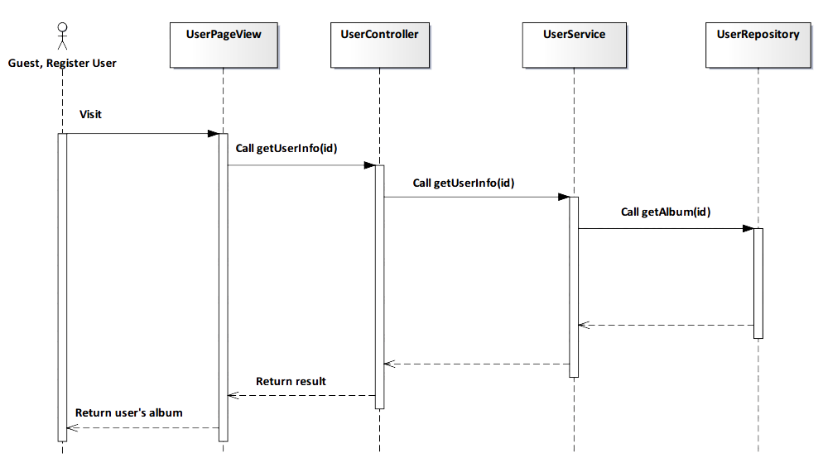

*Figure 4-51: Get all Album of user Sequence Diagram*

#### Screen Design

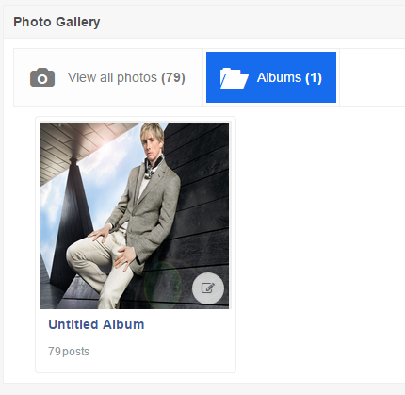

*Figure 4-52: Get all Album of user Screen*

#### 4.3.4.1.11. Suggest related user

#### Description

* User see related user to following.

#### Class Diagram

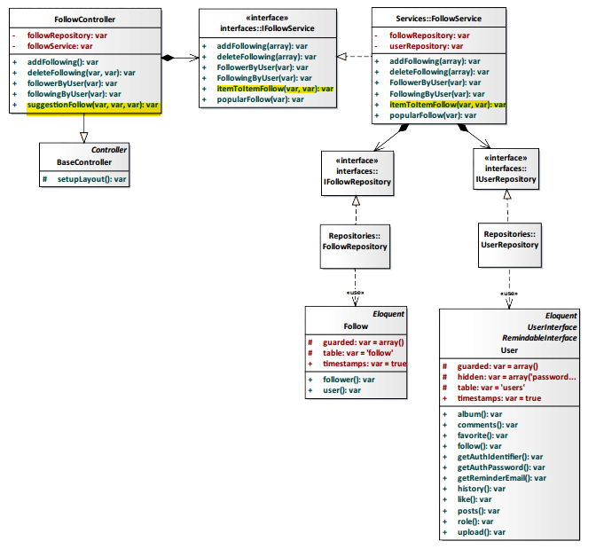

*Figure 4-53: Suggest related user Class Diagram*

#### Class Specification

#### FollowController class

#### Physical Address: Trendy-Server\app\Controller*FollowController.php*

#### Attribute

|  |  |  |  |
| --- | --- | --- | --- |
| No | Name | Type | Description |
| 1 | followService | var | Instance of interface using to call methods in IFollowService. |
| 2 | followRepository | var | Instance of interface using to call methods in IFollowRepository. |

#### Method: suggestionFollow($id, $type, $userId)

|  |  |  |  |  |
| --- | --- | --- | --- | --- |
| Purpose | Display the like number of shop to client. | | | |
| Return | **Type** | | | **Description** |
| var | | | Return list suggestion follow. |
| Parameter | **No** | **Name** | **Type** | **Description** |
| 1 | id | var | id of user who received suggestion. |
| 2 | type | var | type of follow. |
| 3 | user_id | var | id of user who is suggested other people. |

#### FollowService class

#### Physical Address: Trendy-Server\app\Services*FollowService.php*

#### Attribute

|  |  |  |  |
| --- | --- | --- | --- |
| No | Name | Type | Description |
| 1 | userRepository | var | Instance of interface using to call methods in IUserRepository. |
| 2 | followRepository | var | Instance of interface using to call methods in IFollowRepository. |

#### Method: itemToItemFollow($loginId, $user_id)

|  |  |  |  |  |
| --- | --- | --- | --- | --- |
| Purpose | User see related user to following. | | | |
| Return | **Type** | | | **Description** |
| var | | | Return list following people. |
| Parameter | **No** | **Name** | **Type** | **Description** |
| 1 | loginId | var | id of the user that want to view list following. |
| 2 | user_id | var | id of user who is suggested other people. |

#### Sequence Diagram

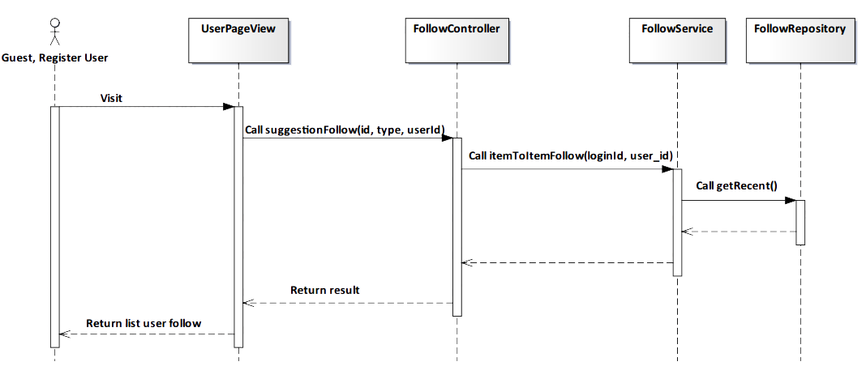

*Figure 4-54: Suggest related user Sequence Diagram*

#### Screen Design

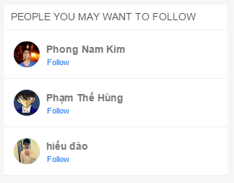

*Figure 4-55: Suggest related user Screen*

|  |  |  |
| --- | --- | --- |
| **Element** | **Type** | **Description** |
| **Follow** | Hyperlink | Click to follow user. |

### 4.3.4.2. Register User

#### 4.3.4.2.1. Delete Album

#### Description

* Actor deletes actor‘s album.

#### Class Diagram

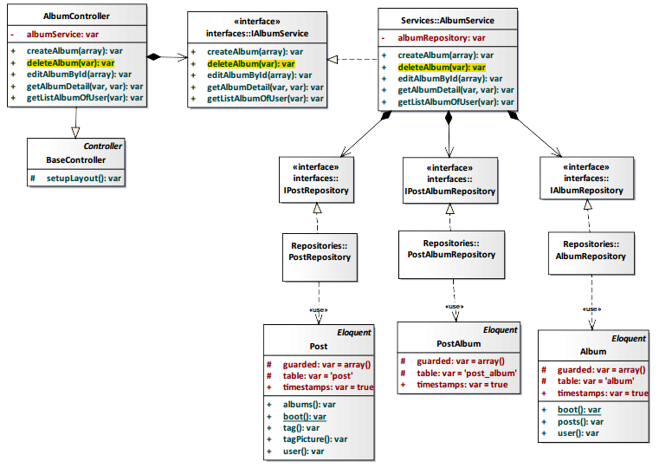

*Figure 4-56: Delete Album Class Diagram*

#### Class Specification

#### AlbumController class

#### Physical Address: Trendy-Server\app\controllers*AlbumController.php*

#### Attribute

|  |  |  |  |
| --- | --- | --- | --- |
| No | Name | Type | Description |
| 1 | albumService | var | Instance of interface using to call methods in IAlbumService. |

#### Method: deleteAlbumByName($album_name)

|  |  |  |  |  |
| --- | --- | --- | --- | --- |
| Purpose | Delete album of actor. | | | |
| Return | **Type** | | | **Description** |
| var | | | Return successful or error. |
| Parameter | **No** | **Name** | **Type** | **Description** |
| 1 | album_name | var | Name of album need delete. |

#### AlbumService class

#### Physical Address: Trendy-Server\app\Services*AlbumService.php*

#### Attribute

|  |  |  |  |
| --- | --- | --- | --- |
| No | Name | Type | Description |
| 1 | AlbumRepository | var | Instance of interface using to call methods in IAlbumRepository. |

#### Method: deleteAlbum($album_name)

|  |  |  |  |  |
| --- | --- | --- | --- | --- |
| Purpose | Delete album of actor. | | | |
| Return | **Type** | | | **Description** |
| var | | | Return successful or error. |
| Parameter | **No** | **Name** | **Type** | **Description** |
| 1 | album_name | var | Name of album need delete. |

#### Sequence Diagram

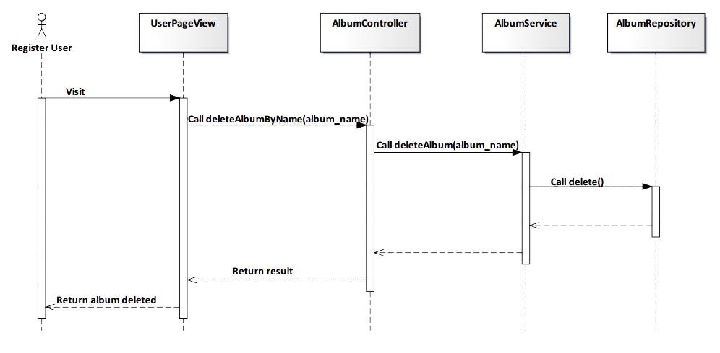

*Figure 4-57: Delete Album Sequence Diagram*

#### Screen Design

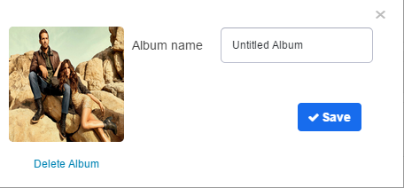

*Figure 4-58: Delete Album Screen*

|  |  |  |
| --- | --- | --- |
| **Element** | **Type** | **Description** |
| **Delete Album** | Hyperlink | Click to delete album. |
| **Save** | Button | Click to save changes. |

#### 4.3.4.2.2. Edit Album

#### Description

* Actor edits actor‘s album.

#### Class Diagram

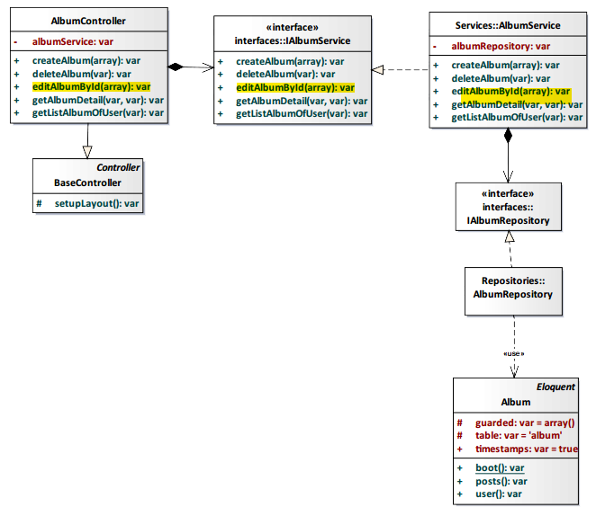

*Figure 4-59: Edit Album Class Diagram*

#### Class Specification

#### AlbumController class

#### Physical Address: Trendy-Server\app\controllers*AlbumController.php*

#### Attribute

|  |  |  |  |
| --- | --- | --- | --- |
| No | Name | Type | Description |
| 1 | albumService | var | Instance of interface using to call methods in IAlbumService. |

#### Method: editAlbumById($data)

|  |  |  |  |  |
| --- | --- | --- | --- | --- |
| Purpose | Edit content album of actor. | | | |
| Return | **Type** | | | **Description** |
| var | | | Return successful or error. |
| Parameter | **No** | **Name** | **Type** | **Description** |
| 1 | data | var | Album’s data need edit. |

#### AlbumService class

#### Physical Address: Trendy-Server\app\Services*AlbumService.php*

#### Attribute

|  |  |  |  |
| --- | --- | --- | --- |
| No | Name | Type | Description |
| 1 | AlbumRepository | var | Instance of interface using to call methods in IAlbumRepository. |

#### Method: editAlbumById($data)

|  |  |  |  |  |
| --- | --- | --- | --- | --- |
| Purpose | Edit content album of actor. | | | |
| Return | **Type** | | | **Description** |
| var | | | Return successful or error. |
| Parameter | **No** | **Name** | **Type** | **Description** |
| 1 | data | var | Album’s data need edit. |

#### Sequence Diagram

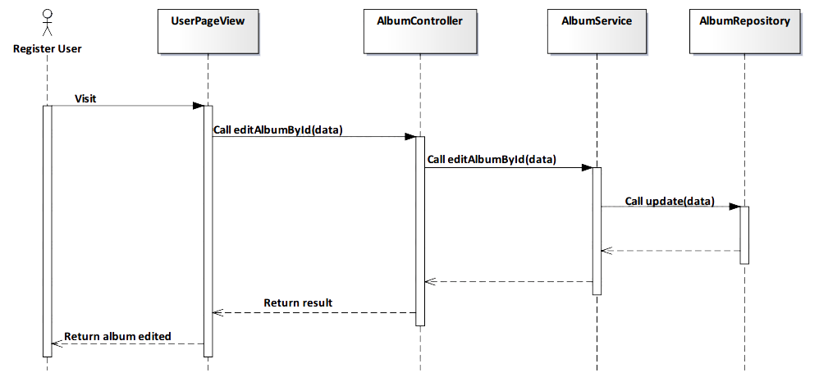

*Figure 4-60: Edit Album Sequence Diagram*

#### Screen Design



*Figure 4-60: Edit Album Class Diagram*

|  |  |  |
| --- | --- | --- |
| **Element** | **Type** | **Description** |
| **Delete Album** | Hyperlink | Click to delete album. |
| **Save** | Button | Click to save changes. |

#### 4.3.4.2.3. Add Post’s comment

#### Description

* Actor adds comment of actor in post

#### Class Diagram

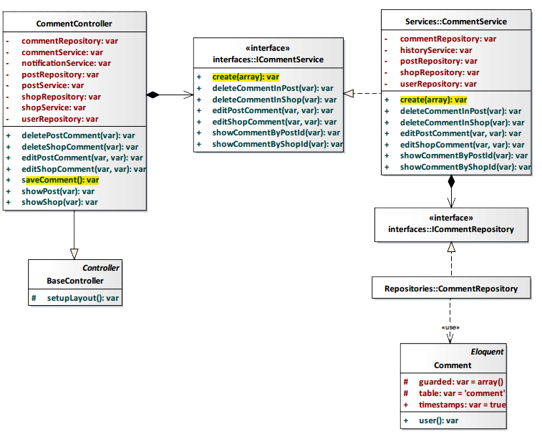

*Figure 4-61: Add Post’s comment Class Diagram*

#### Class Specification

#### CommentController class

#### Physical Address: Trendy-Server\app\controllers*CommentController.php*

#### Attribute

|  |  |  |  |
| --- | --- | --- | --- |
| No | Name | Type | Description |
| 1 | commentRepository | var | Instance of interface using to call methods in ICommentRepository. |
| 2 | commentService | var | Instance of interface using to call methods in ICommentService. |
| 3 | notificationService | var | Instance of interface using to call methods in INotificationService. |
| 4 | postRepository | var | Instance of interface using to call methods in IPostRepository. |
| 5 | postService | var | Instance of interface using to call methods in IPostService. |
| 6 | shopRepository | var | Instance of interface using to call methods in IShopRepository. |
| 7 | shopService | var | Instance of interface using to call methods in IShopService. |
| 8 | userRepository | var | Instance of interface using to call methods in IUserRepostiory. |

#### Method: saveComment()

|  |  |  |
| --- | --- | --- |
| Purpose | Add comment of actor in post. | |
| Return | **Type** | **Description** |
| var | Return successful or error. |

#### CommentService class

#### Physical Address: Trendy-Server\app\Services*CommentService.php*

#### Attribute

|  |  |  |  |
| --- | --- | --- | --- |
| No | Name | Type | Description |
| 1 | commentRepository | var | Instance of interface using to call methods in ICommentRepository. |
| 2 | historyService | var | Instance of interface using to call methods in IHistoryService. |
| 3 | postRepository | var | Instance of interface using to call methods in IPostRepository. |
| 4 | shopRepository | var | Instance of interface using to call methods in IShopRepository. |
| 5 | userRepository | var | Instance of interface using to call methods in IUserRepository. |

#### Method: create($data)

|  |  |  |  |  |
| --- | --- | --- | --- | --- |
| Purpose | Add comment of actor in post. | | | |
| Return | **Type** | | | **Description** |
| var | | | Return successful or error. |
| Parameter | **No** | **Name** | **Type** | **Description** |
| 1 | data | var | Content of comment and information insert to database. |

#### Sequence Diagram

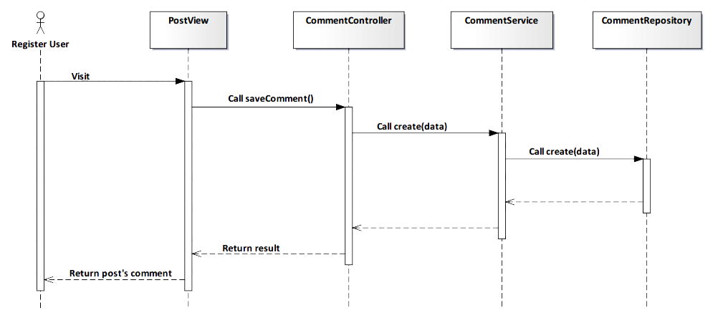

*Figure 4-62: Add Post’s comment Sequence Diagram*

#### Screen Design

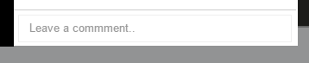

*Figure 4-63: Add Post’s comment Screen*

|  |  |  |
| --- | --- | --- |
| **Element** | **Type** | **Description** |
| **Leave a comment** | Input text | Text field for entering comment. |

#### 4.3.4.2.4. Edit Post’s comment

#### Description

* Actor edits comment of actor in post

#### Class Diagram

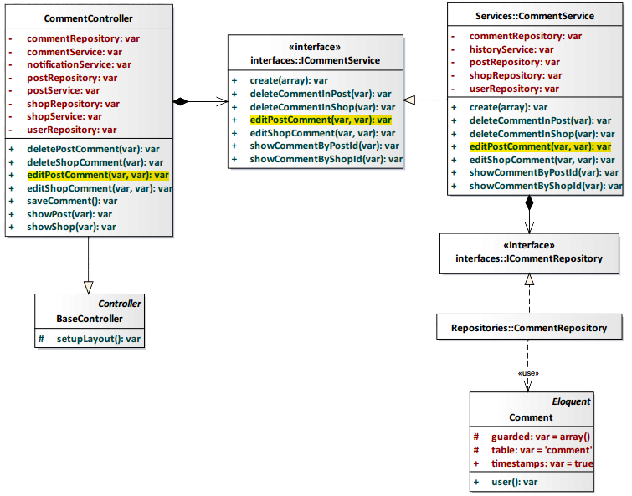

*Figure 4-64: Edit Post’s comment Class Diagram*

#### Class Specification

#### CommentController class

#### Physical Address: Trendy-Server\app\controllers*CommentController.php*

#### Attribute

|  |  |  |  |
| --- | --- | --- | --- |
| No | Name | Type | Description |
| 1 | commentRepository | var | Instance of interface using to call methods in ICommentRepository. |
| 2 | commentService | var | Instance of interface using to call methods in ICommentService. |
| 3 | notificationService | var | Instance of interface using to call methods in INotificationService. |
| 4 | postRepository | var | Instance of interface using to call methods in IPostRepository. |
| 5 | postService | var | Instance of interface using to call methods in IPostService. |
| 6 | shopRepository | var | Instance of interface using to call methods in IShopRepository. |
| 7 | shopService | var | Instance of interface using to call methods in IShopService. |
| 8 | userRepository | var | Instance of interface using to call methods in IUserRepostiory. |

#### Method: editPostComment($id)

|  |  |  |  |  |
| --- | --- | --- | --- | --- |
| Purpose | Edit comment of actor in post. | | | |
| Return | **Type** | | | **Description** |
| var | | | Return successful or error. |
| Parameter | **No** | **Name** | **Type** | **Description** |
| 1 | id | var | id comment need edit. |

#### CommentService class

#### Physical Address: Trendy-Server\app\Services*CommentService.php*

#### Attribute

|  |  |  |  |
| --- | --- | --- | --- |
| No | Name | Type | Description |
| 1 | commentRepository | var | Instance of interface using to call methods in ICommentRepository. |
| 2 | historyService | var | Instance of interface using to call methods in IHistoryService. |
| 3 | postRepository | var | Instance of interface using to call methods in IPostRepository. |
| 4 | shopRepository | var | Instance of interface using to call methods in IShopRepository. |
| 5 | userRepository | var | Instance of interface using to call methods in IUserRepository. |

#### Method: editPostComment($id)

|  |  |  |  |  |
| --- | --- | --- | --- | --- |
| Purpose | Edit comment of actor in post. | | | |
| Return | **Type** | | | **Description** |
| var | | | Return successful or error. |
| Parameter | **No** | **Name** | **Type** | **Description** |
| 1 | id | var | id comment need edit. |

#### Sequence Diagram

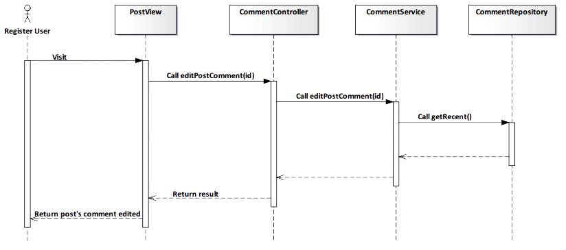

*Figure 4-65: Edit Post’s comment Sequence Diagram*

#### Screen Design

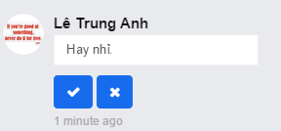

*Figure 4-66: Edit Post’s comment Screen*

#### 4.3.4.2.5. Delete Post’s comment

#### Description

* Actor deletes comment of actor in post

#### Class Diagram

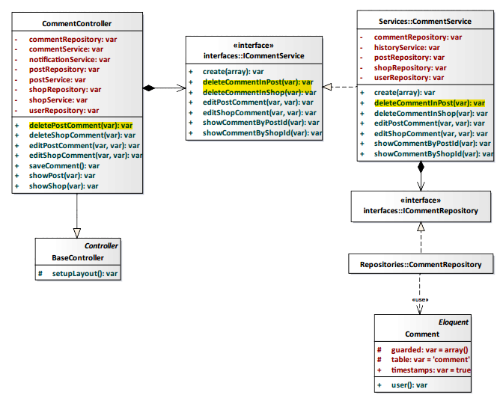

*Figure 4-67: Delete Post’s comment Class Diagram*

#### Class Specification

#### CommentController class

#### Physical Address: Trendy-Server\app\controllers*CommentController.php*

#### Attribute

|  |  |  |  |
| --- | --- | --- | --- |
| No | Name | Type | Description |
| 1 | commentRepository | var | Instance of interface using to call methods in ICommentRepository. |
| 2 | commentService | var | Instance of interface using to call methods in ICommentService. |
| 3 | notificationService | var | Instance of interface using to call methods in INotificationService. |
| 4 | postRepository | var | Instance of interface using to call methods in IPostRepository. |
| 5 | postService | var | Instance of interface using to call methods in IPostService. |
| 6 | shopRepository | var | Instance of interface using to call methods in IShopRepository. |
| 7 | shopService | var | Instance of interface using to call methods in IShopService. |
| 8 | userRepository | var | Instance of interface using to call methods in IUserRepostiory. |

#### Method: deletePostComment($id)

|  |  |  |  |  |
| --- | --- | --- | --- | --- |
| Purpose | Delete comment of actor in post. | | | |
| Return | **Type** | | | **Description** |
| var | | | Return successful or error. |
| Parameter | **No** | **Name** | **Type** | **Description** |
| 1 | id | var | id comment need delete. |

#### CommentService class

#### Physical Address: Trendy-Server\app\Services*CommentService.php*

#### Attribute

|  |  |  |  |
| --- | --- | --- | --- |
| No | Name | Type | Description |
| 1 | commentRepository | var | Instance of interface using to call methods in ICommentRepository. |
| 2 | historyService | var | Instance of interface using to call methods in IHistoryService. |
| 3 | postRepository | var | Instance of interface using to call methods in IPostRepository. |
| 4 | shopRepository | var | Instance of interface using to call methods in IShopRepository. |
| 5 | userRepository | var | Instance of interface using to call methods in IUserRepository. |

#### Method: deleteCommentInPost($id)

|  |  |  |  |  |
| --- | --- | --- | --- | --- |
| Purpose | Delete comment of actor in post. | | | |
| Return | **Type** | | | **Description** |
| var | | | Return successful or error. |
| Parameter | **No** | **Name** | **Type** | **Description** |
| 1 | id | var | id comment need delete. |

#### Sequence Diagram

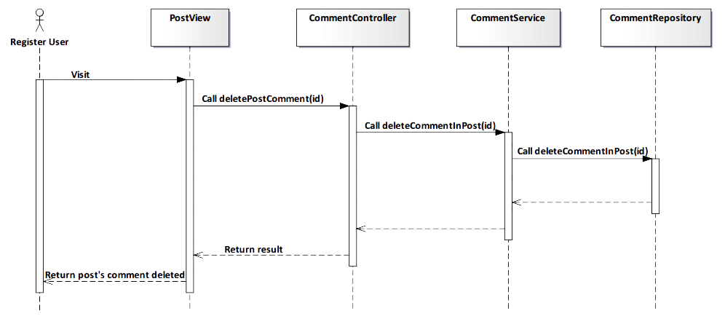

*Figure 4-68: Delete Post’s comment Sequence Diagram*

#### Screen Design

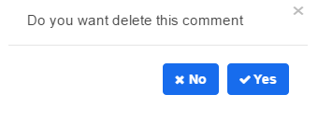

*Figure 4-69: Delete Post’s comment Screen*

|  |  |  |
| --- | --- | --- |
| **Element** | **Type** | **Description** |
| **No** | Button | Click to undelete comment. |
| **Yes** | Button | Click to delete comment. |

#### 4.3.4.2.6. View Post’s comment

#### Description

* Actor views all comments of a post.

#### Class Diagram

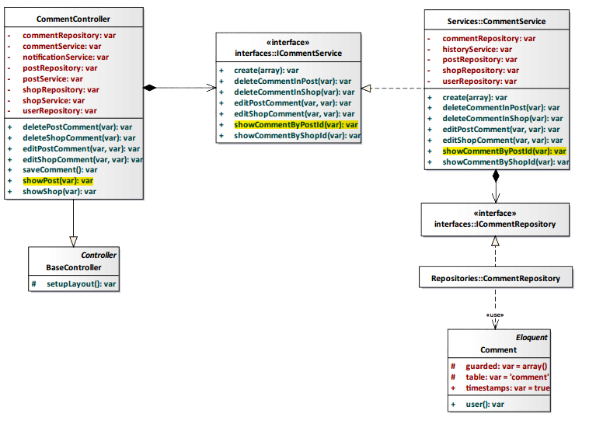

*Figure 4-70: View Post’s comment Class Diagram*

#### Class Specification

#### CommentController class

#### Physical Address: Trendy-Server\app\controllers*\CommentController.php*

#### Attribute

|  |  |  |  |
| --- | --- | --- | --- |
| No | Name | Type | Description |
| 1 | commentRepository | var | Instance of interface using to call methods in ICommentRepository. |
| 2 | commentService | var | Instance of interface using to call methods in ICommentService. |
| 3 | notificationService | var | Instance of interface using to call methods in INotificationService. |
| 4 | postRepository | var | Instance of interface using to call methods in IPostRepository. |
| 5 | postService | var | Instance of interface using to call methods in IPostService. |
| 6 | shopRepository | var | Instance of interface using to call methods in IShopRepository. |
| 7 | shopService | var | Instance of interface using to call methods in IShopService. |
| 8 | userRepository | var | Instance of interface using to call methods in IUserRepostiory. |

#### Method: showPost(var $id)

|  |  |  |  |  |
| --- | --- | --- | --- | --- |
| Purpose | Display all post’s comment to client. | | | |
| Return | **Type** | | | **Description** |
| var | | | Return post’s comment. |
| Parameter | **No** | **Name** | **Type** | **Description** |
| 1 | id | var | id of the post that want to view post’s comment. |

#### CommentService class

#### Physical Address: Trendy-Server\app\Services*CommentService.php*

#### Attribute

|  |  |  |  |
| --- | --- | --- | --- |
| No | Name | Type | Description |
| 1 | commentRepository | var | Instance of interface using to call methods in ICommentRepository. |
| 2 | historyService | var | Instance of interface using to call methods in IHistoryService. |
| 3 | postRepository | var | Instance of interface using to call methods in IPostRepository. |
| 4 | shopRepository | var | Instance of interface using to call methods in IShopRepository. |
| 5 | userRepository | var | Instance of interface using to call methods in IUserRepository. |

#### Method: showCommentByPostId(var $id)

|  |  |  |  |  |
| --- | --- | --- | --- | --- |
| Purpose | Process to show all comments of a post. | | | |
| Return | **Type** | | | **Description** |
| var | | | Return post’s comment. |
| Parameter | **No** | **Name** | **Type** | **Description** |
| 1 | id | var | id of the post that want to view post’s comment. |

#### Sequence Diagram

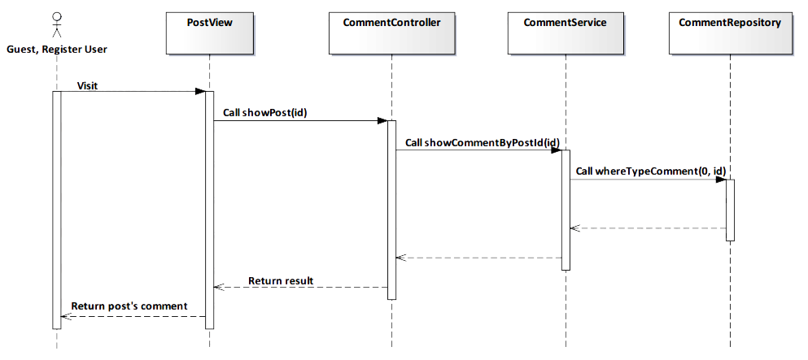

*Figure 4-71: View Post’s comment Sequence Diagram*

#### Screen Design

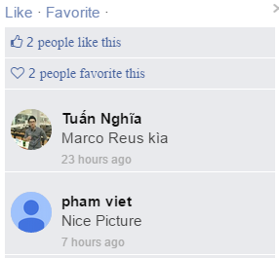

*Figure 4-72: View Post’s comment Screen*

#### 4.3.4.2.7. Add Shop’s comment

#### Description

* Actor writes content that they want comment to a shop.

#### Class Diagram

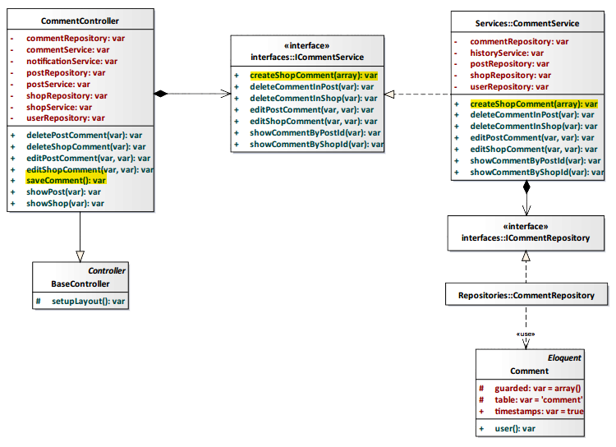

*Figure 4-73: Add Shop’s comment Class Diagram*

#### Class Specification

#### CommentController class

#### Physical Address: Trendy-Server\app\controllers*CommentController.php*

#### Attribute

|  |  |  |  |
| --- | --- | --- | --- |
| No | Name | Type | Description |
| 1 | commentRepository | var | Instance of interface using to call methods in ICommentRepository. |
| 2 | commentService | var | Instance of interface using to call methods in ICommentService. |
| 3 | notificationService | var | Instance of interface using to call methods in INotificationService. |
| 4 | postRepository | var | Instance of interface using to call methods in IPostRepository. |
| 5 | postService | var | Instance of interface using to call methods in IPostService. |
| 6 | shopRepository | var | Instance of interface using to call methods in IShopRepository. |
| 7 | shopService | var | Instance of interface using to call methods in IShopService. |
| 8 | userRepository | var | Instance of interface using to call methods in IUserRepostiory. |

#### Method: saveComment()

|  |  |  |
| --- | --- | --- |
| Purpose | Save content that actor comment to database. | |
| Return | **Type** | **Description** |
| var | Save content when actor comments to shop. |

#### CommentService class

#### Physical Address: Trendy-Server\app\Services*CommentService.php*

#### Attribute

|  |  |  |  |
| --- | --- | --- | --- |
| No | Name | Type | Description |
| 1 | commentRepository | var | Instance of interface using to call methods in ICommentRepository. |
| 2 | historyService | var | Instance of interface using to call methods in IHistoryService. |
| 3 | postRepository | var | Instance of interface using to call methods in IPostRepository. |
| 4 | shopRepository | var | Instance of interface using to call methods in IShopRepository. |
| 5 | userRepository | var | Instance of interface using to call methods in IUserRepository. |

#### Method: createShopComment(array $data)

|  |  |  |  |  |
| --- | --- | --- | --- | --- |
| Purpose | Save content that actor comments to database. | | | |
| Return | **Type** | | | **Description** |
| var | | | Save content when actor comments to shop. |
| Parameter | **No** | **Name** | **Type** | **Description** |
| 1 | data | array | Array contains content of comment will be saved to database. |

#### Sequence Diagram

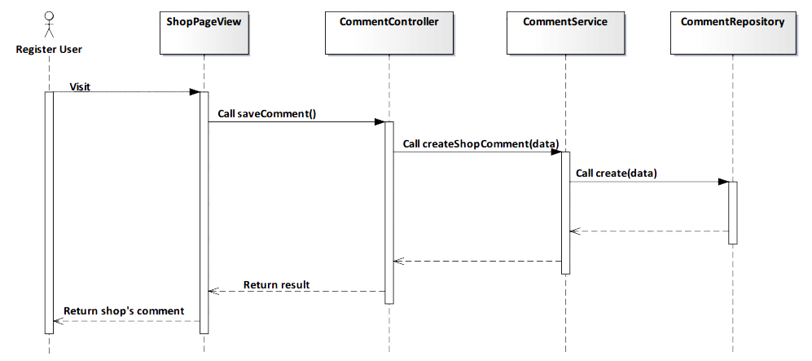

*Figure 4-74: Add Shop’s comment Sequence Diagram*

#### Screen Design



*Figure 4-75: Add Shop’s comment Screen*

|  |  |  |
| --- | --- | --- |
| **Element** | **Type** | **Description** |
| **Write your message** | Input text | Text field for entering comment. |

#### 4.3.4.2.8. Edit Shop’s comment

#### Description

* Actor edits content that they commented to a shop.

#### Class Diagram

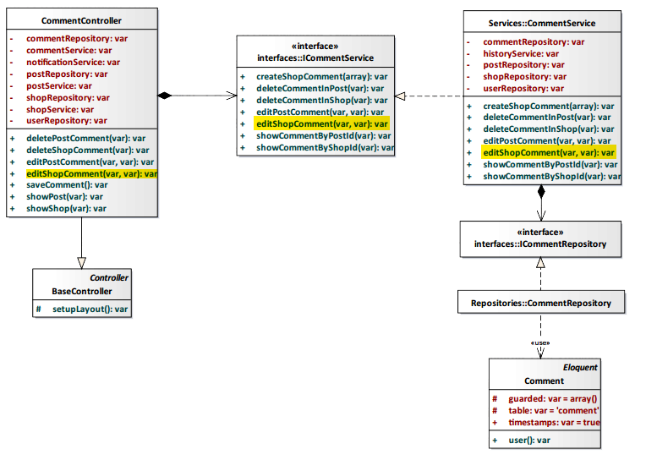

*Figure 4-76: Edit Shop’s comment Class Diagram*

#### Class Specification

#### CommentController class

#### Physical Address: Trendy-Server\app\controllers*CommentController.php*

#### Attribute

|  |  |  |  |
| --- | --- | --- | --- |
| No | Name | Type | Description |
| 1 | commentRepository | var | Instance of interface using to call methods in ICommentRepository. |
| 2 | commentService | var | Instance of interface using to call methods in ICommentService. |
| 3 | notificationService | var | Instance of interface using to call methods in INotificationService. |
| 4 | postRepository | var | Instance of interface using to call methods in IPostRepository. |
| 5 | postService | var | Instance of interface using to call methods in IPostService. |
| 6 | shopRepository | var | Instance of interface using to call methods in IShopRepository. |
| 7 | shopService | var | Instance of interface using to call methods in IShopService. |
| 8 | userRepository | var | Instance of interface using to call methods in IUserRepostiory. |

#### Method: editShopComment(var $id, var $content)

|  |  |  |  |  |
| --- | --- | --- | --- | --- |
| Purpose | Process to edit comment of a shop. | | | |
| Return | **Type** | | | **Description** |
| var | | | Edit comment when actor want edit content that they commented in shop. |
| Parameter | **No** | **Name** | **Type** | **Description** |
| 1 | id | var | id of comment will be edited. |
| 2 | content | var | Content of comment after editing will be saved to database. |

#### CommentService class

#### Physical Address: Trendy-Server\app\Services*CommentService.php*

#### Attribute

|  |  |  |  |
| --- | --- | --- | --- |
| No | Name | Type | Description |
| 1 | commentRepository | var | Instance of interface using to call methods in ICommentRepository. |
| 2 | historyService | var | Instance of interface using to call methods in IHistoryService. |
| 3 | postRepository | var | Instance of interface using to call methods in IPostRepository. |
| 4 | shopRepository | var | Instance of interface using to call methods in IShopRepository. |
| 5 | userRepository | var | Instance of interface using to call methods in IUserRepository. |

#### Method: editShopComment(var $id, var $content)

|  |  |  |  |  |
| --- | --- | --- | --- | --- |
| Purpose | Process to edit comment of a shop. | | | |
| Return | **Type** | | | **Description** |
| var | | | Edit comment when actor want edit content that they commented in shop. |
| Parameter | **No** | **Name** | **Type** | **Description** |
| 1 | id | var | id of comment will be edited. |
| 2 | content | var | Content of comment after editing will be saved to database. |

#### Sequence Diagram

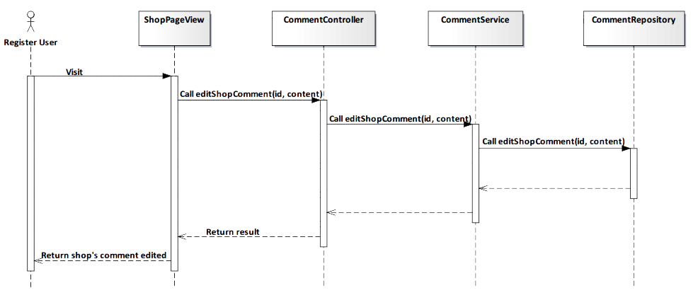

*Figure 4-77: Edit Shop’s comment Sequence Diagram*

#### Screen Design

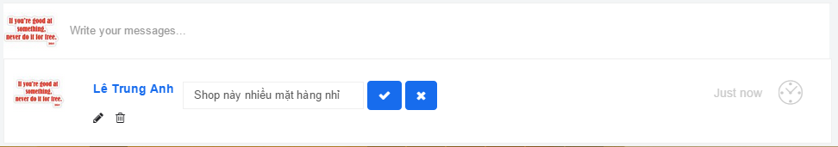

*Figure 4-78: Edit Shop’s comment Screen*

#### 4.3.4.2.9. Delete Shop’s comment

#### Description

* Actor deletes comment that they commented to a shop.

#### Class Diagram

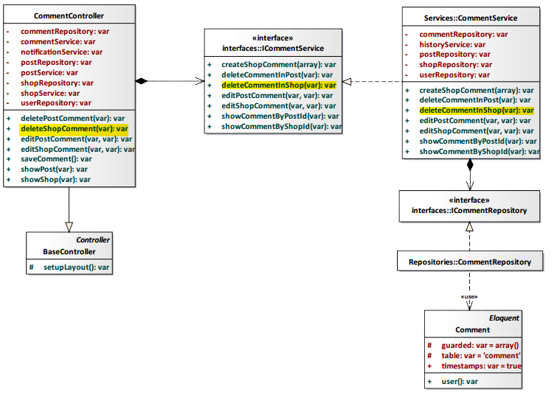

*Figure 4-79: Delete Shop’s comment Class Diagram*

#### Class Specification

#### CommentController class

#### Physical Address: Trendy-Server\app\controllers*CommentController.php*

#### Attribute

|  |  |  |  |
| --- | --- | --- | --- |
| No | Name | Type | Description |
| 1 | commentRepository | var | Instance of interface using to call methods in ICommentRepository. |
| 2 | commentService | var | Instance of interface using to call methods in ICommentService. |
| 3 | notificationService | var | Instance of interface using to call methods in INotificationService. |
| 4 | postRepository | var | Instance of interface using to call methods in IPostRepository. |
| 5 | postService | var | Instance of interface using to call methods in IPostService. |
| 6 | shopRepository | var | Instance of interface using to call methods in IShopRepository. |
| 7 | shopService | var | Instance of interface using to call methods in IShopService. |
| 8 | userRepository | var | Instance of interface using to call methods in IUserRepostiory. |

#### Method: deleteShopComment(var $id)

|  |  |  |  |  |
| --- | --- | --- | --- | --- |
| Purpose | Process to delete comment of a shop. | | | |
| Return | **Type** | | | **Description** |
| var | | | Delelete comment when actor want delete content that they commented in shop. |
| Parameter | **No** | **Name** | **Type** | **Description** |
| 1 | id | var | id of comment will be deleted. |

#### CommentService class

#### Physical Address: Trendy-Server\app\Services*CommentService.php*

#### Attribute

|  |  |  |  |
| --- | --- | --- | --- |
| No | Name | Type | Description |
| 1 | commentRepository | var | Instance of interface using to call methods in ICommentRepository. |
| 2 | historyService | var | Instance of interface using to call methods in IHistoryService. |
| 3 | postRepository | var | Instance of interface using to call methods in IPostRepository. |
| 4 | shopRepository | var | Instance of interface using to call methods in IShopRepository. |
| 5 | userRepository | var | Instance of interface using to call methods in IUserRepository. |

#### Method: deleteCommentInShop(var $id)

|  |  |  |  |  |
| --- | --- | --- | --- | --- |
| Purpose | Process to delete comment of a shop. | | | |
| Return | **Type** | | | **Description** |
| var | | | Delelete comment when actor want delete content that they commented in shop. |
| Parameter | **No** | **Name** | **Type** | **Description** |
| 1 | id | var | id of comment will be deleted. |

#### Sequence Diagram

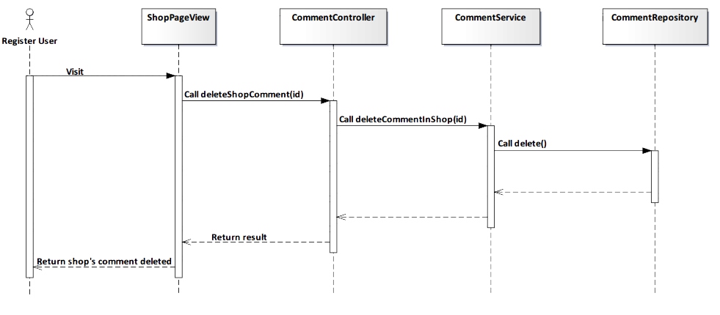

*Figure 4-80: Delete Shop’s comment Sequence Diagram*

#### Screen Design



*Figure 4-81: Delete Shop’s comment Screen*

|  |  |  |
| --- | --- | --- |
| **Element** | **Type** | **Description** |
| **No** | Button | Click to undelete comment. |
| **Yes** | Button | Click to delete comment. |

#### 4.3.4.2.10. View Shop’s comment

#### Description

* Actor views all comments of a shop.

Class Diagram

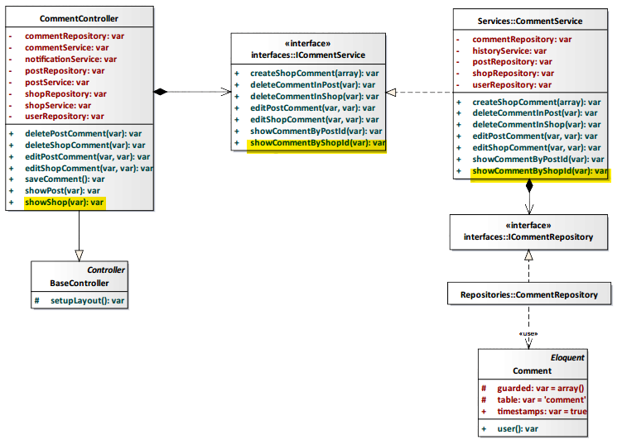

*Figure 4-82: View Shop’s comment Class Diagram*

#### Class Specification

#### CommentController class

#### Physical Address: Trendy-Server\app\controllers*CommentController.php*

#### Attribute

|  |  |  |  |
| --- | --- | --- | --- |
| No | Name | Type | Description |
| 1 | commentRepository | var | Instance of interface using to call methods in ICommentRepository. |
| 2 | commentService | var | Instance of interface using to call methods in ICommentService. |
| 3 | notificationService | var | Instance of interface using to call methods in INotificationService. |
| 4 | postRepository | var | Instance of interface using to call methods in IPostRepository. |
| 5 | postService | var | Instance of interface using to call methods in IPostService. |
| 6 | shopRepository | var | Instance of interface using to call methods in IShopRepository. |
| 7 | shopService | var | Instance of interface using to call methods in IShopService. |
| 8 | userRepository | var | Instance of interface using to call methods in IUserRepostiory. |

#### Method: showShop(var $id)

|  |  |  |  |  |
| --- | --- | --- | --- | --- |
| Purpose | Display all shop’s comment to client. | | | |
| Return | **Type** | | | **Description** |
| var | | | Return shop’s comment. |
| Parameter | **No** | **Name** | **Type** | **Description** |
| 1 | id | var | id of the shop that want to view shop’s comment. |

#### CommentService class

#### Physical Address: Trendy-Server\app\Services*CommentService.php*

#### Attribute

|  |  |  |  |
| --- | --- | --- | --- |
| No | Name | Type | Description |
| 1 | commentRepository | var | Instance of interface using to call methods in ICommentRepository. |
| 2 | historyService | var | Instance of interface using to call methods in IHistoryService. |
| 3 | postRepository | var | Instance of interface using to call methods in IPostRepository. |
| 4 | shopRepository | var | Instance of interface using to call methods in IShopRepository. |
| 5 | userRepository | var | Instance of interface using to call methods in IUserRepository. |

#### Method: showCommentByShopId(var $id)

|  |  |  |  |  |
| --- | --- | --- | --- | --- |
| Purpose | Process to show all comments of a shop. | | | |
| Return | **Type** | | | **Description** |
| var | | | Return shop’s comment. |
| Parameter | **No** | **Name** | **Type** | **Description** |
| 1 | id | var | id of the post that want to view shop’s comment. |

#### Sequence Diagram

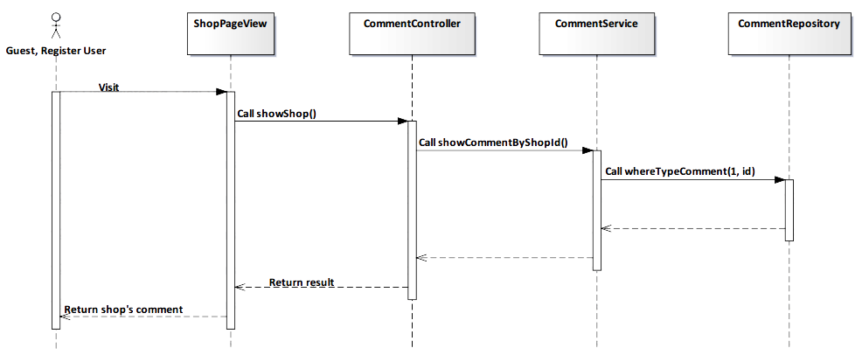

*Figure 4-83: View Shop’s comment Sequence Diagram*

#### Screen Design

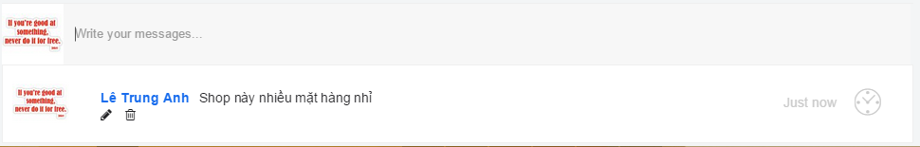

*Figure 4-84: View Shop’s comment Screen*

|  |  |  |
| --- | --- | --- |
| **Element** | **Type** | **Description** |
| **Edit** | Button | Click to edit comment. |
| **Delete** | Button | Click to delete comment. |

#### 4.3.4.2.11. Add Post

#### Description

* Actor adds a post to TrendyPlus.

#### Class Diagram

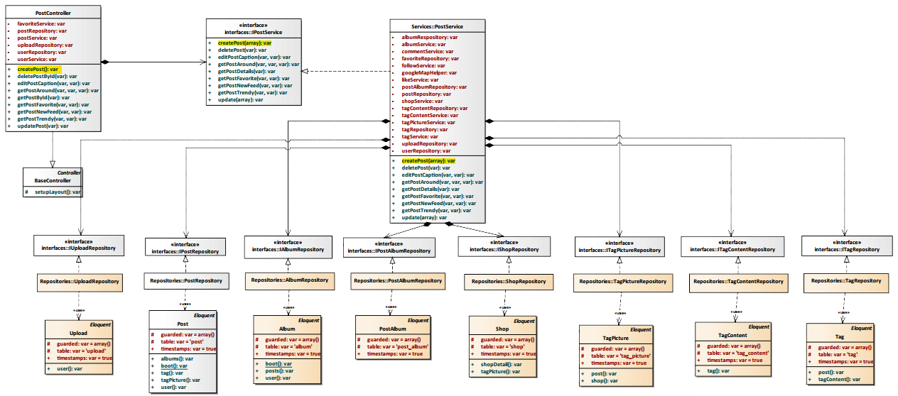

*Figure 4-85: Add Post Class Diagram*

#### Class Specification

#### PostController class

#### Physical Address: Trendy-Server\app\controllers*PostController.php*

#### Attribute

|  |  |  |  |
| --- | --- | --- | --- |
| No | Name | Type | Description |
| 1 | favoriteService | var | Instance of interface using to call methods in IFavoriteService. |
| 2 | postRepository | var | Instance of interface using to call methods in IPostRepository. |
| 3 | postService | var | Instance of interface using to call methods in IPostService. |
| 4 | uploadRepository | var | Instance of interface using to call methods in IUploadRepostiory. |
| 5 | userRepository | var | Instance of interface using to call methods in IUserRepostiory. |
| 6 | userService | var | Instance of interface using to call methods in IUserService. |

#### Method: createPost()

|  |  |  |
| --- | --- | --- |
| Purpose | Process to create post will be display to TrendyPlus. | |
| Return | **Type** | **Description** |
| var | Post after creating will be display to TrendyPlus. |

#### PostService class

#### Physical Address: Trendy-Server\app\Services*PostService.php*

#### Attribute

|  |  |  |  |
| --- | --- | --- | --- |
| No | Name | Type | Description |
| 1 | albumRepository | var | Instance of interface using to call methods in IAlbumRepository. |
| 2 | albumService | var | Instance of interface using to call methods in IAlbumService. |
| 3 | commentService | var | Instance of interface using to call methods in ICommentService. |
| 4 | favoriteRepository | var | Instance of interface using to call methods in IFavoriteRepository. |
| 5 | followService | var | Instance of interface using to call methods in IFollowSerivce. |
| 6 | googleMapHelper | var | Instance of interface using to call methods in IGoogleMapHelper. |
| 7 | likeService | var | Instance of interface using to call methods in ILikeSerivce. |
| 8 | postAlbumRepository | var | Instance of interface using to call methods in IAlbumRepository. |
| 9 | postRepository | var | Instance of interface using to call methods in IPostRepository. |
| 10 | shopService | var | Instance of interface using to call methods in IShopSerivce. |
| 11 | tagContentRepository | var | Instance of interface using to call methods in ITagContentRepository. |
| 12 | tagContentService | var | Instance of interface using to call methods in ITagContentSerivce. |
| 13 | tagPictureService | var | Instance of interface using to call methods in ITagPictureSerivce. |
| 14 | tagRepository | var | Instance of interface using to call methods in ITagRepository. |
| 15 | tagService | var | Instance of interface using to call methods in ITagSerivce. |
| 16 | uploadRepository | var | Instance of interface using to call methods in IUploadRepository. |
| 17 | userRepository | var | Instance of interface using to call methods in IUserRepository. |

#### Method: createPost(array $data)

|  |  |  |  |  |
| --- | --- | --- | --- | --- |
| Purpose | Process to create post will be display to TrendyPlus. | | | |
| Return | **Type** | | | **Description** |
| var | | | Post after creating will be display to TrendyPlus. |
| Parameter | **No** | **Name** | **Type** | **Description** |
| 1 | data | array | Array contains content of post will be saved to database. |

#### Sequence Diagram

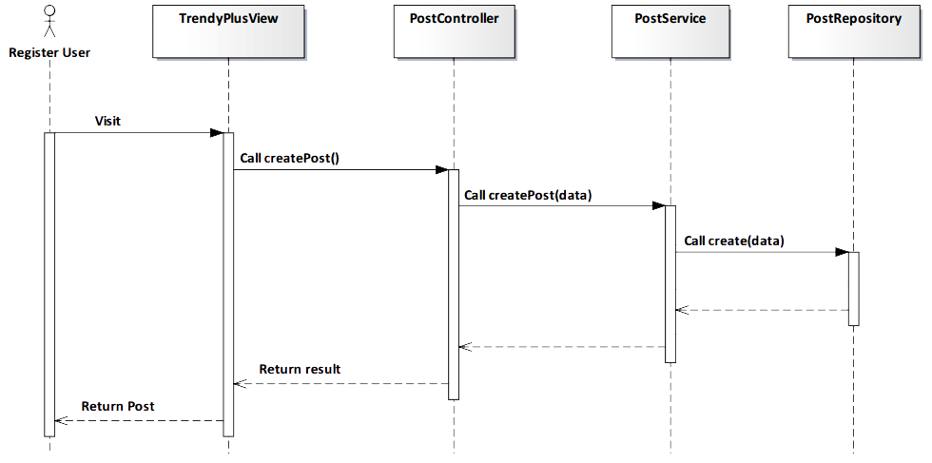

*Figure 4-86: Add Post Sequence Diagram*

#### Screen Design

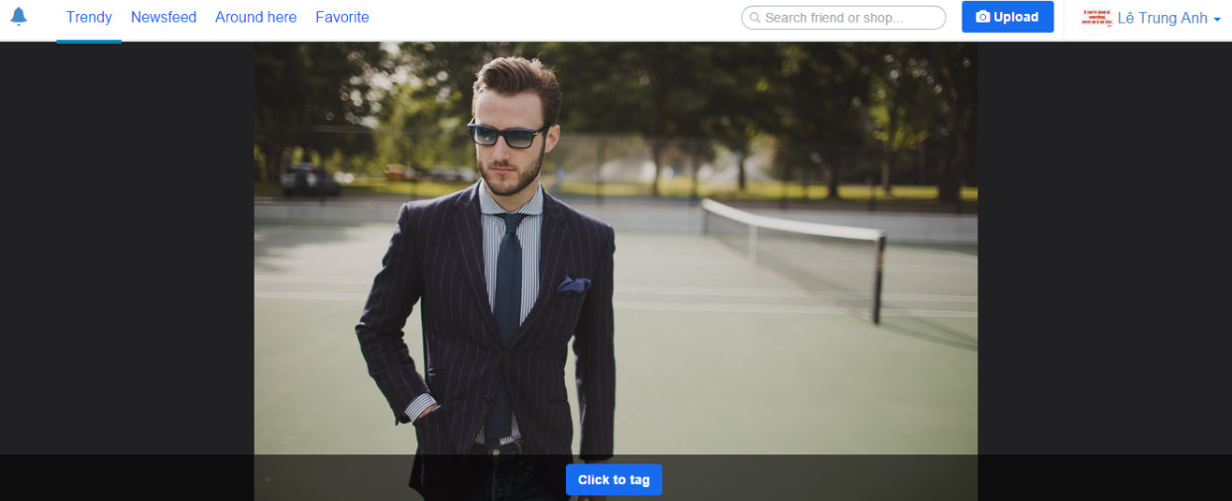

*Figure 4-87: Add Post Screen*

|  |  |  |
| --- | --- | --- |
| **Element** | **Type** | **Description** |
| **Click to tag** | Button | Click to tag product on image. |

#### 4.3.4.2.12. Editor Image

#### Description

* Actor edits image that they want post to TrendyPlus.

#### Class Diagram

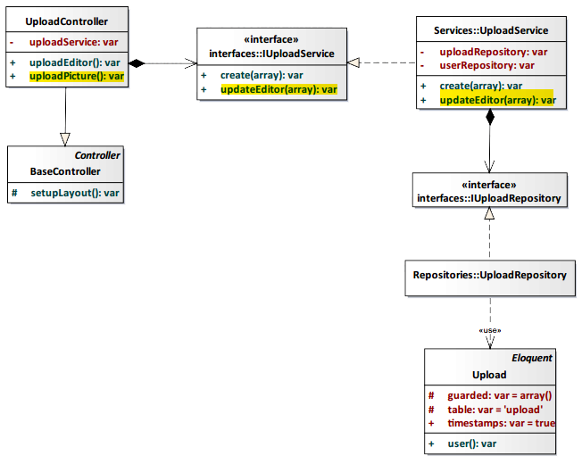

*Figure 4-88: Editor Image Class Diagram*

#### Class Specification

#### UploadController class

#### Physical Address: Trendy-Server\app\controllers*UploadController.php*

#### Attribute

|  |  |  |  |
| --- | --- | --- | --- |
| No | Name | Type | Description |
| 1 | uploadService | var | Instance of interface using to call methods in IUploadService. |

#### Method: uploadEditor()

|  |  |  |
| --- | --- | --- |
| Purpose | Process to edit image that displayed to TrendyPlus. | |
| Return | **Type** | **Description** |
| var | Image after editing will be move to create post page. |

#### UploadService class

#### Physical Address: Trendy-Server\app\Services*UploadService.php*

#### Attribute

|  |  |  |  |
| --- | --- | --- | --- |
| No | Name | Type | Description |
| 1 | uploadRepository | var | Instance of interface using to call methods in IUploadRepository. |
| 2 | userRepository | var | Instance of interface using to call methods in IUserRepository. |

#### Method: updateEditor(array $data)

|  |  |  |  |  |
| --- | --- | --- | --- | --- |
| Purpose | Process to create post will be display to TrendyPlus. | | | |
| Return | **Type** | | | **Description** |
| var | | | Post after creating will be display to TrendyPlus. |
| Parameter | **No** | **Name** | **Type** | **Description** |
| 1 | data | array | Array contains content of image after editing will be saved to database. |

#### Sequence Diagram

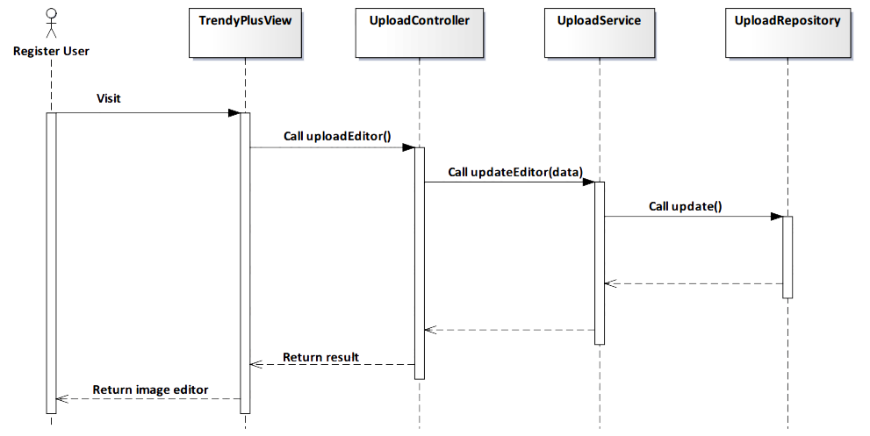

*Figure 4-89: Editor Image Sequence Diagram*

#### Screen Design

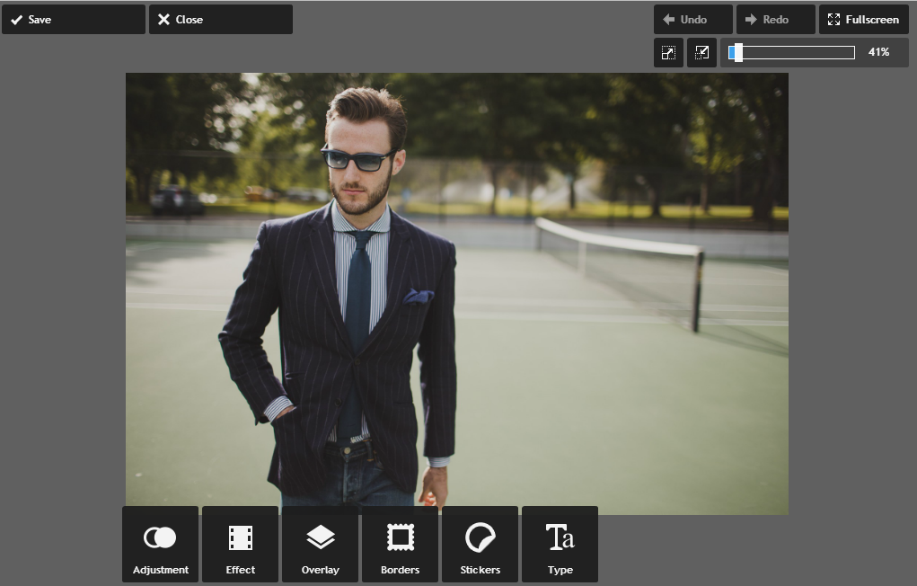

*Figure 4-90: Editor Image Screen*

|  |  |  |
| --- | --- | --- |
| **Element** | **Type** | **Description** |
| **Save** | Button | Click to save image after image edited. |
| **Close** | Button | Click to leave this page. |

#### 4.3.4.2.13. Image tagging

#### Description

* Actor tags image that they want post to TrendyPlus. Tag information will display *“Name”, “Price”, “Address”* of product in image.

#### Class Diagram

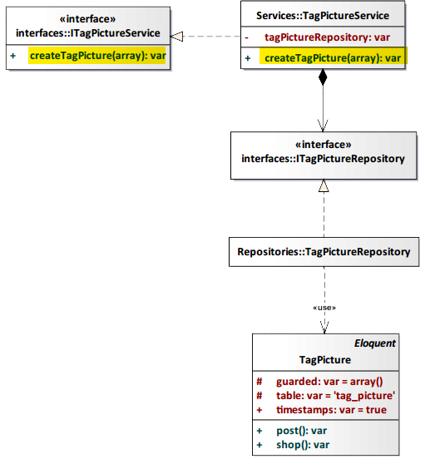

*Figure 4-91: Image Tagging Class Diagram*

#### Class Specification

#### TagPictureService class

#### Physical Address: Trendy-Server\app\Services*TagPictureService.php*

#### Attribute

|  |  |  |  |
| --- | --- | --- | --- |
| No | Name | Type | Description |
| 1 | tagPictureRepository | var | Instance of interface using to call methods in ITagPictureRepository. |

#### Method: createTagPicture(array $data)

|  |  |  |  |  |
| --- | --- | --- | --- | --- |
| Purpose | Process to create tag picture that displayed in post. | | | |
| Return | **Type** | | | **Description** |
| var | | | Image after tagging will be displayed in post on TrendyPlus. |
| Parameter | **No** | **Name** | **Type** | **Description** |
| 1 | data | array | Array contains content of image after tagging will be saved to database. |

#### Sequence Diagram

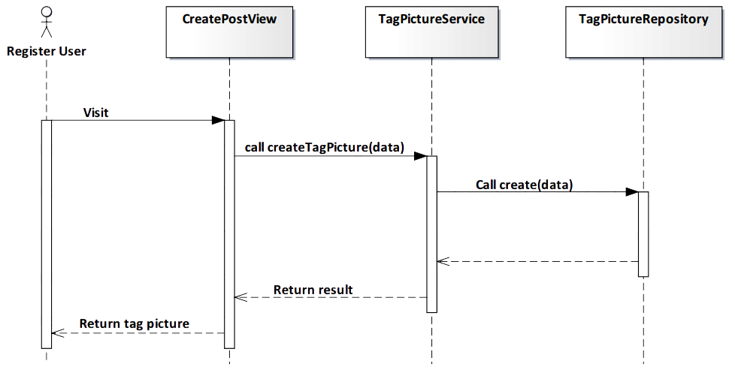

*Figure 4-92: Image Tagging Sequence Diagram*

#### Screen Design

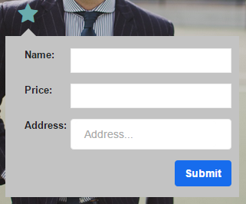

*Figure 4-93: Image Tagging Screen*

|  |  |  |
| --- | --- | --- |
| **Element** | **Type** | **Description** |
| **Name** | Input text | Text field for entering name of product. |
| **Price** | Input text | Text field for entering price of product. |
| **Address** | Input text | Text field for entering address of product. |
| **Submit** | Button | Click to submit. |

#### 4.3.4.2.14. Content tagging

#### Description

* Actor uses this function to classify product in image that they post.

#### Class Diagram

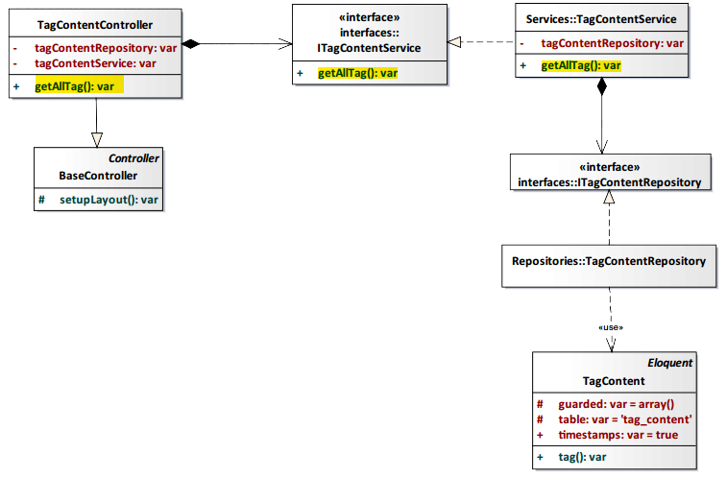

*Figure 4-94: Content Tagging Class Diagram*

#### Class Specification

#### TagContentController class

#### Physical Address: Trendy-Server\app\controllers*TagContentController.php*

#### Attribute

|  |  |  |  |
| --- | --- | --- | --- |
| No | Name | Type | Description |
| 1 | tagContentRepository | var | Instance of interface using to call methods in ITagContentRepository. |
| 2 | tagContentService | var | Instance of interface using to call methods in ITagContentRepository. |

#### Method: getAllTag()

|  |  |  |
| --- | --- | --- |
| Purpose | Get all tag content of system for actor chooses. | |
| Return | **Type** | **Description** |
| var | Content of tag after choosing will be displayed on post. |

#### TagContentService class

#### Physical Address: Trendy-Server\app\Services*TagContentService.php*

#### Attribute

|  |  |  |  |
| --- | --- | --- | --- |
| No | Name | Type | Description |
| 1 | tagContentRepository | var | Instance of interface using to call methods in ITagContentRepository. |

#### Method: getAllTag()

|  |  |  |
| --- | --- | --- |
| Purpose | Get all tag content of system for actor chooses. | |
| Return | **Type** | **Description** |
| var | Content of tag after choosing will be displayed on post. |

#### Sequence Diagram

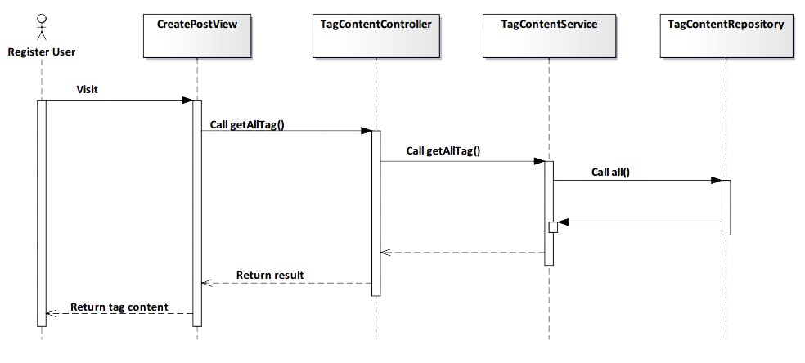

*Figure 4-95: Content Tagging Sequence Diagram*

#### Screen Design

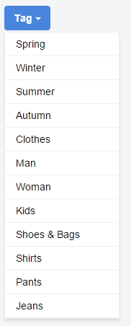

*Figure 4-96: Content Tagging Screen*

|  |  |  |
| --- | --- | --- |
| **Element** | **Type** | **Description** |
| **Tag** | Button | Click to show all list tag order by content. |

#### 4.3.4.2.15. Delete Post

#### Description

* Actor deletes a post that they shared.

#### Class Diagram

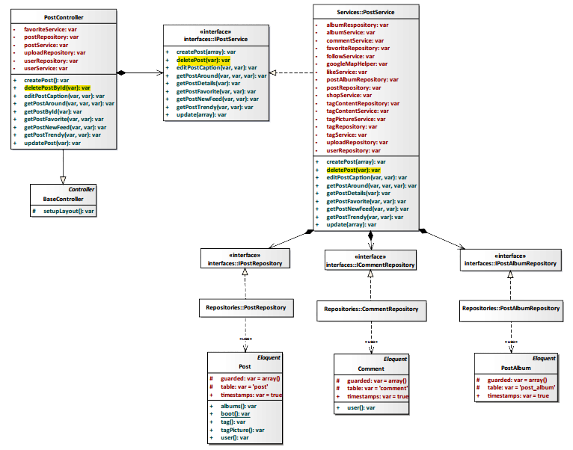

*Figure 4-97: Delete Post Class Diagram*

#### Class Specification

#### PostController class

#### Physical Address: Trendy-Server\app\controllers*PostController.php*

#### Attribute

|  |  |  |  |
| --- | --- | --- | --- |
| No | Name | Type | Description |
| 1 | favoriteService | var | Instance of interface using to call methods in IFavoriteService. |
| 2 | postRepository | var | Instance of interface using to call methods in IPostRepository. |
| 3 | postService | var | Instance of interface using to call methods in IPostService. |
| 4 | uploadRepository | var | Instance of interface using to call methods in IUploadRepostiory. |
| 5 | userRepository | var | Instance of interface using to call methods in IUserRepostiory. |
| 6 | userService | var | Instance of interface using to call methods in IUserService. |

#### Method: deletePostById(var $id)

|  |  |  |  |  |
| --- | --- | --- | --- | --- |
| Purpose | Delete post to client. | | | |
| Return | **Type** | | | **Description** |
| var | | | Post deleted will will no longer exist. |
| Parameter | **No** | **Name** | **Type** | **Description** |
| 1 | id | var | id of the post that want to delete post. |

#### PostService class

#### Physical Address: Trendy-Server\app\Services*PostService.php*

#### Attribute

|  |  |  |  |
| --- | --- | --- | --- |
| No | Name | Type | Description |
| 1 | albumRepository | var | Instance of interface using to call methods in IAlbumRepository. |
| 2 | albumService | var | Instance of interface using to call methods in IAlbumService. |
| 3 | commentService | var | Instance of interface using to call methods in ICommentService. |
| 4 | favoriteRepository | var | Instance of interface using to call methods in IFavoriteRepository. |
| 5 | followService | var | Instance of interface using to call methods in IFollowSerivce. |
| 6 | googleMapHelper | var | Instance of interface using to call methods in IGoogleMapHelper. |
| 7 | likeService | var | Instance of interface using to call methods in ILikeSerivce. |
| 8 | postAlbumRepository | var | Instance of interface using to call methods in IAlbumRepository. |
| 9 | postRepository | var | Instance of interface using to call methods in IPostRepository. |
| 10 | shopService | var | Instance of interface using to call methods in IShopSerivce. |
| 11 | tagContentRepository | var | Instance of interface using to call methods in ITagContentRepository. |
| 12 | tagContentService | var | Instance of interface using to call methods in ITagContentSerivce. |
| 13 | tagPictureService | var | Instance of interface using to call methods in ITagPictureSerivce. |
| 14 | tagRepository | var | Instance of interface using to call methods in ITagRepository. |
| 15 | tagService | var | Instance of interface using to call methods in ITagSerivce. |
| 16 | uploadRepository | var | Instance of interface using to call methods in IUploadRepository. |
| 17 | userRepository | var | Instance of interface using to call methods in IUserRepository. |

#### Method: deletePost(var $id)

|  |  |  |  |  |
| --- | --- | --- | --- | --- |
| Purpose | Process to delete post on TrendyPlus. | | | |
| Return | **Type** | | | **Description** |
| var | | | Post deleted will will no longer exist. |
| Parameter | **No** | **Name** | **Type** | **Description** |
| 1 | id | var | id of the post that want to delete post. |

#### Sequence Diagram

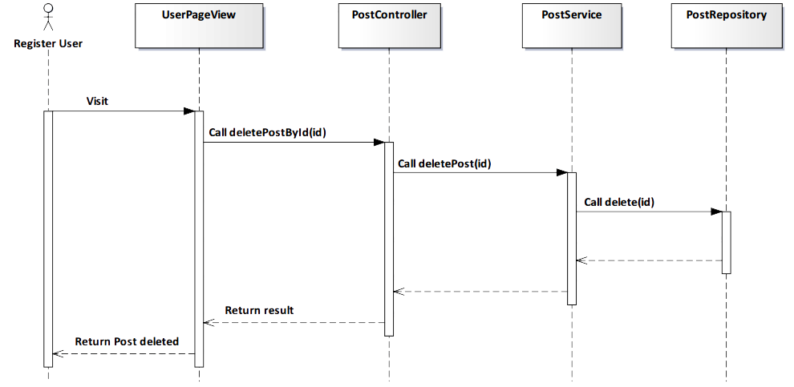

*Figure 4-98: Delete Post Sequence Diagram*

#### Screen Design

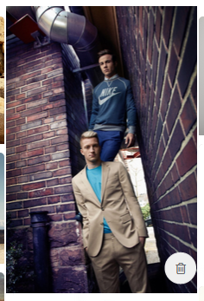

*Figure 4-99: Delete Post Screen*

|  |  |  |
| --- | --- | --- |
| **Element** | **Type** | **Description** |
| **Delelte** | Button | Click to delete post. |

#### 4.3.4.2.16. Edit Post

#### Description

* Actor edits a post that they shared.

#### Class Diagram

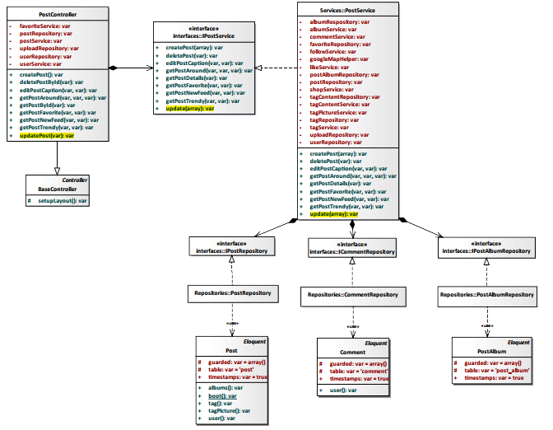

*Figure 4-100: Edit Post Class Diagram*

#### Class Specification

#### PostController class

#### Physical Address: Trendy-Server\app\controllers*PostController.php*

#### Attribute

|  |  |  |  |
| --- | --- | --- | --- |
| No | Name | Type | Description |
| 1 | favoriteService | var | Instance of interface using to call methods in IFavoriteService. |
| 2 | postRepository | var | Instance of interface using to call methods in IPostRepository. |
| 3 | postService | var | Instance of interface using to call methods in IPostService. |
| 4 | uploadRepository | var | Instance of interface using to call methods in IUploadRepostiory. |
| 5 | userRepository | var | Instance of interface using to call methods in IUserRepostiory. |
| 6 | userService | var | Instance of interface using to call methods in IUserService. |

#### Method: updatePost(var $id)

|  |  |  |  |  |
| --- | --- | --- | --- | --- |
| Purpose | Display all informations of post after editing to client. | | | |
| Return | **Type** | | | **Description** |
| var | | | Return post’s new information. |
| Parameter | **No** | **Name** | **Type** | **Description** |
| 1 | id | var | id of the post that want to edit post. |

#### PostService class

#### Physical Address: Trendy-Server\app\Services*PostService.php*

#### Attribute

|  |  |  |  |
| --- | --- | --- | --- |
| No | Name | Type | Description |
| 1 | albumRepository | var | Instance of interface using to call methods in IAlbumRepository. |
| 2 | albumService | var | Instance of interface using to call methods in IAlbumService. |
| 3 | commentService | var | Instance of interface using to call methods in ICommentService. |
| 4 | favoriteRepository | var | Instance of interface using to call methods in IFavoriteRepository. |
| 5 | followService | var | Instance of interface using to call methods in IFollowSerivce. |
| 6 | googleMapHelper | var | Instance of interface using to call methods in IGoogleMapHelper. |
| 7 | likeService | var | Instance of interface using to call methods in ILikeSerivce. |
| 8 | postAlbumRepository | var | Instance of interface using to call methods in IAlbumRepository. |
| 9 | postRepository | var | Instance of interface using to call methods in IPostRepository. |
| 10 | shopService | var | Instance of interface using to call methods in IShopSerivce. |
| 11 | tagContentRepository | var | Instance of interface using to call methods in ITagContentRepository. |
| 12 | tagContentService | var | Instance of interface using to call methods in ITagContentSerivce. |
| 13 | tagPictureService | var | Instance of interface using to call methods in ITagPictureSerivce. |
| 14 | tagRepository | var | Instance of interface using to call methods in ITagRepository. |
| 15 | tagService | var | Instance of interface using to call methods in ITagSerivce. |
| 16 | uploadRepository | var | Instance of interface using to call methods in IUploadRepository. |
| 17 | userRepository | var | Instance of interface using to call methods in IUserRepository. |

#### Method: updatePost(array $**data**)

|  |  |  |  |  |
| --- | --- | --- | --- | --- |
| Purpose | Process to edit information of a post. | | | |
| Return | **Type** | | | **Description** |
| var | | | Return post’s new information. |
| Parameter | **No** | **Name** | **Type** | **Description** |
| 1 | id | var | id of the post that want to edit post. |

#### Sequence Diagram

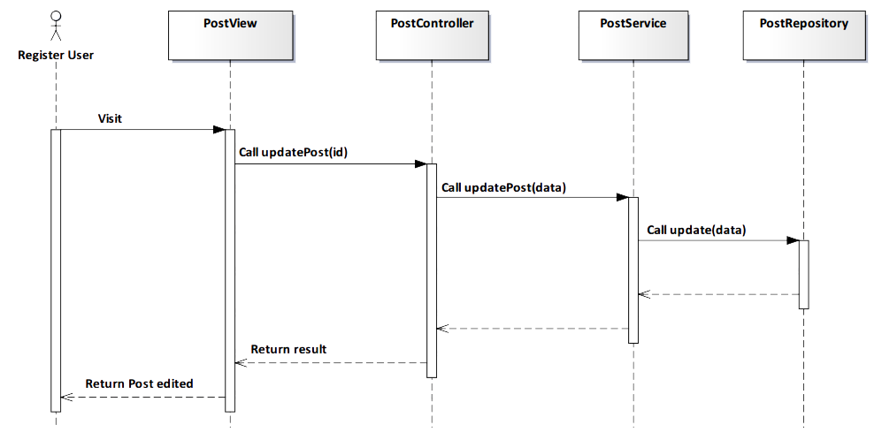

*Figure 4-101: Edit Post Squence Diagram*

#### Screen Design

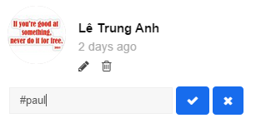

*Figure 4-102: Edit Post Screen*

|  |  |  |
| --- | --- | --- |
| **Element** | **Type** | **Description** |
| **Edit** | Button | Click to edit post’s caption. |
| **Delete** | Button | Click to delete post’s caption. |

#### 4.3.4.2.17. Like Post

#### Description

* Actor likes a post that they want on TrendyPlus.

#### Class Diagram

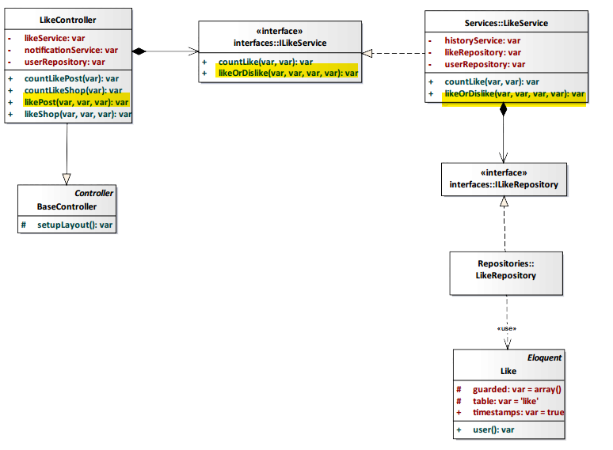

*Figure 4-103: Like Post Class Diagram*

#### Class Specification

#### LikeController class

#### Physical Address: Trendy-Server\app\controllers*LikeController.php*

#### Attribute

|  |  |  |  |
| --- | --- | --- | --- |
| No | Name | Type | Description |
| 1 | likeService | var | Instance of interface using to call methods in ILikeService. |
| 2 | notificationService | var | Instance of interface using to call methods in INotificationService. |
| 3 | userRepository | var | Instance of interface using to call methods in IUserRepository. |

#### Method: likePost(var $id, var $type, var $user_id)

|  |  |  |  |  |
| --- | --- | --- | --- | --- |
| Purpose | Display post was liked to client. | | | |
| Return | **Type** | | | **Description** |
| var | | | Return status *“Liked”* of post. |
| Parameter | **No** | **Name** | **Type** | **Description** |
| 1 | id | var | id of the post that want to unlike. |
| 2 | type | var | type of action (in this case: like). |
| 3 | user_id | var | id of user liked post. |

#### LikeService class

#### Physical Address: Trendy-Server\app\Services*LikeService.php*

#### Attribute

|  |  |  |  |
| --- | --- | --- | --- |
| No | Name | Type | Description |
| 1 | tagPictureRepository | var | Instance of interface using to call methods in ITagPictureRepository. |
| 2 | historyService | var | Instance of interface using to call methods in IHistoryService. |
| 3 | likeRepository | var | Instance of interface using to call methods in ILikeRepository. |

#### Method: likeOrDislike (var $type_like, var $type_id, var $type, var $user_id)

|  |  |  |  |  |
| --- | --- | --- | --- | --- |
| Purpose | Process to show post was liked. | | | |
| Return | **Type** | | | **Description** |
| var | | | Return status *“Liked”* of post. |
| Parameter | **No** | **Name** | **Type** | **Description** |
| 1 | type_like | var | With post will have type like is *“0”*. With shop will have type like is *“1”.* |
| 2 | type_id | var | id of post. |
| 3 | type | var | type of action (in this case: like) |
| 4 | user_id | var | id of user liked post. |

#### Sequence Diagram

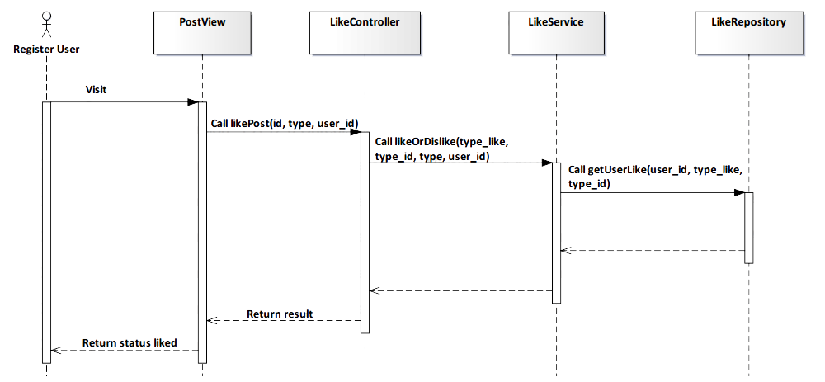

*Figure 4-104: Like Post Sequence Diagram*

#### Screen Design

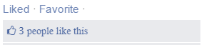

*Figure 4-105: Like Post Screen*

|  |  |  |
| --- | --- | --- |
| **Element** | **Type** | **Description** |
| **Liked** | Button | Click to unlike post. |
| **Favorite** | Button | Click to add favorite. |

#### 4.3.4.2.18. Unlike Post

#### Description

* Actor unlikes a post after they liked.

#### Class Diagram



*Figure 4-106: Unlike Post Class Diagram*

#### Class Specification

#### LikeController class

#### Physical Address: Trendy-Server\app\controllers*LikeController.php*

#### Attribute

|  |  |  |  |
| --- | --- | --- | --- |
| No | Name | Type | Description |
| 1 | likeService | var | Instance of interface using to call methods in ILikeService. |
| 2 | notificationService | var | Instance of interface using to call methods in INotificationService. |
| 3 | userRepository | var | Instance of interface using to call methods in IUserRepository. |

#### Method: likePost(var $id, var $type, var $user_id)

|  |  |  |  |  |
| --- | --- | --- | --- | --- |
| Purpose | Display post was unliked to client. | | | |
| Return | **Type** | | | **Description** |
| var | | | Return status *“Like”* of post. |
| Parameter | **No** | **Name** | **Type** | **Description** |
| 1 | id | var | id of the post that want to unlike. |
| 2 | type | var | type of action (in this case: like). |
| 3 | user_id | var | id of user unliked post. |

#### LikeService class

#### Physical Address: Trendy-Server\app\Services*LikeService.php*

#### Attribute

|  |  |  |  |
| --- | --- | --- | --- |
| No | Name | Type | Description |
| 1 | tagPictureRepository | var | Instance of interface using to call methods in ITagPictureRepository. |
| 2 | historyService | var | Instance of interface using to call methods in IHistoryService. |
| 3 | likeRepository | var | Instance of interface using to call methods in ILikeRepository. |

#### Method: likeOrDislike (var $type_like, var $type_id, var $type, var $user_id)

|  |  |  |  |  |
| --- | --- | --- | --- | --- |
| Purpose | Process to show post was unliked. | | | |
| Return | **Type** | | | **Description** |
| var | | | Return status *“Like”* of post. |
| Parameter | **No** | **Name** | **Type** | **Description** |
| 1 | type_like | var | With post will have type like is *“0”*. With shop will have type like is *“1”.* |
| 2 | type_id | var | id of post. |
| 3 | type | var | type of action (in this case: unlike) |
| 4 | user_id | var | id of user unliked post. |

#### Sequence Diagram

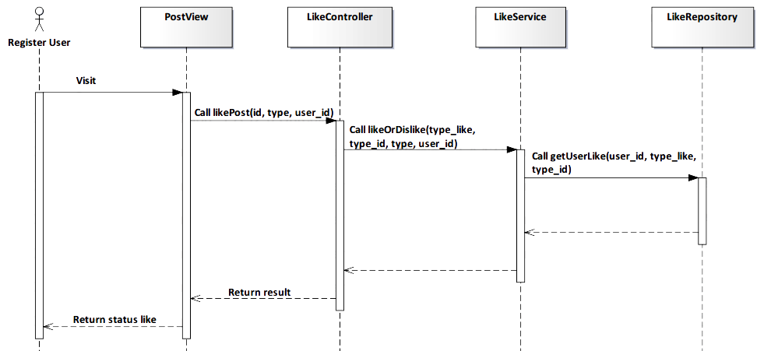

*Figure 4-107: Unlike Post Sequence Diagram*

#### Screen Design

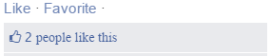

*Figure 4-108: Unlike Post Screen*

|  |  |  |
| --- | --- | --- |
| **Element** | **Type** | **Description** |
| **Like** | Button | Click to like post. |
| **Favorite** | Button | Click to add favorite. |

#### 4.3.4.2.19. Create Shop

#### Description

* User creates a new shop.

#### Class Diagram



*Figure 4-109: Create Shop Class Diagram*

#### Class Specification

#### PostController class

#### Physical Address: Trendy-Server\app\Controller*PostController.php*

#### Attribute

|  |  |  |  |
| --- | --- | --- | --- |
| No | Name | Type | Description |
| 1 | favoriteService | var | Instance of interface using to call methods in IFavoriteService. |
| 2 | postRepository | var | Instance of interface using to call methods in IPostRepository. |
| 3 | postService | var | Instance of interface using to call methods in IPostService. |
| 4 | uploadRepository | var | Instance of interface using to call methods in IUploadRepository. |
| 5 | userRepository | var | Instance of interface using to call methods in IUserRepository. |
| 6 | userService | var | Instance of interface using to call methods in IUserService. |

#### Method: createPost()

|  |  |  |
| --- | --- | --- |
| Purpose | Save a post to the database | |
| Return | **Type** | **Description** |
| var | Save data to database and response status save success or fail. |

#### PostService class

#### Physical Address: Trendy-Server\app\Services*PostService.php*

#### Attribute

|  |  |  |  |
| --- | --- | --- | --- |
| No | Name | Type | Description |
| 1 | albumRepository | var | Instance of interface using to call methods in IAlbumRepository. |
| 2 | albumService | var | Instance of interface using to call methods in IAlbumService. |
| 3 | commentService | var | Instance of interface using to call methods in ICommentService. |
| 4 | favoriteRepository | var | Instance of interface using to call methods in IFavoriteRepository. |
| 5 | followService | var | Instance of interface using to call methods in IFollowSerivce. |
| 6 | googleMapHelper | var | Instance of interface using to call methods in IGoogleMapHelper. |
| 7 | likeService | var | Instance of interface using to call methods in ILikeSerivce. |
| 8 | postAlbumRepository | var | Instance of interface using to call methods in IAlbumRepository. |
| 9 | postRepository | var | Instance of interface using to call methods in IPostRepository. |
| 10 | shopService | var | Instance of interface using to call methods in IShopSerivce. |
| 11 | tagContentRepository | var | Instance of interface using to call methods in ITagContentRepository. |
| 12 | tagContentService | var | Instance of interface using to call methods in ITagContentSerivce. |
| 13 | tagPictureService | var | Instance of interface using to call methods in ITagPictureSerivce. |
| 14 | tagRepository | var | Instance of interface using to call methods in ITagRepository. |
| 15 | tagService | var | Instance of interface using to call methods in ITagSerivce. |
| 16 | uploadRepository | var | Instance of interface using to call methods in IUploadRepository. |
| 17 | userRepository | var | Instance of interface using to call methods in IUserRepository. |

#### Method: createPost(array $data)

|  |  |  |  |  |
| --- | --- | --- | --- | --- |
| Purpose | Save a post to the database | | | |
| Return | **Type** | | | **Description** |
| var | | | Save data to database and response status save success or fail. |
| Parameter | **No** | **Name** | **Type** | **Description** |
| 1 | data | array | Array contains shop’ information that save to database. |

#### Sequence Diagram



*Figure 4-110: Create Shop Sequence Diagram*

#### Screen Design

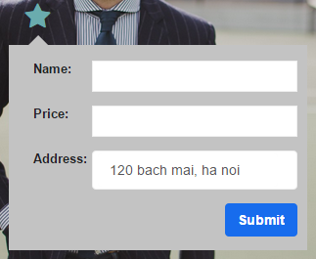

*Figure 4-111: Create Shop Screen*

|  |  |  |
| --- | --- | --- |
| **Element** | **Type** | **Description** |
| **Name** | Input text | Text field for entering name of product. |
| **Price** | Input text | Text field for entering price of product. |
| **Address** | Input text | Text field for entering address of product. |
| **Submit** | Button | Click to submit. |

#### 4.3.4.2.20. Suggest Shop

#### Description

* System suggest shops for user.

#### Class Diagram

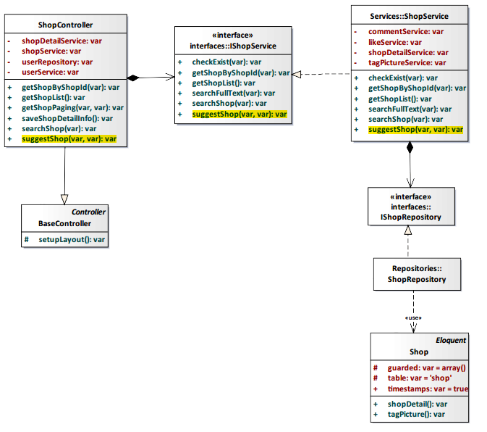

*Figure 4-112: Suggest Shop Class Diagram*

#### Class Specification

#### ShopController class

#### Physical Address: Trendy-Server\app\Controller*ShopController.php*

#### Attribute

|  |  |  |  |
| --- | --- | --- | --- |
| No | Name | Type | Description |
| 1 | shopDetailService | var | Instance of interface using to call methods in IShopDetailService. |
| 2 | shopService | var | Instance of interface using to call methods in IShopService. |
| 3 | userService | var | Instance of interface using to call methods in IUserService. |
| 4 | userRepository | var | Instance of interface using to call methods in IUserRepository. |

#### Method: suggestShop($loginId, $shopId)

|  |  |  |  |  |
| --- | --- | --- | --- | --- |
| Purpose | System suggest shop for user. | | | |
| Return | **Type** | | | **Description** |
| var | | | Show list shop that for user. |
| Parameter | **No** | **Name** | **Type** | **Description** |
| 1 | loginId | var | id of status system. |
| 2 | shopId | var | id of shop. |

#### ShopService class

#### Physical Address: Trendy-Server\app\Services*ShopService.php*

#### Attribute

|  |  |  |  |
| --- | --- | --- | --- |
| No | Name | Type | Description |
| 1 | commentService | var | Instance of interface using to call methods in ICommentService. |
| 2 | likeService | var | Instance of interface using to call methods in ILikeService. |
| 3 | shopDetailRepository | var | Instance of interface using to call methods in IshopDetailRepository. |
| 4 | tagPictureService | var | Instance of interface using to call methods in ITagPictureService. |

#### Method: suggestShop($loginId, $shopId)

|  |  |  |  |  |
| --- | --- | --- | --- | --- |
| Purpose | System suggest shop for user. | | | |
| Return | **Type** | | | **Description** |
| var | | | Show list shop that for user. |
| Parameter | **No** | **Name** | **Type** | **Description** |
| 1 | loginId | var | id of status syste. |
| 2 | shopId | var | id of shop. |

#### Sequence Diagram

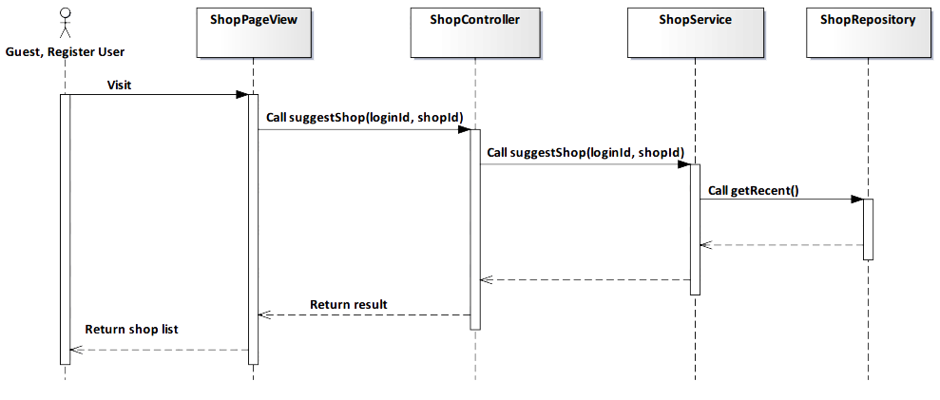

*Figure 4-112: Suggest Shop Squence Diagram*

#### Screen Design

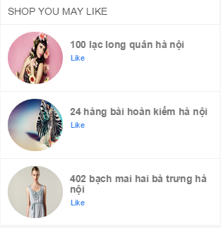

*Figure 4-113: Suggest Shop Screen*

|  |  |  |
| --- | --- | --- |
| **Element** | **Type** | **Description** |
| **Like** | Button | Click to like shop. |

#### 4.3.4.2.21. Suggest Shop’s Information

#### Description

* User suggest shop’s information.

#### Class Diagram

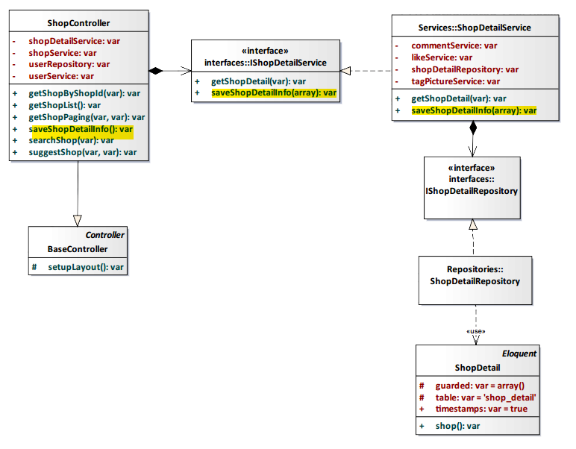

*Figure 4-114: Suggest Shop’s Information Class Diagram*

#### Class Specification

#### ShopController class

#### Physical Address: Trendy-Server\app\Controller*ShopController.php*

#### Attribute

|  |  |  |  |
| --- | --- | --- | --- |
| No | Name | Type | Description |
| 1 | shopDetailService | var | Instance of interface using to call methods in IShopDetailService. |
| 2 | shopService | var | Instance of interface using to call methods in IShopService. |
| 3 | userService | var | Instance of interface using to call methods in IUserService. |
| 4 | userRepository | var | Instance of interface using to call methods in IUserRepository. |

#### Method: saveShopDetailInfo()

|  |  |  |
| --- | --- | --- |
| Purpose | Save the suggestion shop’s information to the database. | |
| Return | **Type** | **Description** |
| var | Save data to database and response status save success or fail. |

#### ShopDetailService class

#### Physical Address: Trendy-Server\app\Services*ShopDetailService.php*

#### Attribute

|  |  |  |  |
| --- | --- | --- | --- |
| No | Name | Type | Description |
| 1 | commentService | var | Instance of interface using to call methods in ICommentService. |
| 2 | likeService | var | Instance of interface using to call methods in ILikeService. |
| 3 | shopDetailRepository | var | Instance of interface using to call methods in IshopDetailRepository. |
| 4 | tagPictureService | var | Instance of interface using to call methods in ITagPictureService. |

#### Method: saveShopDetailInfo(array $data)

|  |  |  |  |  |
| --- | --- | --- | --- | --- |
| Purpose | Save the suggestion shop’s information to the database. | | | |
| Return | **Type** | | | **Description** |
| var | | | Save data to database and response status save success or fail. |
| Parameter | **No** | **Name** | **Type** | **Description** |
| 1 | data | array | Array contains suggestion shop’ information that save to database. |

#### Sequence Diagram

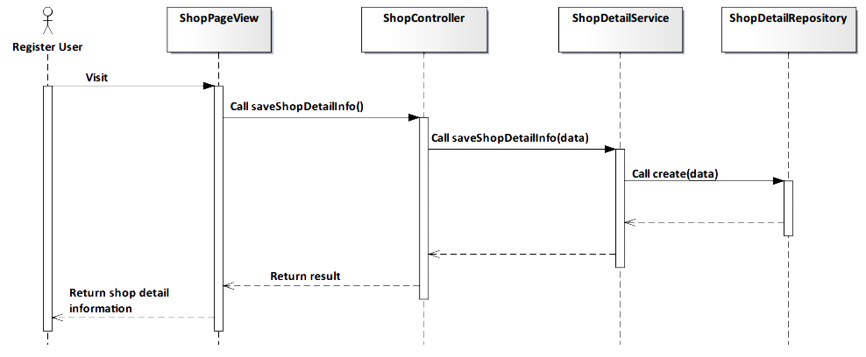

*Figure 4-115: Suggest Shop’s Information Sequence Diagram*

#### Screen Design

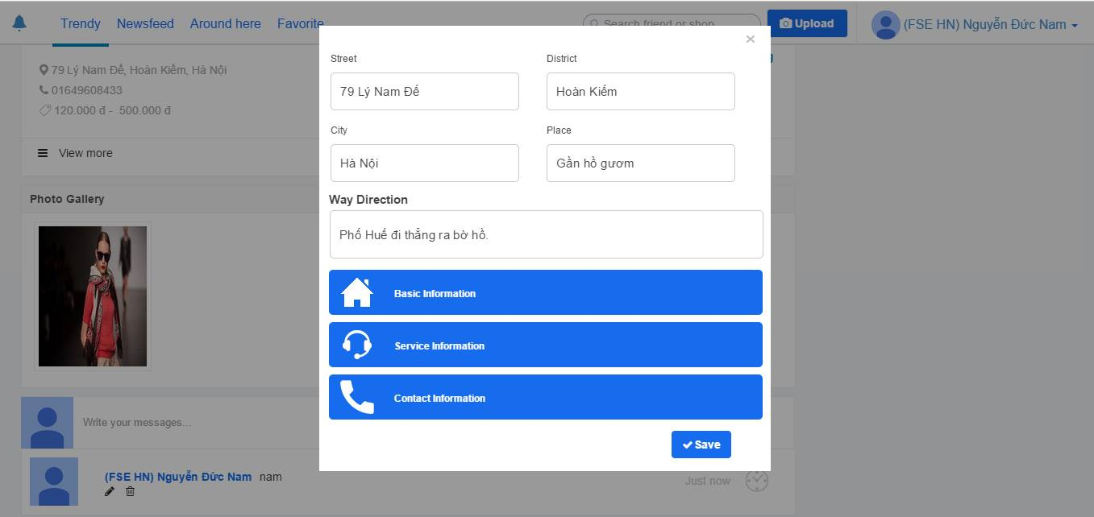

*Figure 4-116: Suggest Shop’s Information Screen*

#### 4.3.4.2.22. View Shop Detail

#### Description

* User view shop detail information.

#### Class Diagram

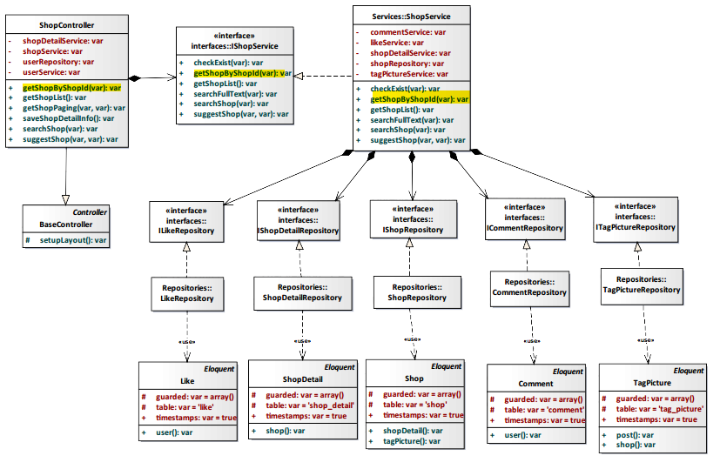

*Figure 4-117: View Shop Detail Class Diagram*

#### Class Specification

#### ShopController class

#### Physical Address: Trendy-Server\app\Controller*ShopController.php*

#### Attribute

|  |  |  |  |
| --- | --- | --- | --- |
| No | Name | Type | Description |
| 1 | shopDetailService | var | Instance of interface using to call methods in IShopDetailService. |
| 2 | shopService | var | Instance of interface using to call methods in IShopService. |
| 3 | userService | var | Instance of interface using to call methods in IUserService. |
| 4 | userRepository | var | Instance of interface using to call methods in IUserRepository. |

#### Method: getShopByShopId($id)

|  |  |  |  |  |
| --- | --- | --- | --- | --- |
| Purpose | Display all shop’s information to client. | | | |
| Return | **Type** | | | **Description** |
| var | | | Return shop information. |
| Parameter | **No** | **Name** | **Type** | **Description** |
| 1 | id | var | id of the shop that want to view. |

#### ShopService class

#### Physical Address: Trendy-Server\app\Services*ShopService.php*

#### Attribute

|  |  |  |  |
| --- | --- | --- | --- |
| No | Name | Type | Description |
| 1 | commentService | var | Instance of interface using to call methods in ICommentService. |
| 2 | likeService | var | Instance of interface using to call methods in ILikeService. |
| 3 | shopDetailService | var | Instance of interface using to call methods in IShopDetailService. |
| 4 | shopRepository | var | Instance of interface using to call methods in IShopRepository |
| 5 | tagPictureService | var | Instance of interface using to call methods in ITagPictureService. |

#### Method: getShopByShopId($id)

|  |  |  |  |  |
| --- | --- | --- | --- | --- |
| Purpose | Process to get all shop’s information. | | | |
| Return | **Type** | | | **Description** |
| var | | | Return shop information. |
| Parameter | **No** | **Name** | **Type** | **Description** |
| 1 | Id | var | id of the shop that want to view. |

#### Sequence Diagram

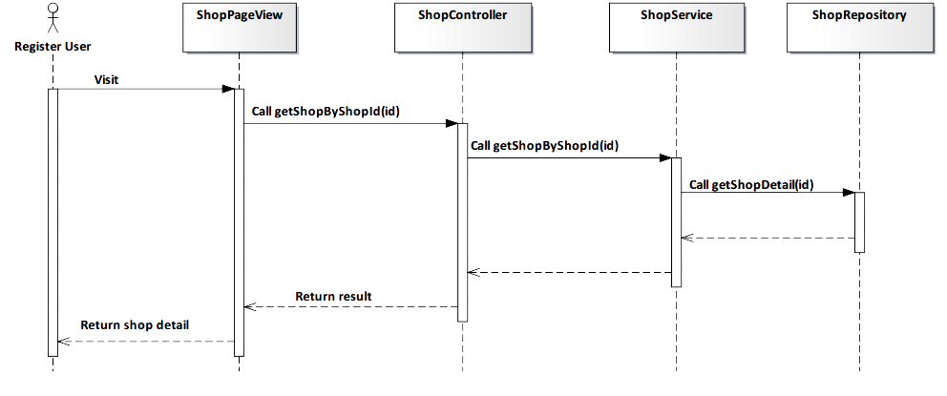

*Figure 4-118: View Shop Detail Sequence Diagram*

#### Screen Design

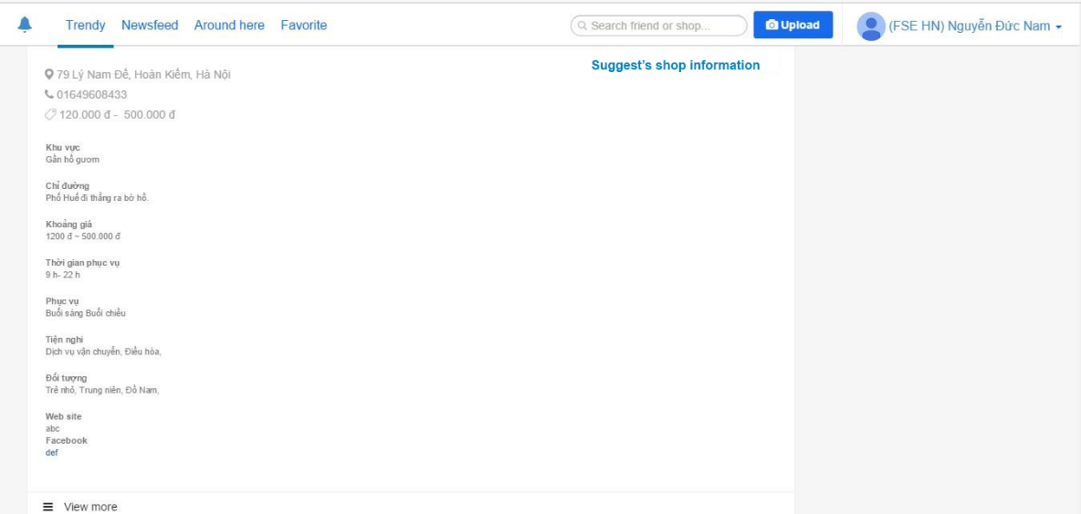

*Figure 4-119: View Shop Detail Screen*

|  |  |  |
| --- | --- | --- |
| **Element** | **Type** | **Description** |
| **View more** | Button | Click to view more shop’s information |

#### 4.3.4.2.23. Like Shop

#### Description

* User like a shop.

#### Class Diagram

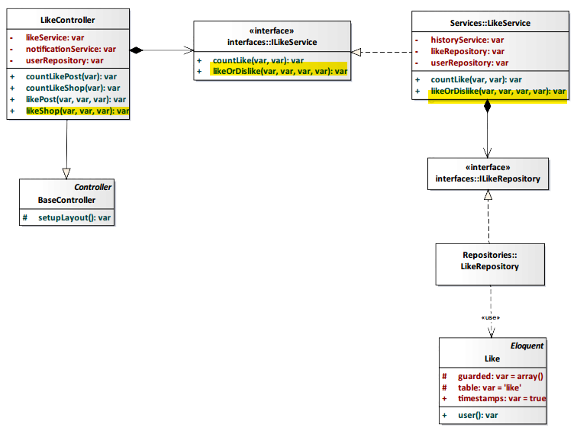

*Figure 4-120: Like Shop Class Diagram*

#### Class Specification

#### LikeController class

#### Physical Address: Trendy-Server\app\Controller*LikeController.php*

#### Attribute

|  |  |  |  |
| --- | --- | --- | --- |
| No | Name | Type | Description |
| 1 | likeService | var | Instance of interface using to call methods in ILikeService. |
| 2 | notificationService | var | Instance of interface using to call methods in INotificationService. |
| 3 | userRepository | var | Instance of interface using to call methods in IUserRepository. |

#### Method: likeShop($id, $type, $user_id)

|  |  |  |  |  |
| --- | --- | --- | --- | --- |
| Purpose | Display the like number of shop to client. | | | |
| Return | **Type** | | | **Description** |
| var | | | The like number of shop. |
| Parameter | **No** | **Name** | **Type** | **Description** |
| 1 | id | var | id of the shop that want to like. |
| 2 | type | var | type of action (in this case: like). |
| 3 | user_id | var | id of the user that like the shop |

#### LikeService class

#### Physical Address: Trendy-Server\app\Services*LikeService.php*

#### Attribute

|  |  |  |  |
| --- | --- | --- | --- |
| No | Name | Type | Description |
| 1 | userRepository | var | Instance of interface using to call methods in IUserRepository. |
| 2 | likeRepository | var | Instance of interface using to call methods in ILikeRepository. |
| 3 | historyService | var | Instance of interface using to call methods in IHistoryService. |

#### Method: likeOrDislike($type_like, $type_id, $type, $user_id)

|  |  |  |  |  |
| --- | --- | --- | --- | --- |
| Purpose | Update the number of like shop is incremented by 1 to database. | | | |
| Return | **Type** | | | **Description** |
| var | | | Save data to database and response status success or fail. |
| Parameter | **No** | **Name** | **Type** | **Description** |
| 1 | type_like | var | type of like action. |
| 2 | type_id | var | id of the shop. |
| 3 | type | var | type of action (in this case: like). |
| 4 | user_id | var | id of the user that like the shop. |

#### Sequence Diagram

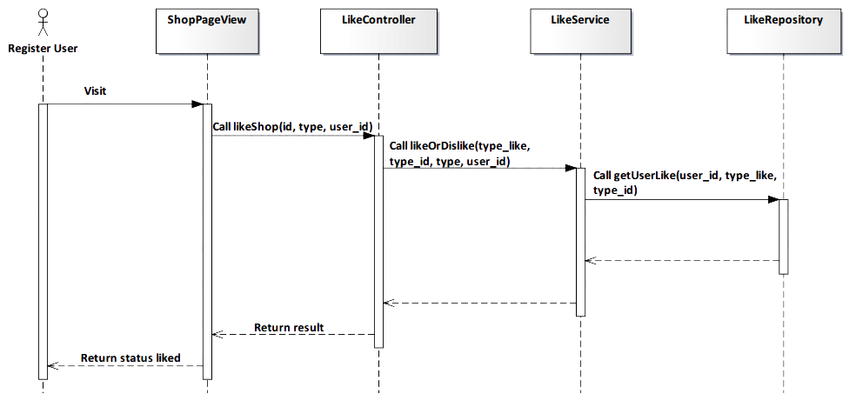

*Figure 4-121: Like Shop Sequence Diagram*

#### Screen Design

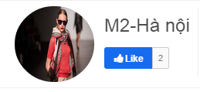

*Figure 4-122: Like Shop Screen*

|  |  |  |
| --- | --- | --- |
| **Element** | **Type** | **Description** |
| **Like** | Button | Click to like shop. |

#### 4.3.4.2.24. Unlike Shop

#### Description

* User unlike a shop that liked before.

#### Class Diagram



*Figure 4-123: Unlike Shop Class Diagram*

#### Class Specification

#### LikeController class

#### Physical Address: Trendy-Server\app\Controller*LikeController.php*

#### Attribute

|  |  |  |  |
| --- | --- | --- | --- |
| No | Name | Type | Description |
| 1 | likeService | var | Instance of interface using to call methods in ILikeService. |
| 2 | notificationService | var | Instance of interface using to call methods in INotificationService. |
| 3 | userRepository | var | Instance of interface using to call methods in IUserRepository. |

#### Method: likeShop($id, $type, $user_id)

|  |  |  |  |  |
| --- | --- | --- | --- | --- |
| Purpose | Display the like number of shop to client. | | | |
| Return | **Type** | | | **Description** |
| var | | | The like number of shop. |
| Parameter | **No** | **Name** | **Type** | **Description** |
| 1 | id | var | Id of the shop that want to like. |
| 2 | type | var | Type of action (in this case: unlike). |
| 3 | user_id | var | Id of the user that unlike the shop. |

#### LikeService class

#### Physical Address: Trendy-Server\app\Services*LikeService.php*

#### Attribute

|  |  |  |  |
| --- | --- | --- | --- |
| No | Name | Type | Description |
| 1 | userRepository | var | Instance of interface using to call methods in IUserRepository. |
| 2 | likeRepository | var | Instance of interface using to call methods in ILikeRepository. |
| 3 | historyService | var | Instance of interface using to call methods in IHistoryService. |

#### Method: likeOrDislike($type_like, $type_id, $type, $user_id)

|  |  |  |  |  |
| --- | --- | --- | --- | --- |
| Purpose | Update the number of like shop is decremented by 1 to database. | | | |
| Return | **Type** | | | **Description** |
| var | | | Save data to database and response status success or fail. |
| Parameter | **No** | **Name** | **Type** | **Description** |
| 1 | type_like | var | Type of like action. |
| 2 | type_id | var | Id of the shop. |
| 3 | type | var | Type of action (in this case: unlike). |
| 4 | user_id | var | Id of the user that unlike the shop. |

#### Sequence Diagram

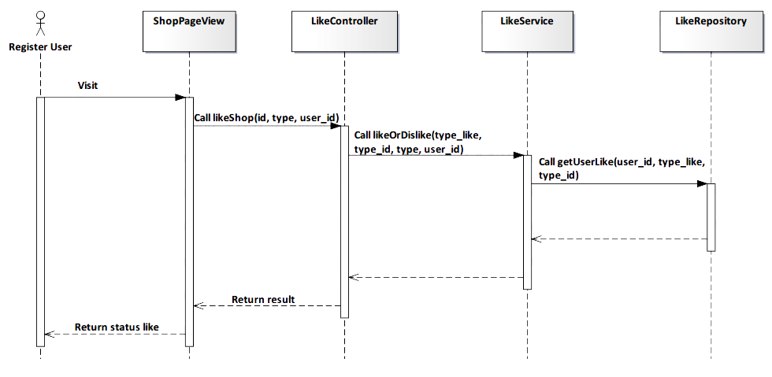

*Figure 4-124: Unlike Shop Sequence Diagram*

#### Screen Design

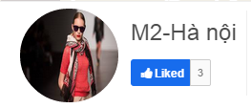

*Figure 4-125: Unlike Shop Screen*

|  |  |  |
| --- | --- | --- |
| **Element** | **Type** | **Description** |
| **Liked** | Button | Click to unlike shop. |

#### 4.3.4.2.25. View Following

#### Description

* User view the following people.

#### Class Diagram

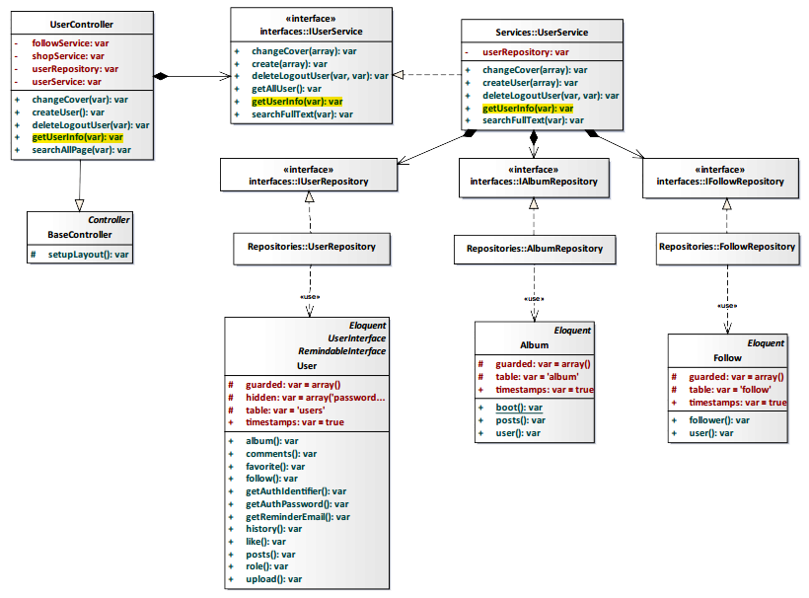

*Figure 4-126: View Following Class Diagram*

#### Class Specification

#### UserController class

#### Physical Address: Trendy-Server\app\Controller*UserController.php*

#### Attribute

|  |  |  |  |
| --- | --- | --- | --- |
| No | Name | Type | Description |
| 1 | followService | var | Instance of interface using to call methods in IFollowService. |
| 2 | shopService | var | Instance of interface using to call methods in IShopService. |
| 3 | userRepository | var | Instance of interface using to call methods in IUserRepository. |
| 4 | userService | var | Instance of interface using to call methods in IUserService. |

#### Method: getUserInfo($id)

|  |  |  |  |  |
| --- | --- | --- | --- | --- |
| Purpose | Display the following people to client | | | |
| Return | **Type** | | | **Description** |
| var | | | Return list following people. |
| Parameter | **No** | **Name** | **Type** | **Description** |
| 1 | id | var | id of the user that want to view list following. |

#### UserService class

#### Physical Address: Trendy-Server\app\Services*UserService.php*

#### Attribute

|  |  |  |  |
| --- | --- | --- | --- |
| No | Name | Type | Description |
| 1 | userRepository | var | Instance of interface using to call methods in IUserRepository. |

#### Method: getUserInfo($id)

|  |  |  |  |  |
| --- | --- | --- | --- | --- |
| Purpose | Process to get list following people | | | |
| Return | **Type** | | | **Description** |
| var | | | Return list following people. |
| Parameter | **No** | **Name** | **Type** | **Description** |
| 1 | id | var | id of the user that want to view list following. |

#### Sequence Diagram

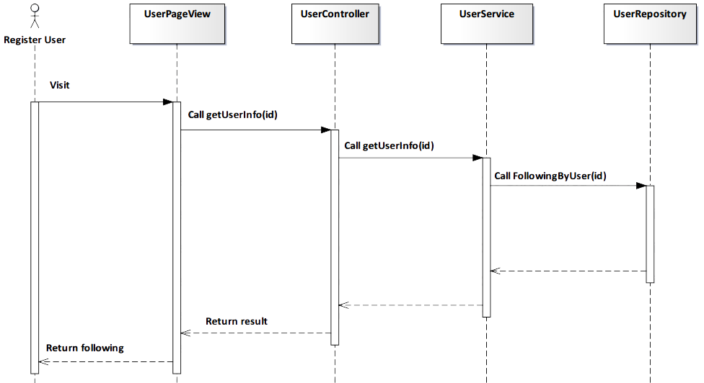

*Figure 4-127: View Following Sequence Diagram*

#### Screen Design

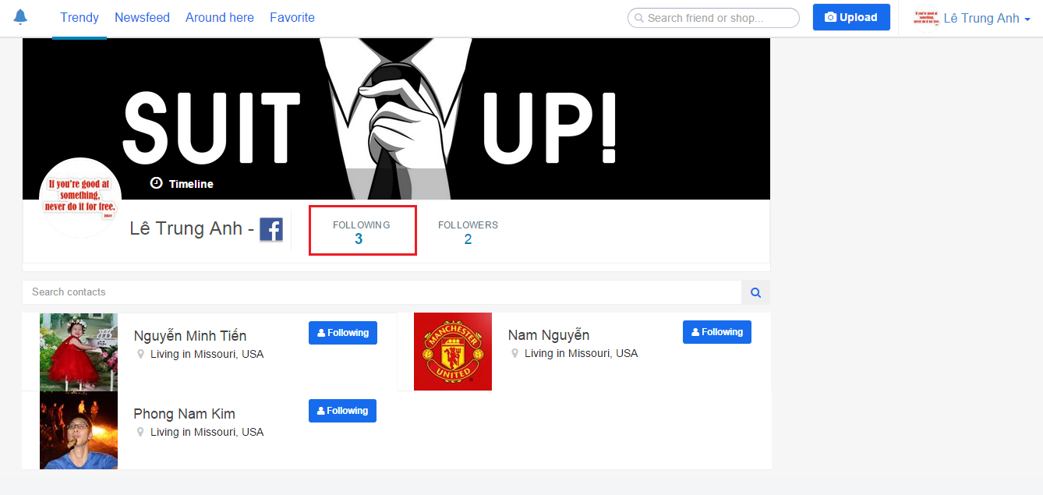

*Figure 4-128: View Following Screen*

|  |  |  |
| --- | --- | --- |
| **Element** | **Type** | **Description** |
| **Following** | Button | Click to unfollow user. |

#### 4.3.4.2.26. View Follower

#### Description

* User view list follower people.

#### Class Diagram



*Figure 4-129: View Follower Class Diagram*

#### Class Specification

#### UserController class

#### Physical Address: Trendy-Server\app\Controller*UserController.php*

#### Attribute

|  |  |  |  |
| --- | --- | --- | --- |
| No | Name | Type | Description |
| 1 | followService | var | Instance of interface using to call methods in IFollowService. |
| 2 | shopService | var | Instance of interface using to call methods in IShopService. |
| 3 | userRepository | var | Instance of interface using to call methods in IUserRepository. |
| 4 | userService | var | Instance of interface using to call methods in IUserService. |

#### Method: getUserInfo($id)

|  |  |  |  |  |
| --- | --- | --- | --- | --- |
| Purpose | Display the list follower people to client. | | | |
| Return | **Type** | | | **Description** |
| var | | | Return list follower people. |
| Parameter | **No** | **Name** | **Type** | **Description** |
| 1 | Id | var | Id of the user that want to view list follower. |

#### UserService class

#### Physical Address: Trendy-Server\app\Services*UserService.php*

#### Attribute

|  |  |  |  |
| --- | --- | --- | --- |
| No | Name | Type | Description |
| 1 | userRepository | var | Instance of interface using to call methods in IUserRepository. |

#### Method: getUserInfo($id)

|  |  |  |  |  |
| --- | --- | --- | --- | --- |
| Purpose | Process to get list follower people. | | | |
| Return | **Type** | | | **Description** |
| var | | | Return list follower people. |
| Parameter | **No** | **Name** | **Type** | **Description** |
| 1 | Id | var | Id of the user that want to view list follower. |

#### Sequence Diagram

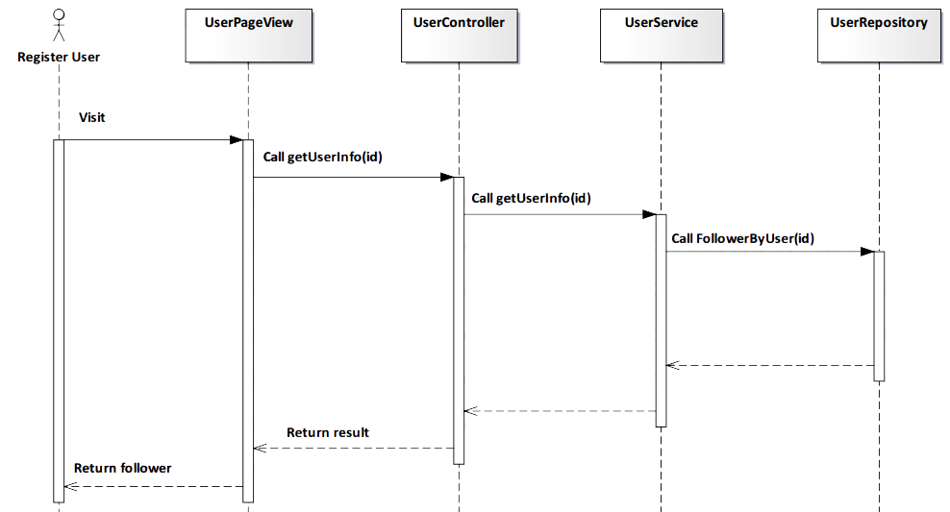

*Figure 4-130: View Follower Sequence Diagram*

#### Screen Design

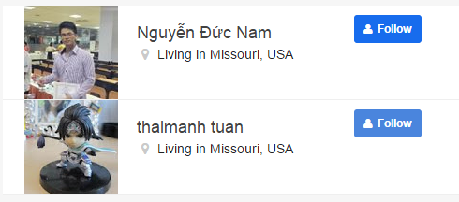

*Figure 4-131: View Follower Screen*

|  |  |  |
| --- | --- | --- |
| **Element** | **Type** | **Description** |
| **Follow** | Button | Click to follow user. |

#### 4.3.4.2.27. Add Follow

#### Description

* User add follow other people.

#### Class Diagram

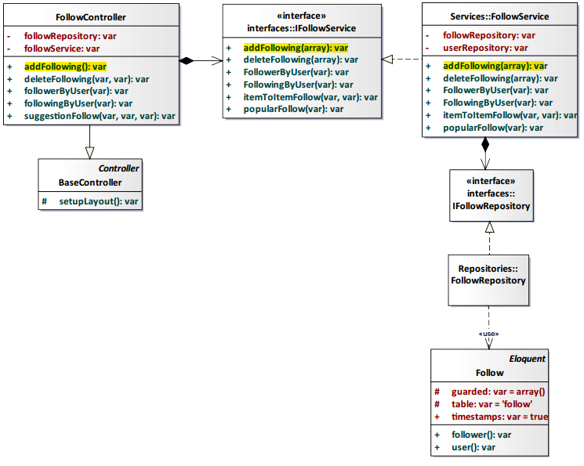

*Figure 4-132: Add Follow Class Diagram*

#### Class Specification

#### FollowController class

#### Physical Address: Trendy-Server\app\Controller*FollowController.php*

#### Attribute

|  |  |  |  |
| --- | --- | --- | --- |
| No | Name | Type | Description |
| 1 | followService | var | Instance of interface using to call methods in IFollowService. |
| 2 | followRepository | var | Instance of interface using to call methods in IFollowRepository. |

#### Method: addFollowing()

|  |  |  |
| --- | --- | --- |
| Purpose | Add following other people. | |
| Return | **Type** | **Description** |
| var | Save data to database and response status success or fail. |

#### FollowService class

#### Physical Address: Trendy-Server\app\Services*FollowService.php*

#### Attribute

|  |  |  |  |
| --- | --- | --- | --- |
| No | Name | Type | Description |
| 1 | userRepository | var | Instance of interface using to call methods in IUserRepository. |
| 2 | followRepository | var | Instance of interface using to call methods in IFollowRepository. |

#### Method: addFollowing(array $data)

|  |  |  |  |  |
| --- | --- | --- | --- | --- |
| Purpose | Process add following other people. | | | |
| Return | **Type** | | | **Description** |
| var | | | Save data to database and response status success or fail. |
| Parameter | **No** | **Name** | **Type** | **Description** |
| 1 | data | array | Array contains following user’s information that save to database. |

#### Sequence Diagram

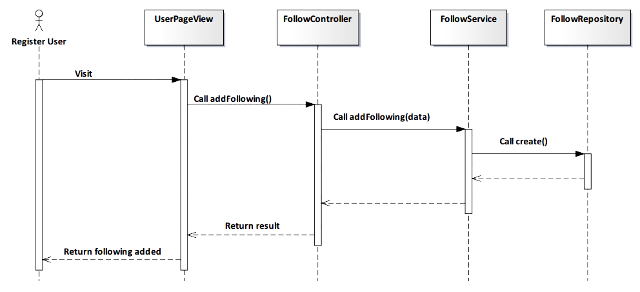

*Figure 4-133: Add Follow Sequence Diagram*

#### Screen Design



*Figure 4-134: Add Follow Screen*

#### 4.3.4.2.28. Remove Follow

#### Description

* User remove follow other people.

#### Class Diagram

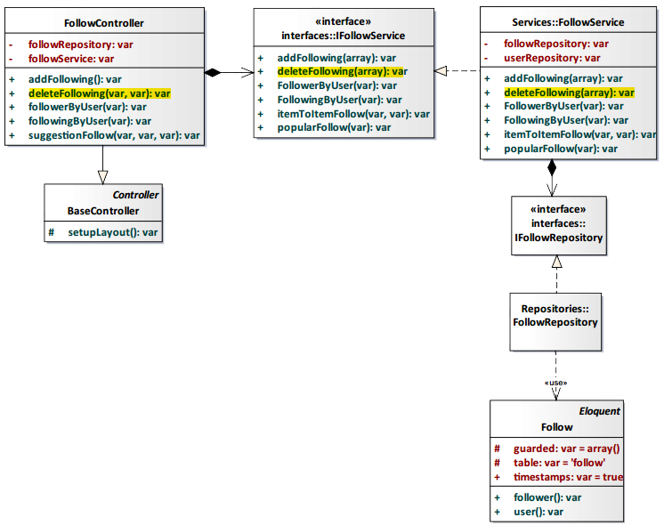

*Figure 4-135: Remove Follow Class Diagram*

#### Class Specification

#### FollowController class

#### Physical Address: Trendy-Server\app\Controller*FollowController.php*

#### Attribute

|  |  |  |  |
| --- | --- | --- | --- |
| No | Name | Type | Description |
| 1 | followService | var | Instance of interface using to call methods in IFollowService. |
| 2 | followRepository | var | Instance of interface using to call methods in IFollowRepository. |

#### Method: deleteFollowing($user_id, $follower_id)

|  |  |  |  |  |
| --- | --- | --- | --- | --- |
| Purpose | Delete following other people. | | | |
| Return | **Type** | | | **Description** |
| var | | | Save data to database and response status success or fail. |
| Parameter | **No** | **Name** | **Type** | **Description** |
| 1 | User_id | var | Id of the user that delete following other people. |
| 2 | Follower_id | var | Id of the user that is deleted from following user list. |

#### FollowService class

#### Physical Address: Trendy-Server\app\Services*FollowService.php*

#### Attribute

|  |  |  |  |
| --- | --- | --- | --- |
| No | Name | Type | Description |
| 1 | userRepository | var | Instance of interface using to call methods in IUserRepository. |
| 2 | followRepository | var | Instance of interface using to call methods in IFollowRepository. |

#### Method: deleteFollowing(array $data)

|  |  |  |  |  |
| --- | --- | --- | --- | --- |
| Purpose | Process delete following other people. | | | |
| Return | **Type** | | | **Description** |
| var | | | Save data to database and response status success or fail. |
| Parameter | **No** | **Name** | **Type** | **Description** |
| 1 | Data | Array | Array contains following user’s information that delete from database. |

#### Sequence Diagram

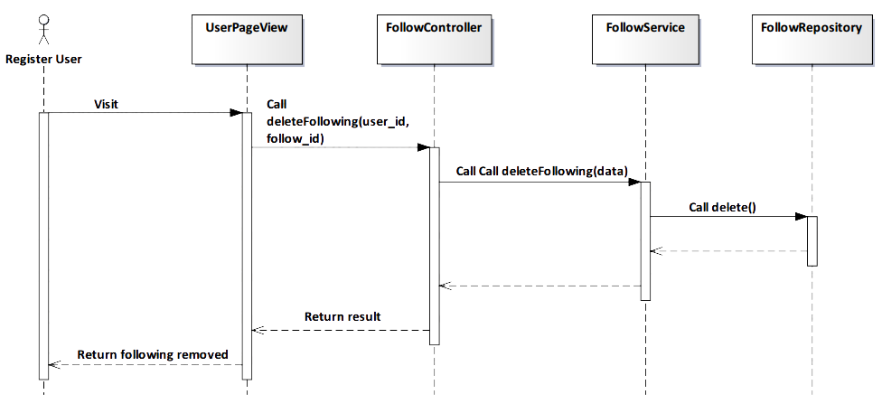

*Figure 4-136: Remove Follow Sequence Diagram*

#### Screen Design

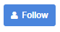

*Figure 4-137: Remove Follow Screen*

#### 4.3.4.2.29. Add Favorite

#### Description

* User add favorite post.

#### Class Diagram

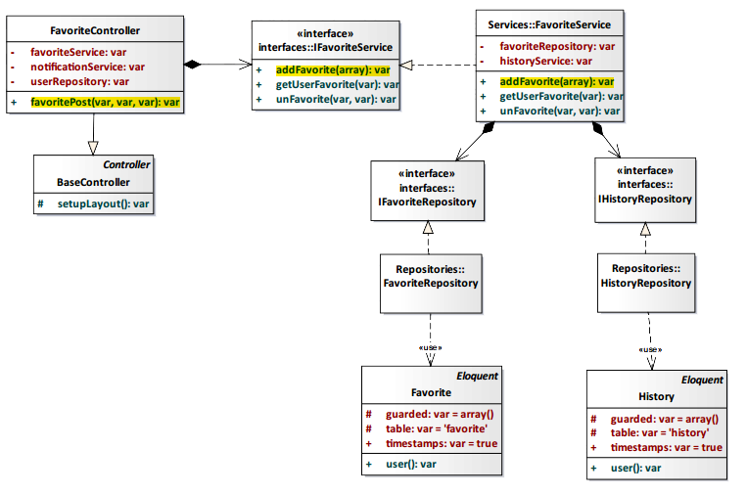

*Figure 4-138: Add Favorite Class Diagram*

#### Class Specification

#### FavoriteController class

#### Physical Address: Trendy-Server\app\Controller*FavoriteController.php*

#### Attribute

|  |  |  |  |
| --- | --- | --- | --- |
| No | Name | Type | Description |
| 1 | favoriteService | var | Instance of interface using to call methods in IFavoriteService. |
| 2 | notificationService | var | Instance of interface using to call methods in INotificationService. |
| 3 | userRepository | var | Instance of interface using to call methods in IUserRepository. |

#### Method: favoritePost($user_id, $post_id, $type)

|  |  |  |  |  |
| --- | --- | --- | --- | --- |
| Purpose | Display the favorite number of post to client. | | | |
| Return | **Type** | | | **Description** |
| var | | | The favorite number of post. |
| Parameter | **No** | **Name** | **Type** | **Description** |
| 1 | user_id | var | id of the user that add favorite post. |
| 2 | post_id | var | id of the post. |
| 3 | type | var | type of action (in this case: favorite). |

#### FavoriteService class

#### Physical Address: Trendy-Server\app\Services*FavoriteService.php*

#### Attribute

|  |  |  |  |
| --- | --- | --- | --- |
| No | Name | Type | Description |
| 1 | favoriteRepository | var | Instance of interface using to call methods in IFavoriteRepository. |
| 2 | historyService | var | Instance of interface using to call methods in IHistoryService. |

#### Method: addFavorite(array $data)

|  |  |  |  |  |
| --- | --- | --- | --- | --- |
| Purpose | Update the number of favorite post is incremented by 1 to database | | | |
| Return | **Type** | | | **Description** |
| var | | | Save data to database and response status success or fail. |
| Parameter | **No** | **Name** | **Type** | **Description** |
| 1 | data | array | Array contains userId and postId that save to database. |

#### Sequence Diagram

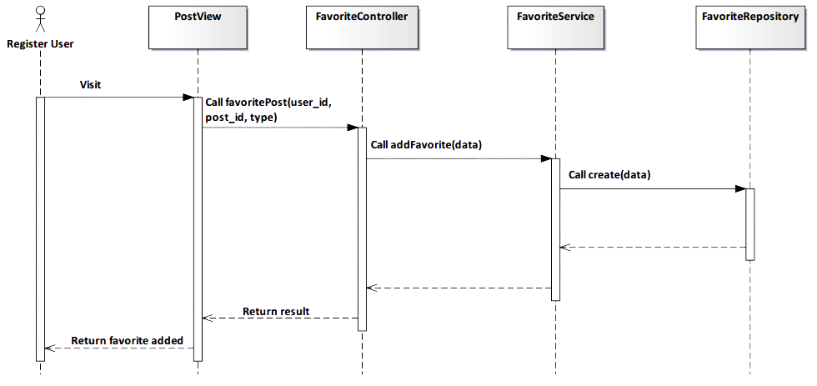

*Figure 4-139: Add Favorite Sequence Diagram*

#### Screen Design

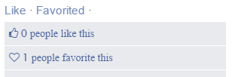

*Figure 4-140: Add Favorite Screen*

|  |  |  |
| --- | --- | --- |
| **Element** | **Type** | **Description** |
| **Like** | Button | Click to like post. |
| **Favorited** | Button | Click to unfavorite post. |

#### 4.3.4.2.30. Remove Favorite

#### Description

* User remove favorite post that added before.

#### Class Diagram



*Figure 4-141: Remove Favorite Class Diagram*

#### Class Specification

#### FavoriteController class

#### Physical Address: Trendy-Server\app\Controller*FavoriteController.php*

#### Attribute

|  |  |  |  |
| --- | --- | --- | --- |
| No | Name | Type | Description |
| 1 | favoriteService | var | Instance of interface using to call methods in IFavoriteService. |
| 2 | notificationService | var | Instance of interface using to call methods in INotificationService. |
| 3 | userRepository | var | Instance of interface using to call methods in IUserRepository. |

#### Method: favoritePost($user_id, $post_id, $type)

|  |  |  |  |  |
| --- | --- | --- | --- | --- |
| Purpose | Display the favorite number of post to client. | | | |
| Return | **Type** | | | **Description** |
| var | | | The favorite number of post. |
| Parameter | **No** | **Name** | **Type** | **Description** |
| 1 | user_id | var | id of the user that add favorite post. |
| 2 | post_id | var | id of the post. |
| 3 | type | var | type of action (in this case: unfavorite). |

#### FavoriteService class

#### Physical Address: Trendy-Server\app\Services*FavoriteService.php*

#### Attribute

|  |  |  |  |
| --- | --- | --- | --- |
| No | Name | Type | Description |
| 1 | favoriteRepository | var | Instance of interface using to call methods in IFavoriteRepository. |
| 2 | historyService | var | Instance of interface using to call methods in IHistoryService. |

#### Method: unFavorite($user_id, $post_id)

|  |  |  |  |  |
| --- | --- | --- | --- | --- |
| Purpose | Update the number of favorite post is decremented by 1 to database. | | | |
| Return | **Type** | | | **Description** |
| var | | | Save data to database and response status success or fail. |
| Parameter | **No** | **Name** | **Type** | **Description** |
| 1 | user_id | var | id of the user that remove favorite post. |
| 2 | post_id | var | id of the post. |

#### Sequence Diagram

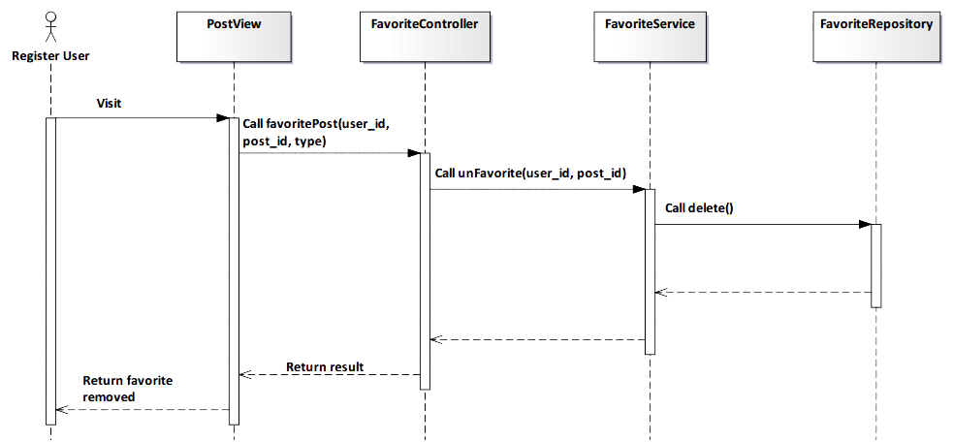

*Figure 4-142: Remove Favorite Sequence Diagram*

#### Screen Design

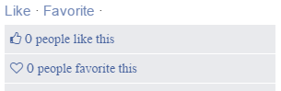

*Figure 4-143: Remove Favorite Screen*

|  |  |  |
| --- | --- | --- |
| **Element** | **Type** | **Description** |
| **Like** | Button | Click to like post. |
| **Favorite** | Button | Click to favorite post. |

#### 4.3.4.2.31. Subscribe Notification

#### Description

* Actor receives notify from TrendyPlus when another user liked/favorited/commented image of actor follows.

#### Class Diagram

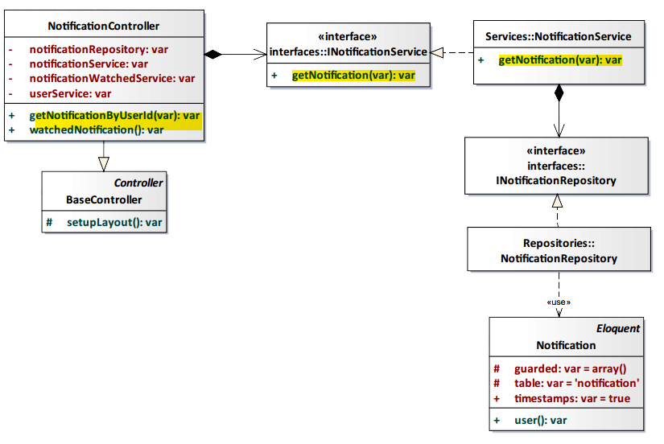

*Figure 4-144: Subscribe Notification Class Diagram*

#### Class Specification

#### NotificationController class

#### Physical Address: Trendy-Server\app\controllers*NotificationController.php*

#### Attribute

|  |  |  |  |
| --- | --- | --- | --- |
| No | Name | Type | Description |
| 1 | notificationService | var | Instance of interface using to call methods in INotificationService. |
| 2 | notificationWatchedService | var | Instance of interface using to call methods in INotificationWatchedService. |
| 3 | notificationRepository | var | Instance of interface using to call methods in INotificationRepository. |
| 4 | userService | var | Instance of interface using to call methods in IUserService. |

#### Method: getNotificationByUserId($id)

|  |  |  |  |  |
| --- | --- | --- | --- | --- |
| Purpose | Get notification of user. | | | |
| Return | **Type** | | | **Description** |
| var | | | Return list notification. |
| Parameter | **No** | **Name** | **Type** | **Description** |
| 1 | id | var | User id had being login. |

#### NotificationService class

#### Physical Address: Trendy-Server\app\Services*NotificationService.php*

#### Attribute

|  |  |  |  |
| --- | --- | --- | --- |
| No | Name | Type | Description |
| 1 | notificationRepository | var | Instance of interface using to call methods in INotificationRepository. |

#### Method: getNotification($user_id)

|  |  |  |  |  |
| --- | --- | --- | --- | --- |
| Purpose | Get notification of user. | | | |
| Return | **Type** | | | **Description** |
| var | | | Return list notification. |
| Parameter | **No** | **Name** | **Type** | **Description** |
| 1 | id | var | User id had being login. |

#### Sequence Diagram

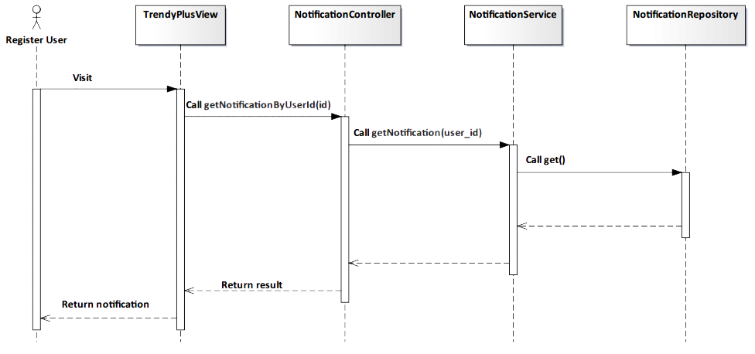

*Figure 4-145: Subscribe Notification Sequence Diagram*

#### Screen Design

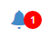

*Figure 4-146: Subscribe Notification Screen*

#### 4.3.4.2.32. View Notification

#### Description

* Actor will view notification when actor clicks to one notice

#### Class Diagram

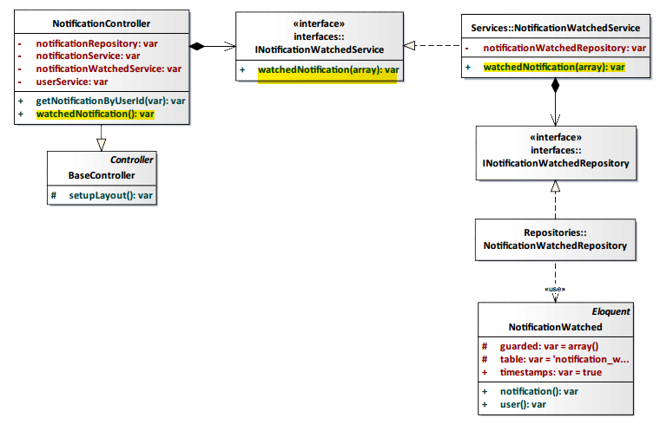

*Figure 4-147: View Notification Class Diagram*

#### Class Specification

#### NotificationController class

#### Physical Address: Trendy-Server\app\controllers*NotificationController.php*

#### Attribute

|  |  |  |  |
| --- | --- | --- | --- |
| No | Name | Type | Description |
| 1 | notificationService | var | Instance of interface using to call methods in INotificationService. |
| 2 | notificationWatchedService | var | Instance of interface using to call methods in INotificationWatchedService. |
| 3 | notificationRepository | var | Instance of interface using to call methods in INotificationRepository. |
| 4 | userService | var | Instance of interface using to call methods in IUserService. |

#### Method: watchedNotification()

|  |  |  |
| --- | --- | --- |
| Purpose | Watch content of notification. | |
| Return | **Type** | **Description** |
| var | Return address need notice. |

#### NotificationWatchedService Class

#### Physical Address: Trendy-Server\app\Services\ *NotificationWatchedService.php*

#### Attribute

|  |  |  |  |
| --- | --- | --- | --- |
| No | Name | Type | Description |
| 1 | notificationWatchedRepository | var | Instance of interface using to call methods in INotificationWatchedRepository. |

#### Method: watchedNotification($data)

|  |  |  |  |  |
| --- | --- | --- | --- | --- |
| Purpose | Watch content of notification. | | | |
| Return | **Type** | | | **Description** |
| var | | | Return address need notice. |
| Parameter | **No** | **Name** | **Type** | **Description** |
| 1 | data | array | Include user_id and notification_id. |

#### Sequence Diagram

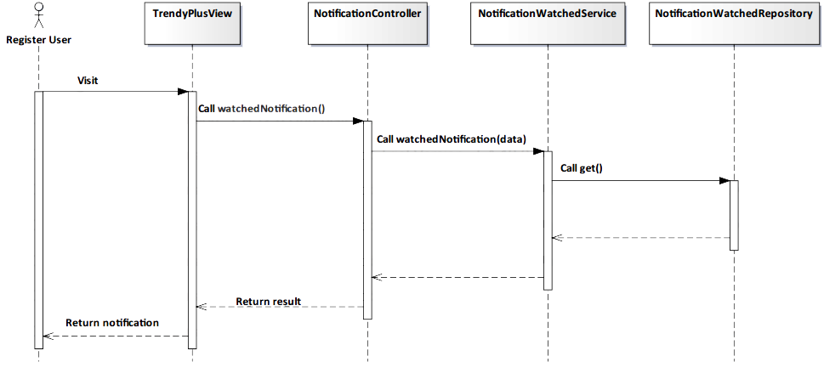

*Figure 4-148: View Notification Sequence Diagram*

#### Screen Design

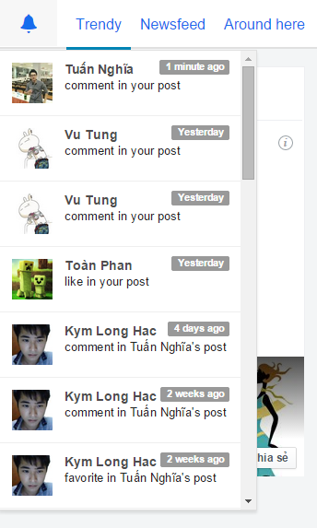

*Figure 4-149: View Notification Screen*

#### 4.3.4.2.33. Change Cover

#### Description

* User can change cover in their profile page.

#### Class Diagram

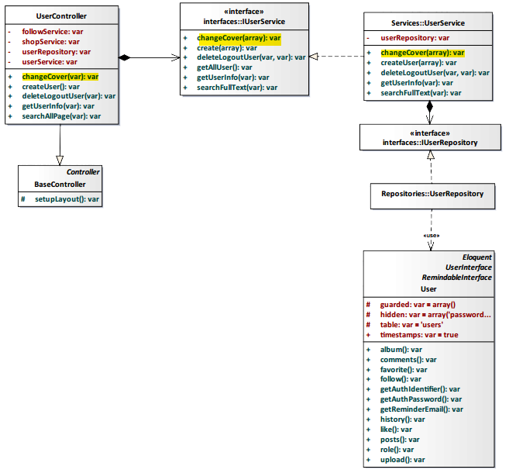

*Figure 4-150: Change Cover Class Diagram*

#### Class Specification

#### UserController class

#### Physical Address: Trendy-Server\app\Controller*UserController.php*

#### Attribute

|  |  |  |  |
| --- | --- | --- | --- |
| No | Name | Type | Description |
| 1 | followService | var | Instance of interface using to call methods in IFollowService. |
| 2 | shopService | var | Instance of interface using to call methods in IShopService. |
| 3 | userRepository | var | Instance of interface using to call methods in IUserRepository. |
| 4 | userService | var | Instance of interface using to call methods in IUserService. |

#### Method: changeCover($id)

|  |  |  |  |  |
| --- | --- | --- | --- | --- |
| Purpose | Update image to be new cover profile page. | | | |
| Return | **Type** | | | **Description** |
| boolean | | | Return true if successful. |
| Parameter | **No.** | **Name** | **Type** | **Description** |
| 1 | id | var | id of the user. |

#### UserService class

#### Physical Address: Trendy-Server\app\Services*UserService.php*

#### Attribute

|  |  |  |  |
| --- | --- | --- | --- |
| No | Name | Type | Description |
| 1 | userRepository | var | Instance of interface using to call methods in IUserRepository. |

#### Method: changeCover ($data)

|  |  |  |  |  |
| --- | --- | --- | --- | --- |
| Purpose | Process to change user’s cover. | | | |
| Return | **Type** | | | **Description** |
| var | | | Return user’s cover. |
| Parameter | **No** | **Name** | **Type** | **Description** |
| 1 | data | array | Array contains information update user’s cover. |

#### Sequence Diagram

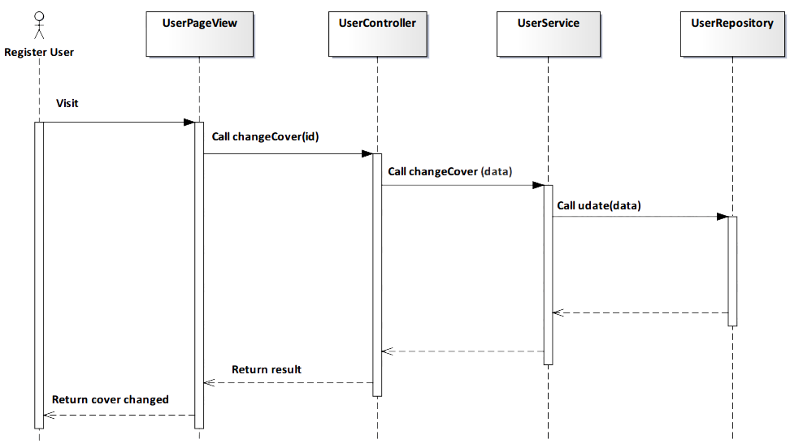

*Figure 4-151: Change Cover Sequence Diagram*

#### Screen Design



*Figure 4-152: Change Cover Screen*

#### 4.3.4.2.34. Logout

#### Description

* Actor logouts TrendyPlus.

#### Class Diagram

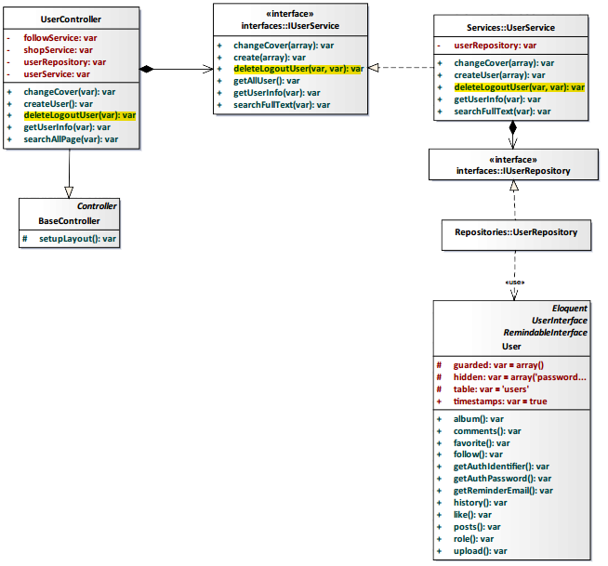

*Figure 4-153: Logout Class Diagram*

#### Class Specification

#### UserController class

#### Physical Address: Trendy-Server\app\controllers*UserController.php*

#### Attribute

|  |  |  |  |
| --- | --- | --- | --- |
| No | Name | Type | Description |
| 1 | followService | var | Instance of interface using to call methods in IFollowService. |
| 2 | shopService | var | Instance of interface using to call methods in IShopService. |
| 3 | userRepository | var | Instance of interface using to call methods in IUserRepository. |
| 4 | userService | var | Instance of interface using to call methods in IUserService. |

#### Method: deleteLogoutUser($id)

|  |  |  |  |  |
| --- | --- | --- | --- | --- |
| Purpose | User implement logout system. | | | |
| Return | **Type** | | | **Description** |
| var | | | Return status logout system. |
| Parameter | **No** | **Name** | **Type** | **Description** |
| 1 | id | var | id of user. |

#### UserService class

#### Physical Address: Trendy-Server\app\Services*UserService.php*

#### Attribute

|  |  |  |  |
| --- | --- | --- | --- |
| No | Name | Type | Description |
| 1 | userRepository | var | Instance of interface using to call methods in IUserRepository. |

#### Method: deleteLogoutUser($column, $value)

|  |  |  |  |  |
| --- | --- | --- | --- | --- |
| Purpose | Process user implement logout system. | | | |
| Return | **Type** | | | **Description** |
| var | | | Return status logout system. |
| Parameter | **No** | **Name** | **Type** | **Description** |
| 1 | column | var | column define user. |
| 2 | value | var | value define exactly position of user.. |

#### Sequence Diagram

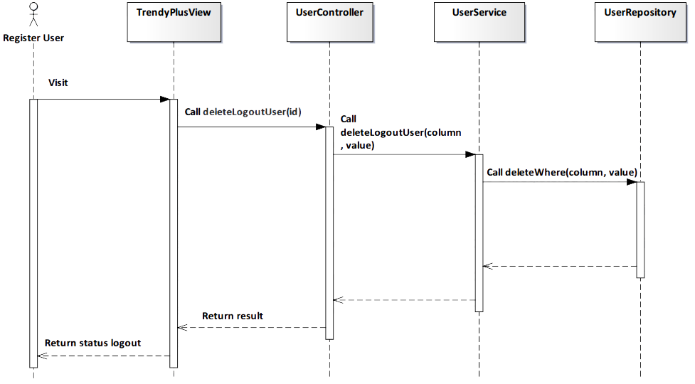

*Figure 4-154: Logout Sequence Diagram*

#### Screen Design

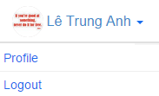

*Figure 4-155: Logout Screen*

|  |  |  |
| --- | --- | --- |
| **Element** | **Type** | **Description** |
| **Profile** | Button | Click to access user’s profile. |
| **Logout** | Button | Click to logout TrendyPlus. |

#### 4.3.4.2.35. General Search

#### Description

* Actor searches users or shops from our system with an input string.

#### Class Diagram

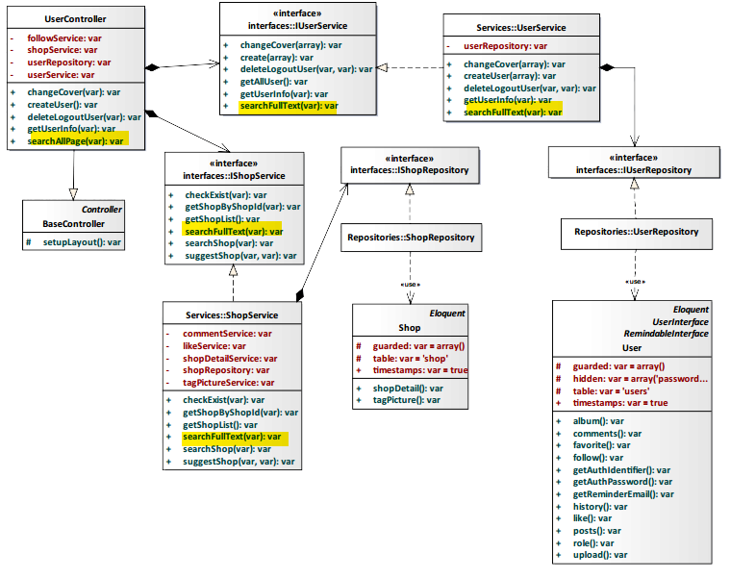

*Figure 4-156: General Search Class Diagram*

#### Class Specification

#### UserController class

#### Physical Address: Trendy-Server\app\Controller*UserController.php*

#### Attribute

|  |  |  |  |
| --- | --- | --- | --- |
| No | Name | Type | Description |
| 1 | followService | var | Instance of interface using to call methods in IFollowService. |
| 2 | shopService | var | Instance of interface using to call methods in IShopService. |
| 3 | userRepository | var | Instance of interface using to call methods in IUserRepository. |
| 4 | userService | var | Instance of interface using to call methods in IUserService. |

#### Method: searchAllPage($type)

|  |  |  |  |  |
| --- | --- | --- | --- | --- |
| Purpose | Search users and shops had name contain $type. | | | |
| Return | **Type** | | | **Description** |
| array | | | Return list of shop and user result of search. |
| Parameter | **No.** | **Name** | **Type** | **Description** |
| 1 | type | var | String is inputed in textbox search. |

#### UserService class

#### Physical Address: Trendy-Server\app\Services*UserService.php*

#### Attribute

|  |  |  |  |
| --- | --- | --- | --- |
| No | Name | Type | Description |
| 1 | userRepository | var | Instance of interface using to call methods in IUserRepository. |

#### Method: searchFullText($type)

|  |  |  |  |  |
| --- | --- | --- | --- | --- |
| Purpose | Search users have name contain $type. | | | |
| Return | **Type** | | | **Description** |
| var | | | Return list user. |
| Parameter | **No** | **Name** | **Type** | **Description** |
| 1 | type | var | String is inputed in textbox search. |

#### ShopService class

#### Physical Address: Trendy-Server\app\Services*ShopService.php*

#### Attribute

|  |  |  |  |
| --- | --- | --- | --- |
| No | Name | Type | Description |
| 1 | commentService | var | Instance of interface using to call methods in ICommentService. |
| 2 | likeService | var | Instance of interface using to call methods in ILikeService. |
| 3 | shopDetailService | var | Instance of interface using to call methods in IShopDetailService. |
| 4 | shopRepository | var | Instance of interface using to call methods in IShopRepository. |
| 5 | tagPictureService | var | Instance of interface using to call methods in ITagPictureService. |

#### Method: searchFullText ($type)

|  |  |  |  |  |
| --- | --- | --- | --- | --- |
| Purpose | Search shops have name contain $type. | | | |
| Return | **Type** | | | **Description** |
| var | | | Return list shop. |
| Parameter | **No** | **Name** | **Type** | **Description** |
| 1 | type | var | String is inputed in textbox search. |

#### Sequence Diagram

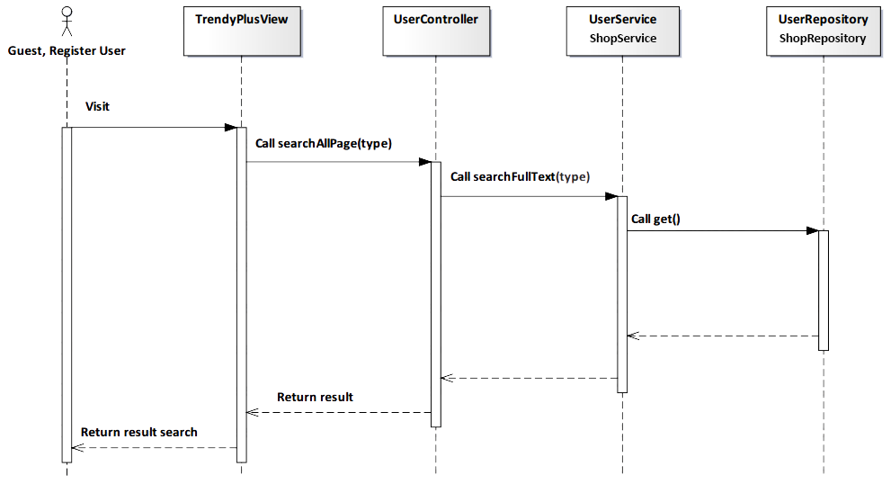

*Figure 4-157: General Search Sequence Diagram*

#### Screen Design

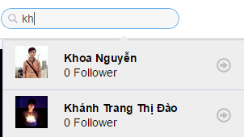

*Figure 4-158: General Search Screen*

|  |  |  |
| --- | --- | --- |
| **Element** | **Type** | **Description** |
| **Search** | Input text | Text field for entering content to search. |

### 4.3.4.3. Administrator

#### 4.3.4.3.1. Search User

#### Description

* Admin search user to view information of user.

#### Class Diagram

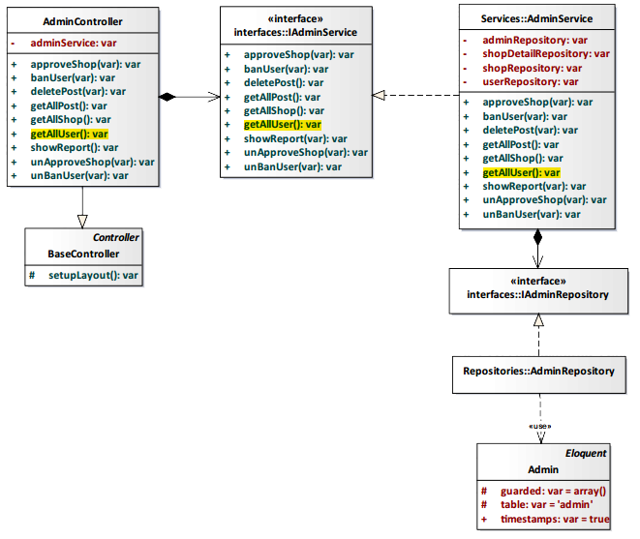

*Figure 4-159: Search User Class Diagram*

#### Class Specification

#### AdminController class

#### Physical Address: Trendy-Server\app\Controller*AdminController.php*

#### Attribute

|  |  |  |  |
| --- | --- | --- | --- |
| No | Name | Type | Description |
| 1 | adminService | var | Instance of interface using to call methods in IAdminService. |

#### Method: getAllUser()

|  |  |  |
| --- | --- | --- |
| Purpose | Process and display a result search user. | |
| Return | **Type** | **Description** |
| arrayList | Represents the result of an action method. Return list all user. |

#### AdminService class

#### Physical Address: Trendy-Server\app\Services*AdminService.php*

#### Attribute

|  |  |  |  |
| --- | --- | --- | --- |
| No | Name | Type | Description |
| 1 | adminRepository | var | Instance of interface using to call methods in IAdminRepository. |
| 2 | shopDetailRepository | var | Instance of interface using to call methods in IShopDetailRepository. |
| 3 | shopRepository | var | Instance of interface using to call methods in IShopRepository. |
| 4 | userRepository | var | Instance of interface using to call methods in IUserRepository. |

#### Method: getAllUser()

|  |  |  |
| --- | --- | --- |
| Purpose | Process and display a result search user. | |
| Return | **Type** | **Description** |
| arrayList | Represents the result of an action method. Return list all user. |

#### Sequence Diagram

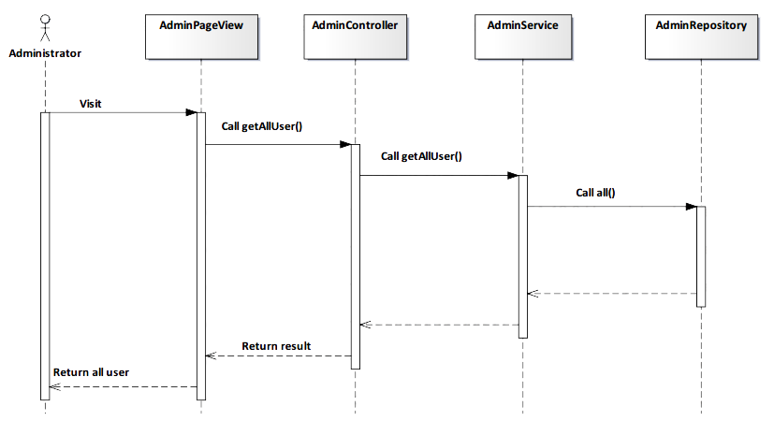

*Figure 4-160: Search User Sequence Diagram*

#### Screen Design

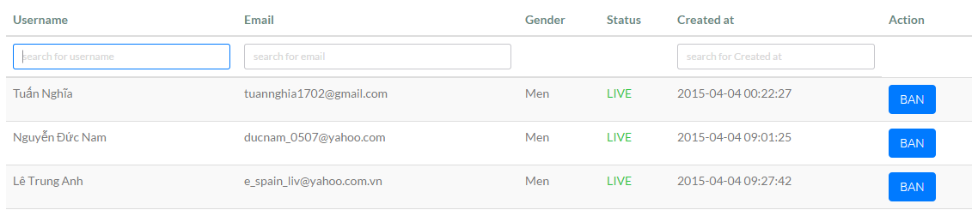

*Figure 4-161: Search User Screen*

|  |  |  |
| --- | --- | --- |
| **Element** | **Type** | **Description** |
| **Username** | Input text | Text field for entering username. |
| **Email** | Input text | Text field for entering email. |
| **Create at** | Input text | Text field for entering create at. |

#### 4.3.4.3.2. Search Shop

#### Description

* Admin search shop to view information of shop.

#### Class Diagram

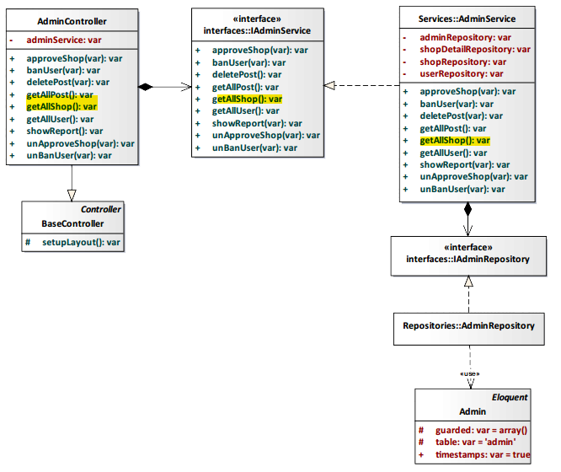

*Figure 4-162: Search Shop Class Diagram*

#### Class Specification

#### AdminController class

#### Physical Address: Trendy-Server\app\Controller*AdminController.php*

#### Attribute

|  |  |  |  |
| --- | --- | --- | --- |
| No | Name | Type | Description |
| 1 | adminService | var | Instance of interface using to call methods in IAdminService. |

#### Method: getAllShop()

|  |  |  |
| --- | --- | --- |
| Purpose | Process and display a result search shop. | |
| Return | **Type** | **Description** |
| arrayList | Represents the result of an action method. Return list all shop. |

#### AdminService class

#### Physical Address: Trendy-Server\app\Services*AdminService.php*

#### Attribute

|  |  |  |  |
| --- | --- | --- | --- |
| No | Name | Type | Description |
| 1 | adminRepository | var | Instance of interface using to call methods in IAdminRepository. |
| 2 | shopDetailRepository | var | Instance of interface using to call methods in IShopDetailRepository. |
| 3 | shopRepository | var | Instance of interface using to call methods in IShopRepository. |
| 4 | userRepository | var | Instance of interface using to call methods in IUserRepository. |

#### Method: getAllShop()

|  |  |  |
| --- | --- | --- |
| Purpose | Process and display a result search shop. | |
| Return | **Type** | **Description** |
| arrayList | Represents the result of an action method. Return list all shop. |

#### Sequence Diagram

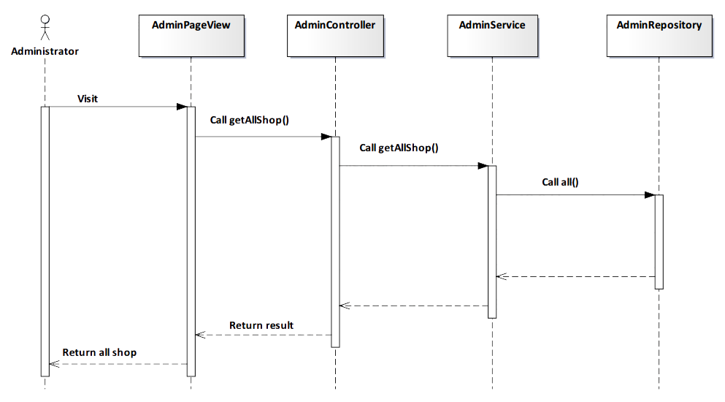

*Figure 4-163: Search Shop Sequence Diagram*

#### Screen Design

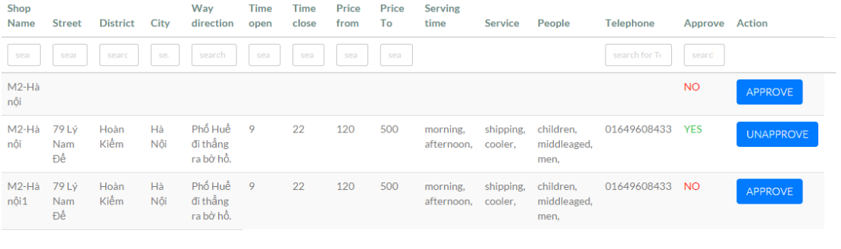

*Figure 4-164: Search Shop Screen*

|  |  |  |
| --- | --- | --- |
| **Element** | **Type** | **Description** |
| **Shop Name** | Input text | Text field for entering shop name. |
| **Street** | Input text | Text field for entering street. |
| **District** | Input text | Text field for entering district. |
| **City** | Input text | Text field for entering city. |
| **Way direction** | Input text | Text field for entering way direction. |
| **Time open** | Input text | Text field for entering time open. |
| **Time close** | Input text | Text field for entering time close. |
| **Price from** | Input text | Text field for entering price from. |
| **Price To** | Input text | Text field for entering price to. |
| **Telephone** | Input text | Text field for entering telephone. |
| **Approve** | Input text | Text field for entering approve. |
| **Approve** | Button | Click to approve information shop. |
| **Unapprove** | Button | Click to unapprove information shop. |

#### 4.3.4.3.3. View All User

#### Description

* Admin view all user.

#### Class Diagram



*Figure 4-165: View All User Class Diagram*

#### Class Specification

#### AdminController class

#### Physical Address: Trendy-Server\app\Controller*AdminController.php*

#### Attribute

|  |  |  |  |
| --- | --- | --- | --- |
| No | Name | Type | Description |
| 1 | adminService | var | Instance of interface using to call methods in IAdminService. |

#### Method: getAllUser()

|  |  |  |
| --- | --- | --- |
| Purpose | Show all user for administrator. | |
| Return | **Type** | **Description** |
| arrayList | Represents the result of an action method. Return list all user. |

#### AdminService class

#### Physical Address: Trendy-Server\app\Services*AdminService.php*

#### Attribute

|  |  |  |  |
| --- | --- | --- | --- |
| No | Name | Type | Description |
| 1 | adminRepository | var | Instance of interface using to call methods in IAdminRepository. |
| 2 | shopDetailRepository | var | Instance of interface using to call methods in IShopDetailRepository. |
| 3 | shopRepository | var | Instance of interface using to call methods in IShopRepository. |
| 4 | userRepository | var | Instance of interface using to call methods in IUserRepository. |

#### Method: getAllUser()

|  |  |  |
| --- | --- | --- |
| Purpose | Show all user for administrator. | |
| Return | **Type** | **Description** |
| arrayList | Represents the result of an action method. Return list all user. |

#### Sequence Diagram



*Figure 4-166: View All User Sequence Diagram*

#### Screen Design

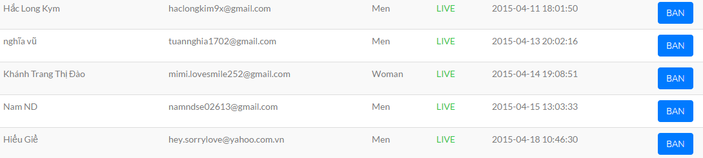

*Figure 4-167: View All User Screen*

|  |  |  |
| --- | --- | --- |
| **Element** | **Type** | **Description** |
| **Scroll** | Button | Scroll down to view more user. |
| **Page** | Button | Next page to view more user. |

#### 4.3.4.3.4. Delete Post

#### Description

* Admin delete post of user.

#### Class Diagram

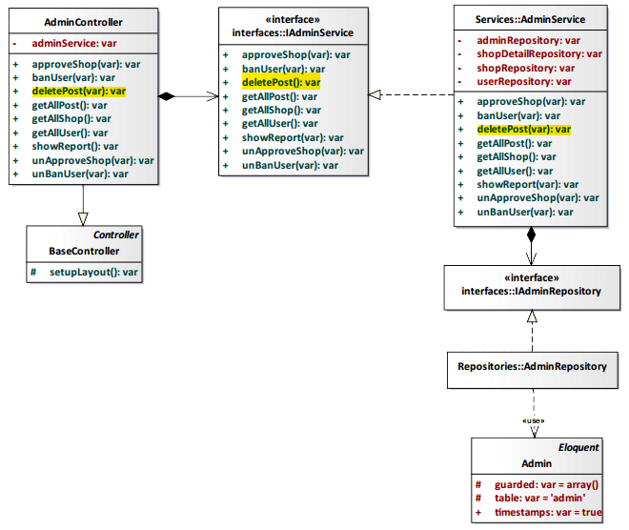

*Figure 4-168: Delete Post Class Diagram*

#### Class Specification

#### AdminController class

#### Physical Address: Trendy-Server\app\Controller*AdminController.php*

#### Attribute

|  |  |  |  |
| --- | --- | --- | --- |
| No | Name | Type | Description |
| 1 | adminService | var | Instance of interface using to call methods in IAdminService. |

#### Method: deletePost()

|  |  |  |
| --- | --- | --- |
| Purpose | Delete post of user. | |
| Return | **Type** | **Description** |
| boolean | Represents the result of an action method. Return true or false. |

#### AdminService class

#### Physical Address: Trendy-Server\app\Services*AdminService.php*

#### Attribute

|  |  |  |  |
| --- | --- | --- | --- |
| No | Name | Type | Description |
| 1 | adminRepository | var | Instance of interface using to call methods in IAdminRepository. |
| 2 | shopDetailRepository | var | Instance of interface using to call methods in IShopDetailRepository. |
| 3 | shopRepository | var | Instance of interface using to call methods in IShopRepository. |
| 4 | userRepository | var | Instance of interface using to call methods in IUserRepository. |

#### Method: deletePost()

|  |  |  |
| --- | --- | --- |
| Purpose | Delete post of user. | |
| Return | **Type** | **Description** |
| boolean | Represents the result of an action method. Return true or false. |

#### Sequence Diagram

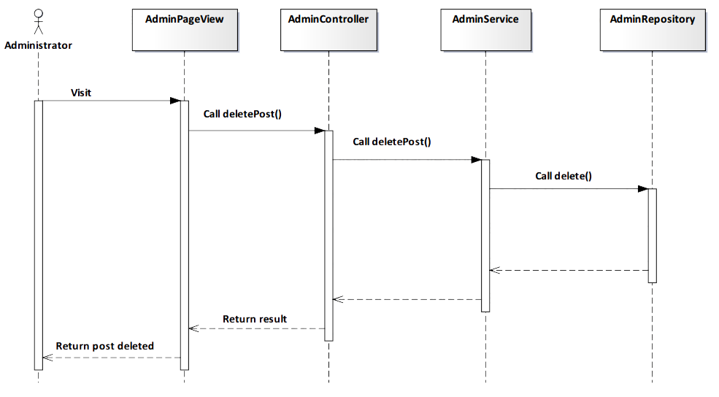

*Figure 4-169: Delete Post Sequence Diagram*

#### Screen Design

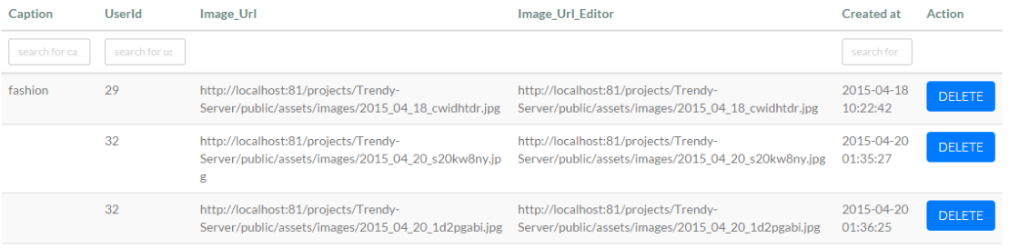

*Figure 4-170: Delete Post Screen*

|  |  |  |
| --- | --- | --- |
| **Element** | **Type** | **Description** |
| **Delete** | Button | Click to delete post. |

#### 4.3.4.3.5. View All Shop

#### Description

* Admin view list all shop.

#### Class Diagram



*Figure 4-171: View All Shop Class Diagram*

#### Class Specification

#### AdminController class

#### Physical Address: Trendy-Server\app\Controller*AdminController.php*

#### Attribute

|  |  |  |  |
| --- | --- | --- | --- |
| No | Name | Type | Description |
| 1 | adminService | var | Instance of interface using to call methods in IAdminService. |

#### Method: getAllShop()

|  |  |  |
| --- | --- | --- |
| Purpose | Show all shop for administrator. | |
| Return | **Type** | **Description** |
| arrayList | Represents the result of an action method. Return list all shop. |

#### AdminService class

#### Physical Address: Trendy-Server\app\Services*AdminService.php*

#### Attribute

|  |  |  |  |
| --- | --- | --- | --- |
| No | Name | Type | Description |
| 1 | adminRepository | var | Instance of interface using to call methods in IAdminRepository. |
| 2 | shopDetailRepository | var | Instance of interface using to call methods in IShopDetailRepository. |
| 3 | shopRepository | var | Instance of interface using to call methods in IShopRepository. |
| 4 | userRepository | var | Instance of interface using to call methods in IUserRepository. |

#### Method: getAllShop()

|  |  |  |
| --- | --- | --- |
| Purpose | Show all shop for administrator. | |
| Return | **Type** | **Description** |
| arrayList | Represents the result of an action method. Return list all shop. |

#### Sequence Diagram



*Figure 4-172: View All Shop Sequence Diagram*

#### Screen Design



*Figure 4-173: View All Shop Screen*

|  |  |  |
| --- | --- | --- |
| **Element** | **Type** | **Description** |
| **Next** | Button | Next page to view more shop. |

#### 4.3.4.3.6. Update Information Shop

#### Description

* Admin approve or unapproved request update shop’s information of user.

#### Class Diagram

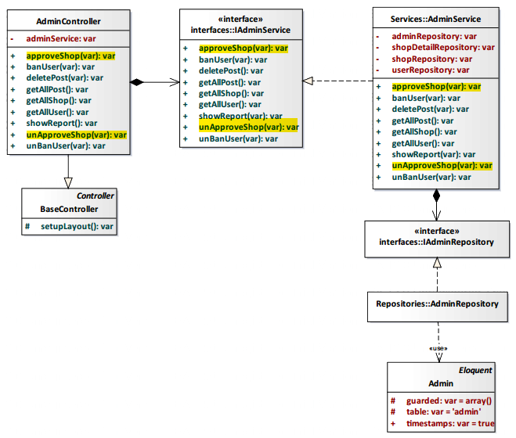

*Figure 4-174: Update Information Shop Class Diagram*

#### Class Specification

#### AdminController class

#### Physical Address: Trendy-Server\app\Controller*AdminController.php*

#### Attribute

|  |  |  |  |
| --- | --- | --- | --- |
| No | Name | Type | Description |
| 1 | adminService | var | Instance of interface using to call methods in IAdminService. |

#### Method: approveShop()

|  |  |  |
| --- | --- | --- |
| Purpose | Approve request update shop’s information of user. | |
| Return | **Type** | **Description** |
| boolean | Represents the result of an action method. Return true or false. |

#### Method: unAproveShop()

|  |  |  |
| --- | --- | --- |
| Purpose | Unapproved request update shop’s information of user. | |
| Return | **Type** | **Description** |
| boolean | Represents the result of an action method. Return true or false. |

#### AdminService class

#### Physical Address: Trendy-Server\app\Services*AdminService.php*

#### Attribute

|  |  |  |  |
| --- | --- | --- | --- |
| No | Name | Type | Description |
| 1 | adminRepository | var | Instance of interface using to call methods in IAdminRepository. |
| 2 | shopDetailRepository | var | Instance of interface using to call methods in IShopDetailRepository. |
| 3 | shopRepository | var | Instance of interface using to call methods in IShopRepository. |
| 4 | userRepository | var | Instance of interface using to call methods in IUserRepository. |

#### Method: approveShop()

|  |  |  |
| --- | --- | --- |
| Purpose | Approve request update shop’s information of user. | |
| Return | **Type** | **Description** |
| boolean | Represents the result of an action method. Return true or false. |

#### Method: unAproveShop()

|  |  |  |
| --- | --- | --- |
| Purpose | Unapproved request update shop’s information of user. | |
| Return | **Type** | **Description** |
| boolean | Represents the result of an action method. Return true or false. |

#### Sequence Diagram

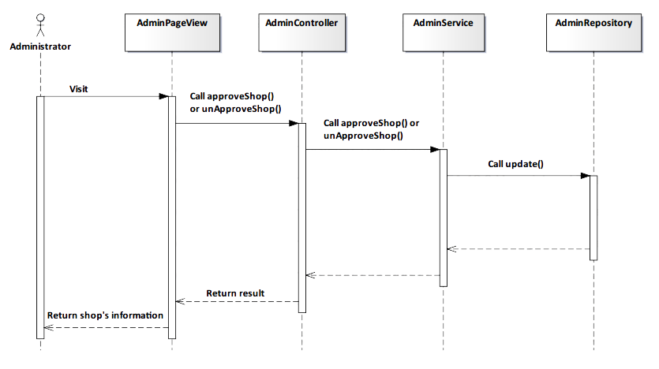

*Figure 4-175: Update Information Shop Sequence Diagram*

#### Screen Design



*Figure 4-176: Update Information Shop Screen*

|  |  |  |
| --- | --- | --- |
| **Element** | **Type** | **Description** |
| **Approve** | Button | Click to approve information shop. |
| **Unapprove** | Button | Click to unapprove information shop. |

#### 4.3.4.3.7. Ban User

#### Description

* Admin ban user in system.

#### Class Diagram

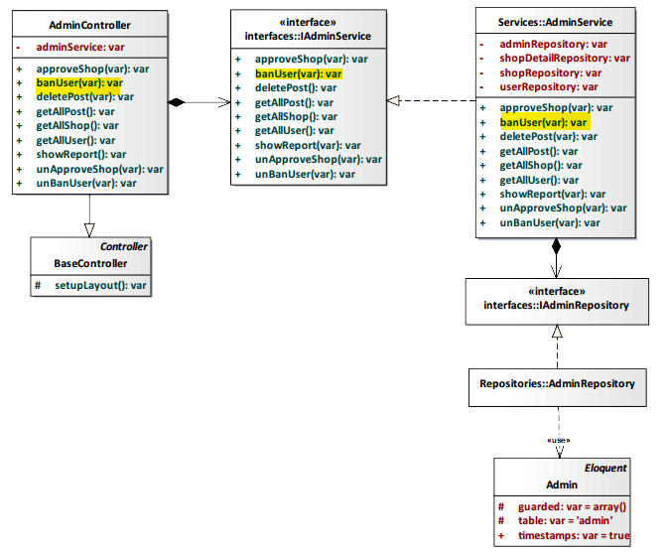

*Figure 4-177: Ban User Class Diagram*

#### Class Specification

#### AdminController class

#### Physical Address: Trendy-Server\app\Controller*AdminController.php*

#### Attribute

|  |  |  |  |
| --- | --- | --- | --- |
| No | Name | Type | Description |
| 1 | adminService | var | Instance of interface using to call methods in IAdminService. |

#### Method: banUser(var)

|  |  |  |  |  |
| --- | --- | --- | --- | --- |
| Purpose | Implementation progress ban user of administrator. | | | |
| Return | **Type** | | | **Description** |
| boolean | | | Return success or error. |
| Parameter | **No.** | **Name** | **Type** | **Description** |
| 1 | user_id | var | id of user. |

#### AdminService class

#### Physical Address: Trendy-Server\app\Services*AdminService.php*

#### Attribute

|  |  |  |  |
| --- | --- | --- | --- |
| No | Name | Type | Description |
| 1 | adminRepository | var | Instance of interface using to call methods in IAdminRepository. |
| 2 | shopDetailRepository | var | Instance of interface using to call methods in IShopDetailRepository. |
| 3 | shopRepository | var | Instance of interface using to call methods in IShopRepository. |
| 4 | userRepository | var | Instance of interface using to call methods in IUserRepository. |

#### Method: banUser(var)

|  |  |  |  |  |
| --- | --- | --- | --- | --- |
| Purpose | Implementation progress ban user of administrator. | | | |
| Return | **Type** | | | **Description** |
| boolean | | | Return success or error. |
| Parameter | **No.** | **Name** | **Type** | **Description** |
| 1 | user_id | var | id of user. |

#### Sequence Diagram

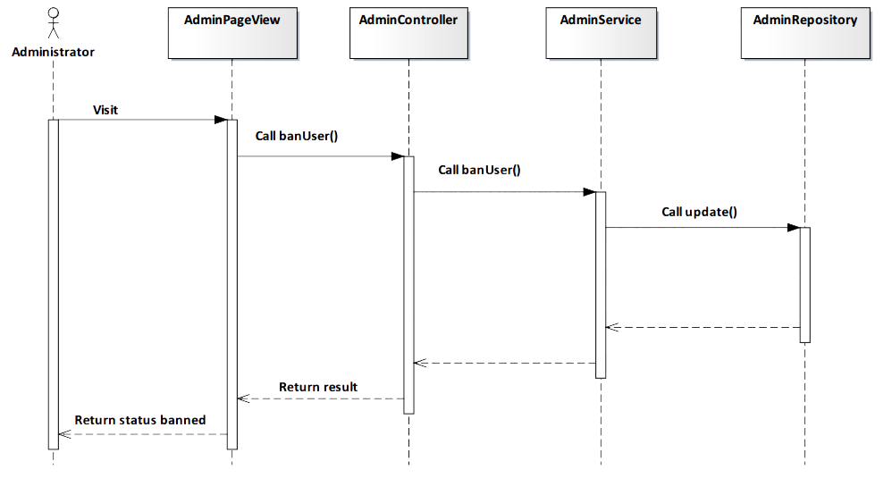

*Figure 4-178: Ban User Sequence Diagram*

#### Screen Design



*Figure 4-179: Ban User Scree*

|  |  |  |
| --- | --- | --- |
| **Element** | **Type** | **Description** |
| **Ban** | Button | Click to ban user. |

#### 4.3.4.3.8. Unban User

#### Description

* Admin unban user in system.

#### Class Diagram

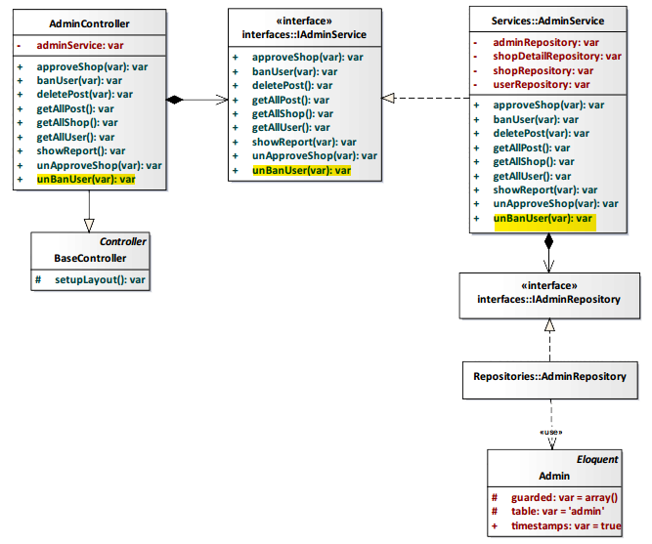

*Figure 4-180: Unban User Class Diagram*

#### Class Specification

#### AdminController class

#### Physical Address: Trendy-Server\app\Controller*AdminController.php*

#### Attribute

|  |  |  |  |
| --- | --- | --- | --- |
| No | Name | Type | Description |
| 1 | adminService | var | Instance of interface using to call methods in IAdminService. |

#### Method: unBanUser(var)

|  |  |  |  |  |
| --- | --- | --- | --- | --- |
| Purpose | Implementation progress unban user of administrator. | | | |
| Return | **Type** | | | **Description** |
| boolean | | | Return success or error |
| Parameter | **No.** | **Name** | **Type** | **Description** |
| 1 | user_id | var | id of user |

#### AdminService class

#### Physical Address: Trendy-Server\app\Services*AdminService.php*

#### Attribute

|  |  |  |  |
| --- | --- | --- | --- |
| No | Name | Type | Description |
| 1 | adminRepository | var | Instance of interface using to call methods in IAdminRepository. |
| 2 | shopDetailRepository | var | Instance of interface using to call methods in IShopDetailRepository. |
| 3 | shopRepository | var | Instance of interface using to call methods in IShopRepository. |
| 4 | userRepository | var | Instance of interface using to call methods in IUserRepository. |

#### Method: unBanUser(var)

|  |  |  |  |  |
| --- | --- | --- | --- | --- |
| Purpose | Implementation progress unban user of administrator. | | | |
| Return | **Type** | | | **Description** |
| boolean | | | Return success or error |
| Parameter | **No.** | **Name** | **Type** | **Description** |
| 1 | user_id | var | id of user |

#### Sequence Diagram

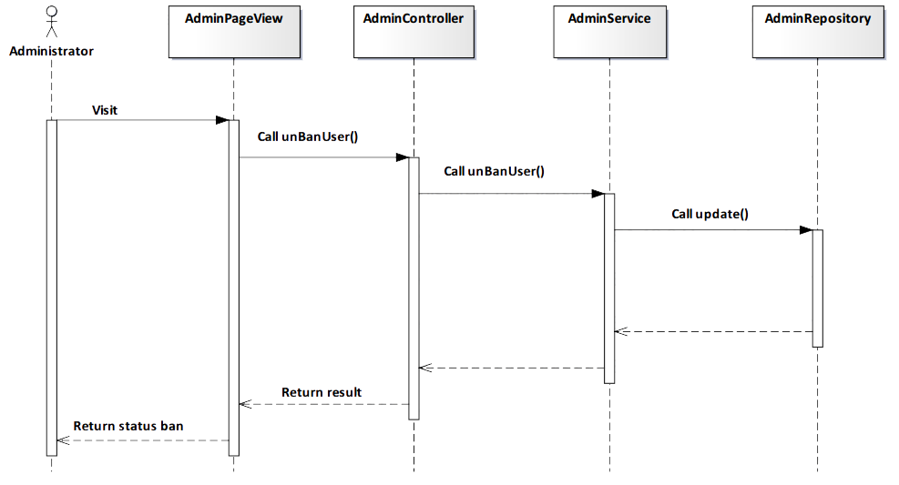

*Figure 4-181: Unban User Sequence Diagram*

#### Screen Design

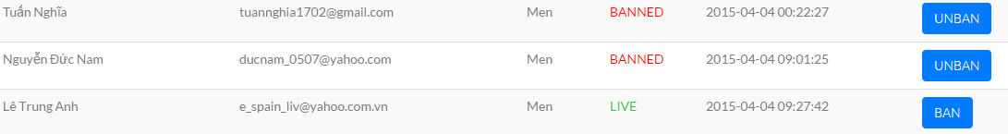

*Figure 4-182: Unban User Screen*

|  |  |  |
| --- | --- | --- |
| **Element** | **Type** | **Description** |
| **Unban** | Button | Click to unban user. |

#### 4.3.4.3.9. Show report

#### Description

* Admin view report about statistics user’s account.

#### Class Diagram

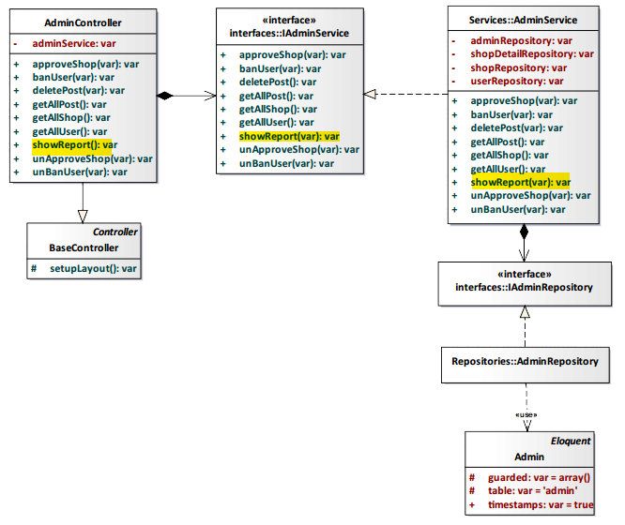

*Figure 4-183: Show Report Class Diagram*

#### Class Specification

#### AdminController class

#### Physical Address: Trendy-Server\app\Controller*AdminController.php*

#### Attribute

|  |  |  |  |
| --- | --- | --- | --- |
| No | Name | Type | Description |
| 1 | adminService | var | Instance of interface using to call methods in IAdminService. |

#### Method: showReport()

|  |  |  |
| --- | --- | --- |
| Purpose | Process and display report. | |
| Return | **Type** | **Description** |
| boolean | Represents the result of an action method. Return true or false. |

#### AdminService class

#### Physical Address: Trendy-Server\app\Services*AdminService.php*

#### Attribute

|  |  |  |  |
| --- | --- | --- | --- |
| No | Name | Type | Description |
| 1 | userResponsitory | var | Instance of interface using to call methods in IUserResponsitory |
| 2 | shopResponsitory | var | Instance of interface using to call methods in IShopResponsitory |
| 3 | postResponsitory | var | Instance of interface using to call methods in IPostResponsitory |
| 4 | adminResponsitory | var | Instance of interface using to call methods in IAdminResponsitory |
| 5 | postAlbumResponsitory | var | Instance of interface using to call methods in IAdminResponsitory |

#### Method: showReport()

|  |  |  |
| --- | --- | --- |
| Purpose | Process and display report. | |
| Return | **Type** | **Description** |
| boolean | Represents the result of an action method. Return true or false |

#### Sequence Diagram

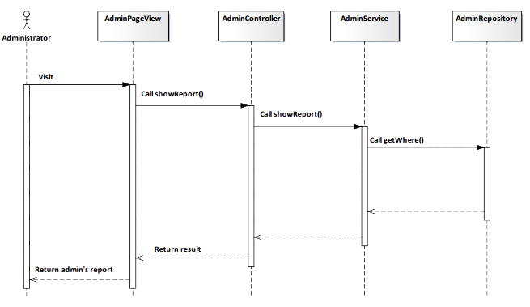

*Figure 4-184: Show Report Sequence Diagram*

#### Screen Design

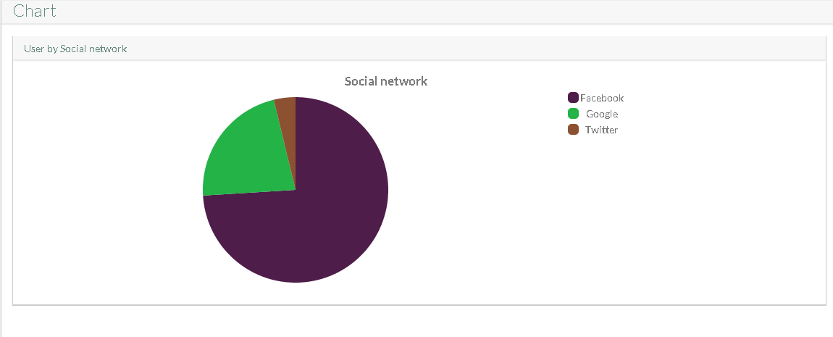

*Figure 4-185: Show Report User’s account Screen*

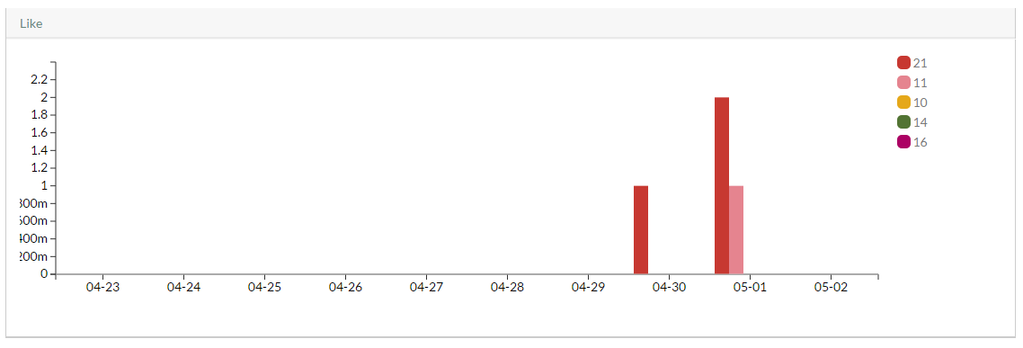

*Figure 4-186: Show Report Like quantity Screen*

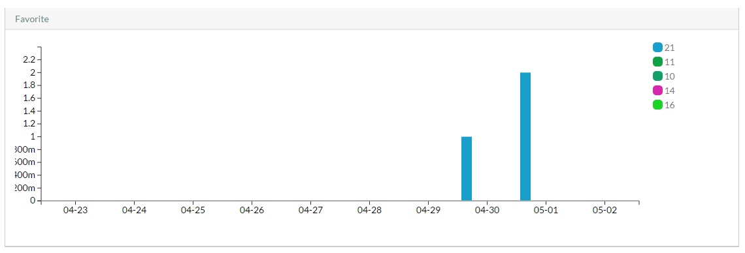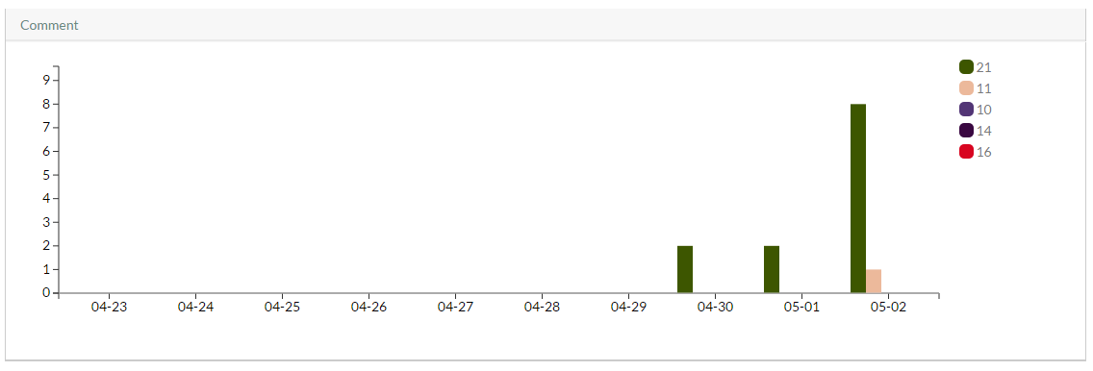

*Figure 4-187: Show Report Favorite quantity Screen*

*Figure 4-187: Show Report Comment quantity Screen*